**Graph**

**Index**

1. Introduction
2. GraphRepresent
3. WhyWeNeedAnVisitedArray

**Graph Traversal**

1. BFS
2. DFS
3. NumberofProvinces
4. NoofIsland
5. FloodFill
6. RottonOranges

**Detect The Cycle**

1. DetectTheCycleUsingBFS
2. DetectTheCycleUsingDFS
3. Matrix01
4. SurroundingRegions
5. NoOfEnclaves
6. NoofDistinctIsland
7. BipartiteGraph
8. DetetchTheLoopInDirectedGraph
9. FindEventualSafeStates
10. WordLadder1

**Topological Sort**

1. TopologicalSort
2. KahnsAlgorithm
3. DirectedGraphCycleDetectionBFS
4. CourseSchedule1
5. CourseSchedule2
6. AlienDictionary

**Shortest Path**

1. ShortestPathInUndirectedGraph
2. ShortestPathInDAG
3. DijkstraAlgorithm_PriorityQueue
4. WhyPriorityQueueNotSimpleQueue
5. PrintShortestPath
6. ShortestDistanceBinaryMaze
7. PathWithMinimumEffort
8. CheapestFlightsWithinKStops
9. MinimumMultiplicationsReachEnd
10. NumberOfWaysArriveAtDestination
11. BellmanFordAlgorithm
12. FloydWarshallAlgorithm
13. FindCityWithSmallestNoNeighbourThresold

**Minimum Spanning Tree**

1. MinimumSpanningTree
2. PrimsAlgorithm

**DSU**

1. DSUBYRANK
2. NumberOfOperationsMakeNetworkConnected
3. AccountMerge
4. NumberOfIslands2
5. MakingLargeIsland

**Introduction**

**🔹 What is a Graph?**

A **Graph** is a type of data structure that shows a set of **objects (nodes or vertices)** and the **connections (edges)** between them.

A graph is a non-linear data structure consisting of nodes that have data and are connected to other nodes through edges.

* **Vertices (Nodes):** The objects (e.g., cities, people, computers).
* **Edges (Links):** The connections between them (e.g., roads, friendships, network cables).

👉 Think of a graph like a **map** – the places are the vertices, and the roads connecting them are the edges.

**🔹 Types of Graphs**

Graphs can be classified in many ways:

1. **Based on Direction:**
   * **Directed Graph (Digraph):** Edges have a direction (A → B). Example: Twitter followers (A follows B doesn’t mean B follows A).
   * **Undirected Graph:** Edges have no direction (A—B). Example: Facebook friendship (if A is friend with B, B is also friend with A).

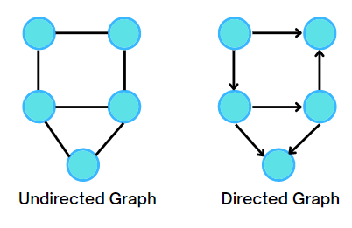

1. **Based on Weights:**
   * **Weighted Graph:** Each edge has a weight (like distance, cost, or time). Example: Google Maps (distance between cities).
   * **Unweighted Graph:** No weights on edges, only connections matter.
2. **Based on Cycles:**
   * **Cyclic Graph:** At least one cycle exists (a path that starts and ends at the same vertex).
   * **Acyclic Graph:** No cycles exist. Example: Tree structure.
3. **Special Types:**
   * **Complete Graph:** Every node is connected to every other node.
   * **Connected Graph:** All vertices are reachable from each other.
   * **Disconnected Graph:** Some vertices are isolated (not reachable).

|  |  |  |
| --- | --- | --- |
| Feature | Tree | Graph |
| Definition | A tree is a special type of graph with no cycles and exactly one path between any two nodes. | A graph is a general data structure that can have cycles and multiple paths. |
| Hierarchy | Always hierarchical (parent → child). | Not necessarily hierarchical. |
| Edges | For n nodes, a tree always has n-1 edges. | A graph can have any number of edges. |
| Connectivity | Always connected. | Can be connected or disconnected. |
| Cycles | Never contains cycles. | May contain cycles. |
| Example | Family tree, file system, company hierarchy. | Social networks, Google Maps, internet connections. |

**🔹 Applications of Graphs**

Graphs are widely used in the real world:

1. **Social Networks** – Represent users as nodes and friendships/followers as edges (Facebook, Twitter, Instagram).
2. **Google Maps & GPS Navigation** – Cities are vertices, roads are edges, and distances are weights. Used to find shortest path.
3. **Computer Networks** – Computers/routers as nodes, connections as edges.
4. **Web Page Ranking** – Google’s PageRank uses graph theory to rank websites.
5. **Recommendation Systems** – Amazon, Netflix use graphs to recommend products/movies (based on similarity).
6. **Project Scheduling (PERT/CPM)** – Graphs are used to plan tasks in project management.
7. **Biology & Chemistry** – Protein interaction networks, molecular structures.

**📘 Properties of Graphs**

A **graph** has some important properties that help us understand its structure and behaviour.

**🔹 1. Degree of a Vertex**

The **degree** of a vertex is the number of edges connected to it.

* **Indegree (for directed graphs):** Number of incoming edges to a vertex.
* **Outdegree (for directed graphs):** Number of outgoing edges from a vertex.
* **Total Degree (for undirected graphs):** Number of edges incident (touching) a vertex.

👉 Example:

* In an **undirected graph**, if vertex A is connected to B, C, D → Degree of A = 3.
* In a **directed graph**, if A has 2 incoming and 1 outgoing → Indegree = 2, Outdegree = 1.

📌 **Property (Handshaking Lemma):**  
In an undirected graph, the **sum of degrees of all vertices = 2 × (number of edges).**

**🔹 2. Path**

A **path** is a sequence of vertices connected by edges.  
Example: In graph A—B—C—D, the path from A to D is [A, B, C, D].

**🔹 3. Cycle**

A **cycle** is a path that starts and ends at the same vertex without repeating edges.  
Example: A → B → C → A.

* If a graph has **no cycles**, it is called an **acyclic graph**.
* Example: Trees are acyclic graphs.

**🔹 4. Connected Graph**

A graph is **connected** if there is a path between every pair of vertices.

* **Connected Graph:** You can travel from any node to any other.
* **Disconnected Graph:** At least one vertex cannot be reached.

👉 Example:

* Social network where everyone is connected → connected graph.
* Two separate friend circles with no link → disconnected graph.

**🔹 5. Complete Graph (Fully Connected Graph)**

A graph is **complete** if **every vertex is directly connected to every other vertex**.

* Notation: Kₙ (Complete graph with n vertices).
* Number of edges in a complete graph = **n(n-1)/2** (for undirected).

👉 Example:

* In K₃ (triangle), each of the 3 vertices is connected to the other 2.
* In K₄ (square with diagonals), each vertex connects to 3 others.

**🔹 6. Subgraph**

A **subgraph** is a smaller part of a graph formed by selecting some of its vertices and edges.

👉 Example: If original graph has {A, B, C, D}, a subgraph may include {A, B, C} with edges among them.

**🔹 7. Dense and Sparse Graphs**

* **Dense Graph:** A graph with a large number of edges, close to complete.
* **Sparse Graph:** A graph with relatively few edges compared to possible maximum.

**🔹 8. Bipartite Graph**

A **bipartite graph** is one in which vertices can be divided into **two sets** such that every edge connects a vertex from one set to a vertex in the other set (no edge connects vertices within the same set).

👉 Example:

* Jobs and workers (edges show which worker can do which job).
* Dating apps (set of men, set of women, edges represent matches).

**🔹 9. Weighted Graph**

A graph where each edge has a **weight (value)** like distance, cost, or time.

👉 Example: Google Maps uses a weighted graph (distance between two cities).

**Graph Represent**

Graph is represented in following two ways

* Adjacency Matrix
* Adjacency Lists

1. **Adjacency Matrix :** An adjacency matrix of a graph is a two-dimensional array of size n x n, where n is the number of nodes in the graph, with the property that a[ i ][ j ] = 1 if the edge (vᵢ, vⱼ) is in the set of edges, and a[ i ][ j ] = 0 if there is no such edge.

In java when we create an array by default is initialized with 0 so no need for not connected edges.

Consider the example of the following undirected graph,

**Input:**

5 6 // 5 : no of nodes 6 : no of edges

1 2 // edge from 1 - > 2 and check if graph is directed or unDirected

1 3

2 4

3 4

3 5

4 5

**Explanation**:

Number of nodes, n = 5

Number of edges, m = 6

Next m lines represent the edges.

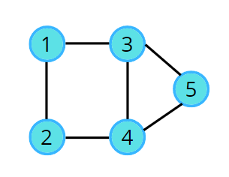



If you can’t see above video then [click](https://lh6.googleusercontent.com/RJXRgXqBBveetZajhikyA8q29MhMzKKDUXH0WuQb9-k7owhUIi6rZxqvyU-gNicg7HqRYHOE44_C5ojbCpQlbi0QDIn2ZuwWUA6LD5wYSWz6ehdDthINzqofzZ5NZJyEbShmYhJmn7j7IZFlhvyh_uY)

**Code:**

class Graph

{

    int graph[][];

    int vertices,edges;

    Graph(int vertices, int edges)

    {

*this*.vertices = vertices;

*this*.edges = edges;

        graph = new int[vertices + 1][ vertices + 1];

    }

    void addEdge(int source,int destination)

    {

        graph[source][destination] = 1;

        graph[destination][source] = 1;

    }

    void printGraph()

    {

        for(int s=1;s <= vertices;s++) {

            for(int d = 1;d <= vertices;d++)            {

                System.out.print(graph[s][d] + " ");

            }

            System.out.println();

        }

    }

}

public class MatrixRepresentGraph {

    public static void main(String[] args) {

        Scanner sc = new Scanner(System.in);

        System.out.println("Enter No of vertices : ");

        int vertices = sc.nextInt();

        System.out.println("Enter No of edges : ");

        int edges = sc.nextInt();

        Graph graph = new Graph(vertices, edges);

        System.out.println("Now enter in this format (source,destination) for craeteing edge between these two vertex");

        for(int e=1;e<=edges;e++)

        {

            // System.out.println("Source veretx is " + v);

            int src = sc.nextInt();

            int dest = sc.nextInt();

            graph.addEdge(src, dest);

        }

        graph.printGraph();

        sc.close();

    }

}

1. ✅ Adjacency Lists
2. In the previous storing method, we saw it was taking n² space to store the graph, this is where the adjacency list comes into the picture, it takes a very less amount of space.
3. This is a node-based representation. In this representation, we associate with each node a list of nodes adjacent to it. Normally an array is used to store the nodes. The array provides random access to the adjacency list for any particular node.
4. Consider the example of the following undirected graph,



Link [click](https://lh6.googleusercontent.com/4tesls8e58HF6qAqwEf9S-ZmsgmB9l0VcJR9VL0JG9rBzYwuWgW342wWkb7vQm3E6KP5-bGsTgVvAv_Y0hTSu3AA9f4Og76RjXW8W2dM6esXc4aCy6ekmXFe_u5RnwQQMihbqp9J3iJ0MscUlrZFJKg)

**Code:**

class Graph

{

    ArrayList<ArrayList<Integer>> graph;

    int vertices,edges;

    Graph(int vertices, int edges)

    {

*this*.vertices = vertices;

*this*.edges = edges;

        graph = new ArrayList<>();

        for(int v = 0; v <= vertices;v++) // from 0 to verties

            graph.add(v, new ArrayList<>());

    }

    void addEdge(int source,int destination)    {

        graph.get(source).add(destination);

        graph.get(destination).add(source);

    }

    void printGraph()    {

        for(int s=1;s <= vertices;s++)

        {

            System.out.print(s + " -> ");

            for(int d=0; d < graph.get(s).size();d++)

                System.out.print(graph.get(s).get(d) + " ");

            System.out.println();

        }

    }

}

public class ListRepresentGraph {

        public static void main(String[] args) {

        Scanner sc = new Scanner(System.in);

        System.out.println("Enter No of vertices : ");

        int vertices = sc.nextInt();

        System.out.println("Enter No of edges : ");

        int edges = sc.nextInt();

        Graph graph = new Graph(vertices, edges);

        System.out.println("Now enter in this format (source,destination) for craeteing edge between these two vertex");

        for(int e=1;e<=edges;e++)

        {

            // System.out.println("Source veretx is " + v);

            int src = sc.nextInt();

            int dest = sc.nextInt();

            graph.addEdge(src, dest);

        }

        graph.printGraph();

        sc.close();

    }

}

**Weighted Graph Representation :** As of now, we were considering graphs with unit weight edges (i.e., if there is an edge between two nodes then the weight on the edge is unit weight ), now what if there are weights on its edges as shown in the following example?

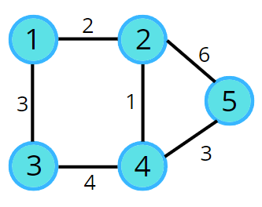 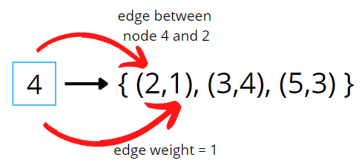

For weight graph we create an Pair

Class Pair {

int dest,const;

Pair(int dest,int cost) {

this.dest = dest;

this.cost = cost;

}

**Why We need an visited Array**

Given an undirected graph with 10 nodes and 8 edges. The edges are (1,2), (1,3), (2,4), (4,3), (5,6), (5,7), (6,7), (8,9) .The graph that can be formed with the given information is as follows:

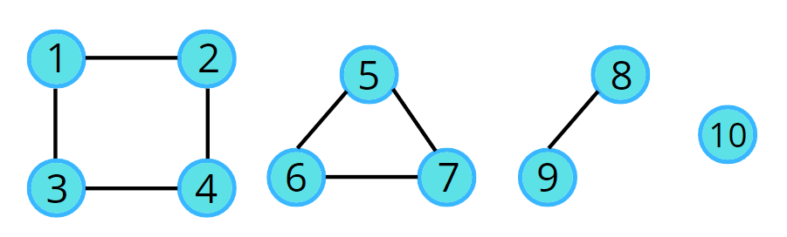

Apparently, it's a graph, which is in 4 pieces, the last one being a single node. In this case, we can say, the graph has been broken down into 4 different connected components. So next time if you see two different parts of a graph and they are not connected, then do not say that it cannot be a single graph. In the above example, they can be 4 different graphs but according to the given question and the input, we can call them parts of a single graph

In the upcoming topics, we’ll be learning about a lot of algorithms. Now, assume a traversal algorithm. Any traversal algorithm will always use a **visited array**.

**And in graph there may be un connected component so without keeping visited array we cannot traverse other component that’s why graph traversal always keep an visited array**

**And graph may contains an cycle**

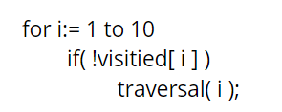



if video is not play then [click](https://lh3.googleusercontent.com/sDVRYlJkE03iLf86hfv-90LJumUlNJqv9Osa0KiPjsVyU-QeFt2GFOyswPQYn03JqnQOezQDHt2JsuR6i_rGsVspGaui3U-I1NUQPxSO2EYTVChPiQHMzHpYyqd-EUyMiMBLyMvjS16eS9iIxoCJRDY)

**Traversal**

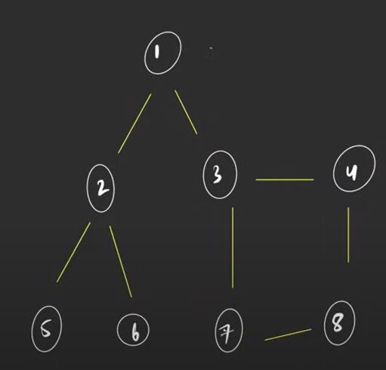

**1)** **BFS**

* Queue data structure: follows FIFO, and will always contain the starting.
* Visited array: an array initialized to 0
* In BFS, we start with a “starting” node, mark it as visited, and push it into the queue data structure.
* In every iteration, we pop out the node ‘v’ and put it in the solution vector, as we are traversing this node.
* All the unvisited adjacent nodes from ‘v’ are visited next and are pushed into the queue. The list of adjacent neighbors of the node can be accessed from the adjacency list.
* Repeat steps 2 and 3 until the queue becomes empty, and this way you can easily traverse all the nodes in the graph. [click](https://lh5.googleusercontent.com/JKY4V8OZEs5L68Mh2ZY5ZqiqGkaj8esWnTEUwEdygFQdRFowh7aCWpibaPRqkcR3SHBh2Q4Io856f2fAzM5Ae3nD2uLj7AEU3NnQfZ55E2ni0EzXceoVTJtHzqGlUhQ9-izy5Y0v1DK0xIQ4vUxs9Ds)



**Code for connected graph only:**

    public List<Integer> bfsOfGraph(int V, List<List<Integer>> adj) {

        boolean[] visited = new boolean[V];

        Queue<Integer> queue = new LinkedList<>();

        queue.offer(0);

        visited[0] = true;

        List<Integer> traversal = new ArrayList<>();

        while (!queue.isEmpty()) {

            int src = queue.poll();

            //add the src to traversal

            traversal.add(src);

            //go to its all neighbour

            for(int i=0;i<adj.get(src).size();i++)

            {

                int vertex = adj.get(src).get(i);

                if(!visited[vertex])                {

                    // make it visted and add to the queue

                    visited[vertex] = true;

                    queue.offer(vertex);

                }

            }

        }

        return traversal;

    }

2) **DFS (for connected graph only)**: DFS is a traversal technique which involves the idea of recursion and backtracking. DFS goes in-depth, i.e., traverses all nodes by going ahead, and when there are no further nodes to traverse in the current path, then it backtracks on the same path and traverses other unvisited nodes.

* In DFS, we start with a node ‘v’, mark it as visited and store it in the solution vector. It is unexplored as its adjacent nodes are not visited.
* We run through all the adjacent nodes, and call the recursive dfs function to explore the node ‘v’ which has not been visited previously. This leads to the exploration of another node ‘u’ which is its adjacent node and is not visited.
* The adjacency list stores the list of neighbours for any node. Pick the neighbour list of node ‘v’ and run a for loop on the list of neighbours (say nodes ‘u’ and ‘w’ are in the list). We go in-depth with each node. When node ‘u’ is explored completely then it backtracks and explores node ‘w’.
* This traversal terminates when all the nodes are completely explored.



If not visible [click](https://lh6.googleusercontent.com/vik8WfOcj6-PKulF6ANSFAxW0j16cw78Xzf3k5HYQHbFsfx-u1VOZfH56T3iblO8KP98z1OEa0iQc_4l8d0WbkIVXnTRVJs53MTBH1X5rPxoeVqkTYHOBPcARVT31gGIsBcsM0RndYOiNCSgjt-2Ppk)

**Code:**

public void dfs(int src,List<List<Integer>> adj,boolean visited[],List<Integer> traversal) {

        // append to the traversal list

        visited[src] = true;

        traversal.add(src);

        for(int i=0;i<adj.get(src).size();i++)

        {

            int vertex = adj.get(src).get(i);

            if(!visited[vertex])

            {

                // call its neighbout

                dfs(vertex,adj,visited,traversal);

            }

        }

    }

    public List<Integer> dfsOfGraph(int V, List<List<Integer>> adj) {

        boolean[] visited = new boolean[V];

        List<Integer> traversal = new ArrayList<>();

        //start with any node

        // go to depth

        dfs(0, adj, visited, traversal);

        return traversal;

    }

**Number of Provinces**

**Problem Statement:** There are n cities. Some of them are connected, while some are not. If city a is connected directly with city b, and city b is connected directly with city c, then city a is connected indirectly with city c.

A province is a group of directly or indirectly connected cities and no other cities outside of the group.

You are given an n x n matrix isConnected where isConnected[i][j] = 1 if the ith city and the jth city are directly connected, and isConnected[i][j] = 0 otherwise.

Return *the total number of provinces*.

**Example 1:**

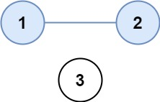

**Input:** isConnected = [[1,1,0],[1,1,0],[0,0,1]]

**Output:** 2

**Example 2:**

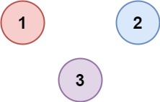

**Input:** isConnected = [[1,0,0],[0,1,0],[0,0,1]]

**Output:** 3

**Solution:**

**👉 A group of cities (nodes) that are directly or indirectly connected to each other but not connected to any other group.**

**In other words:**

* **Each province = one connected component of the graph.**

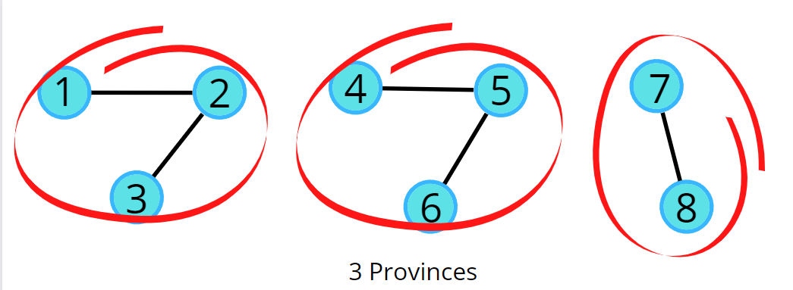

📌 Example:  
If you have 5 cities and roads like this:

* City 1 connected to 2 and 3
* City 4 connected to 5 and 6
* City 7 connected to 8

Then we have:

* Province 1 → {1,2,3}
* Province 2 → {4,5,6}
* Province 3 → {7,8}

**provinces = number of connected components**.

**The algorithm steps are as follows:**

* We need a visited array initialized to 0, representing the nodes that are not visited.
* Run the for loop looping from 0 to N, and call the DFS for the first unvisited node.
* DFS function call will make sure that it starts the DFS call from that unvisited node, and visits all the nodes that are in that province, and at the same time, it will also mark them as visited.
* Since the nodes traveled in a traversal will be marked as visited, they will no further be called for any further DFS traversal.
* Keep repeating these steps, for every node that you find unvisited, and visit the entire province.
* Add a counter variable to count the number of times the DFS function is called, as in this way we can count the total number of starting nodes, which will give us the number of provinces.



[Click](https://lh6.googleusercontent.com/U-cUtfolQyssIPc7MUp-_6myMN5ZeCvSJ0Tvo0iLKeYm1qQvbTb5j3-rIQcn_Klk8KrglrOfPYuctDU9JMeeCN_fTJ1hYPk9L6YAeqb2hkowwQcY9ILgrt4V3WmIfBei7WhUt2H1Ouc9fCZZd87ptkU) if video is not playing

**Code (BFS):**

    private void bfs(int startVertex,boolean[] visited,int[][] adj,Queue<Integer> queue)    {

        visited[startVertex] = true;

        queue.offer(startVertex);

        while (!queue.isEmpty()) {

            int src = queue.poll();

            for(int i=0;i<adj.length;i++)

            {

                if(src != i && adj[src][i] == 1 && !visited[i] )

                {

                    //maer as visited

                    visited[i] = true;

                    queue.offer(i);

                }

            }

        }

    }

    public int findCircleNum(int[][] isConnected) {

        int n = isConnected.length;

        int cnt = 0;

        boolean[] visited = new boolean[n];

        Queue<Integer> queue = new LinkedList<>();

        for(int i=0;i<n;i++)

        {

            if(!visited[i])

            {

                cnt++;

                bfs(i, visited, isConnected,queue);

            }

        }

        return cnt;

    }

**No of Island**

**Problem Statement:** Given an m x n 2D binary grid grid which represents a map of '1's (land) and '0's (water), return *the number of islands*.

An island is surrounded by water and is formed by connecting adjacent lands horizontally or vertically. You may assume all four edges of the grid are all surrounded by water.

**Note : here talk about only 4 directions(horizontal & vertical ) in other question also includes diagonals as well so become 8 directions**

**Example -1:**

**Input Explanation**

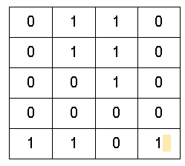 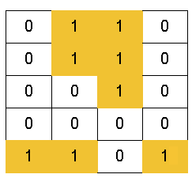

**o/p :** 3(There are 3 islands as the different components are surrounded by water (i.e. 0), and there is no land connectivity in either of the 8 directions hence separating them into 3 islands.)

**Example - 2:**

**Input:**

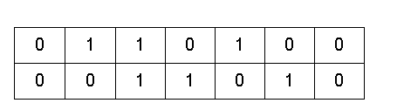 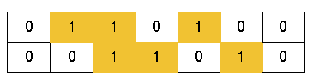



**Output: 1**

**Explanation:** All lands are connected. So, only 1 island is present.

**Solution:**

**Intuition:**

An island is surrounded by water and is formed by connecting adjacent lands horizontally or vertically or diagonally i.e., in all 8 directions and also 4 direction.

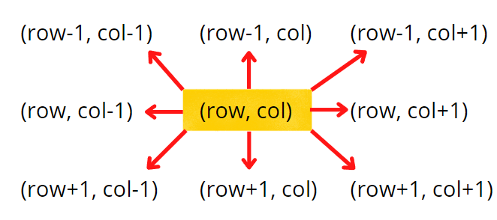

**4 directions**



**8 directions**

**🔑 Key Idea**

Think of the grid as a **map of land and water**:

* 1 = 🟩 land
* 0 = 🌊 water

An **island** is formed when multiple 1s are **connected together** (up, down, left, right).

👉 So the problem reduces to:  
**Count how many connected groups of 1s exist in the grid.**

Every time we find a new unvisited land cell ('1'), it means:

* We discovered a **new island** 🏝️.
* Now we must explore the **whole island** using BFS/DFS, marking every land cell of that island as visited.
* Once that island is completely marked, we continue searching for the next unvisited land.

Thus:

**Number of times we start BFS/DFS = Number of Islands**

**🟩 Why do we need a 2D visited array?**

When solving **Number of Islands**, we want to explore each piece of land ('1') only **once**.  
But grids allow movement in multiple directions → so without proper tracking, we may:

* Revisit the same land cell multiple times.
* Fall into **infinite loops** (keep jumping between already explored neighbors).
* Overcount the number of islands.

**🔎 How visited[][] helps**

* visited[i][j] = true means: **this cell has already been processed as part of some island**.
* Once marked, we never explore it again.
* This ensures:
  1. Every land cell belongs to **exactly one island**.
  2. BFS/DFS terminates correctly without looping.

**🔹 Approach**

1. **Create visited[][]**
   * A 2D array visited[i][j] same size as grid.
   * It will store whether we have already explored this cell.
2. **Traverse the entire grid** (row by row, column by column).
   * For each cell (i,j):
     + If grid[i][j] == '1' **and not visited**, then we found a **new island**.
     + Increase island count (cnt++).
3. **Explore the entire island (BFS/DFS)**
   * From this cell (i,j), run BFS or DFS.
   * Mark all reachable land cells (connected in 4 directions) as visited.
   * This ensures we don’t count the same island again.
4. **Continue scanning the grid** until all cells are processed.
5. **Return the count**.

**🔄 How to Process Neighbors in the Grid**

**1. What are neighbors?**

Neighbors are the cells **directly connected** to (i, j):

 

**2. Conditions for a Valid Neighbor**

Before processing a neighbor (nrow, ncol), we check:

1. **Boundary check** →  
   0 <= nrow < grid.length and 0 <= ncol < grid[0].length  
   (So we don’t go outside the grid).
2. **Land check** →  
   grid[nrow][ncol] == '1'  
   (Only land can be part of the island).
3. **Visited check** →  
   !visited[nrow][ncol]  
   (So we don’t reprocess the same cell).

**🔹 4-Direction Neighbors (Including Diagonals)**

int[] drow = {-1, 0, 1, 0}; // change in row → Up, Right, Down, Left

int[] dcol = {0, 1, 0, -1}; // change in col → Up, Right, Down, Left

So:

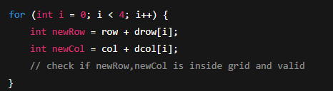

* (-1, 0) → Up
* (0, 1) → Right
* (1, 0) → Down
* (0, -1) → Left

**🔹 8-Direction Neighbors (Including Diagonals)**

Now, either we can apply 8 conditions or follow the following method. From the above image, it is clear that the row can be row-1, row, or row+1,i.e., the delta row varies from -1 to 1. Similarly, the delta column varies from -1 to 1. So we can apply the same logic to find the neighbours of a particular pair (<row, column>).

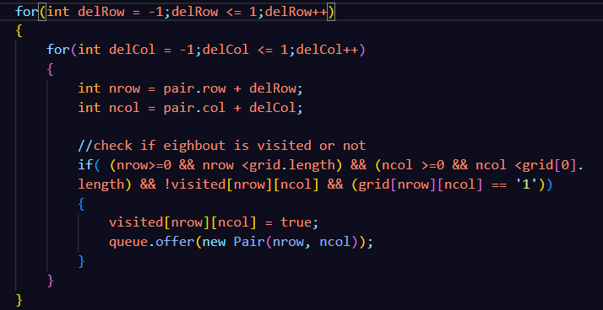

**Code:**

class Pair{

    int row,col;

    Pair(int row,int col)

    {

*this*.row = row;

*this*.col = col;

    }

}

private void bfs(int row,int col,char[][] grid,boolean[][] visited)

    {

        Queue<Pair> queue = new LinkedList<>();

        visited[row][col] = true;

        queue.offer(new Pair(row, col));

        while (!queue.isEmpty()) {

            //visit all level

            Pair pair = queue.poll();

            /*

            * this is for 8 direction

            for(int delRow = -1;delRow <= 1;delRow++)

            {

                for(int delCol = -1;delCol <= 1;delCol++)

                {

                    int nrow = pair.row + delRow;

                    int ncol = pair.col + delCol;

                    //check if eighbout is visited or not

                    if( (nrow>=0 && nrow <grid.length) && (ncol >=0 && ncol <grid[0].length) && !visited[nrow][ncol] && (grid[nrow][ncol] == '1'))

                    {

                        visited[nrow][ncol] = true;

                        queue.offer(new Pair(nrow, ncol));

                    }

                }

            }*/

            // for 4 direction

            int[] drwo = {-1,0,1,0};

            int[] dcol = {0,1,0,-1};

            for(int k = 0;k<4;k++)

            {

                int nrow = pair.row + drwo[k];

                int ncol = pair.col + dcol[k];

                if( (nrow>=0 && nrow <grid.length) && (ncol >=0 && ncol <grid[0].length) && !visited[nrow][ncol] && (grid[nrow][ncol] == '1'))

                   {

                       visited[nrow][ncol] = true;

                       queue.offer(new Pair(nrow, ncol));

                   }

            }

        }

    }

    public int numIslands(char[][] grid) {

        int cnt = 0;

        boolean[][] visited = new boolean[grid.length][grid[0].length];

        for(int i=0;i<grid.length;i++)

        {

            for(int j=0;j<grid[0].length;j++)

            {

                if(!visited[i][j] && grid[i][j] == '1')

                {

                    ++cnt;

                    // call the bfs or dfs

                    bfs(i, j, grid, visited);

                }

            }

        }

        return cnt;

    }

**Flood Fill**

**Problem Statement:** You are given an image represented by an m x n grid of integers image, where image[i][j] represents the pixel value of the image. You are also given three integers sr, sc, and color. Your task is to perform a flood fill on the image starting from the pixel image[sr][sc].

To perform a flood fill:

1. Begin with the starting pixel and change its color to color.
2. Perform the same process for each pixel that is directly adjacent (pixels that share a side with the original pixel, either horizontally or vertically) and shares the same color as the starting pixel.
3. Keep repeating this process by checking neighboring pixels of the *updated* pixels and modifying their color if it matches the original color of the starting pixel.
4. The process stops when there are no more adjacent pixels of the original color to update.

Return the modified image after performing the flood fill.

**Example 1:**

**Input:** image = [[1,1,1],[1,1,0],[1,0,1]], sr = 1, sc = 1, color = 2

**Output:** [[2,2,2],[2,2,0],[2,0,1]]

**Explanation:**

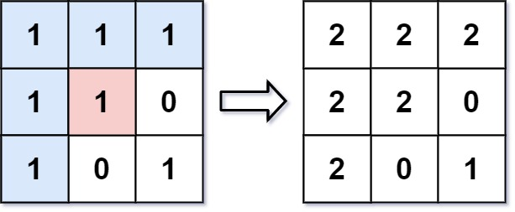

From the center of the image with position (sr, sc) = (1, 1) (i.e., the red pixel), all pixels connected by a path of the same color as the starting pixel (i.e., the blue pixels) are colored with the new color.

Note the bottom corner is **not** colored 2, because it is not horizontally or vertically connected to the starting pixel.

**Example 2:**

**Input:** image = [[0,0,0],[0,0,0]], sr = 0, sc = 0, color = 0

**Output:** [[0,0,0],[0,0,0]]

**Explanation:** The starting pixel is already colored with 0, which is the same as the target color. Therefore, no changes are made to the image.

**Solution:**

**🎯 Key idea**

Treat the image as a **grid graph**:

* **Node** = a pixel (r, c).
* **Edges** = 4 neighbors: **⬆️ up, ➡️ right, ⬇️ down, ⬅️ left** (no diagonals).

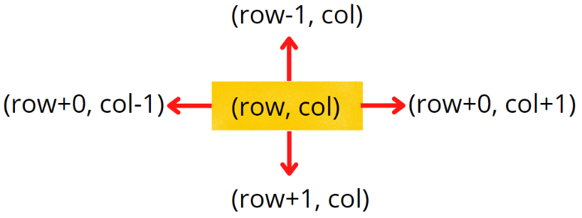

* Start from (sr, sc), **recolor every connected pixel** that has the **same initial color** as (sr, sc).



[Click](https://lh4.googleusercontent.com/pwSg5Puu0EoS1k0hqsvv3pdVToispoUy5Ugw26M9isACoJIjtEO9drqfj6jRbcMZZYhdq6jtGV0auZK5NPaHtAT7qZMPk8ch1BdJHEgm9lUS7d6mJIm0faSSUq5QfCBSwEFjTQrz6G22cp7yKzJCRVQ) to see the video

We stop when:

* Out of bounds,
* Already processed,
* Or the pixel’s color ≠ initial color.

**🧠 Intuition (water fill mental model)**

* Imagine pouring paint at (sr, sc).
* **DFS** = a narrow stream that **dives deep** along one path, backs up, then explores the next path.
* **BFS** = a **ripple** that spreads level by level (all neighbors at distance 1, then 2, etc.).

For flood fill, **order doesn’t matter**, only that you eventually reach every connected pixel with the initial color.

**🧭 DFS approach**

**1) Base checks** ✅  
Stop if:

* r, c is outside the grid,
* the pixel is already visited[r][c] == true,
* or image[r][c] != initColor.

**2) Visit + color** 🖌️  
Mark visited[r][c] = true, then set image[r][c] = color.

**3) Go deeper in 4 directions** 🧗  
Call DFS on:

* ⬆️ dfs(r-1, c)
* ➡️ dfs(r, c+1)
* ⬇️ dfs(r+1, c)
* ⬅️ dfs(r, c-1)

**4) Correctness invariant** 🧩  
Every time you recur, you only move to pixels that are:

* valid cells,
* not yet visited,
* and still equal to the original initColor.  
  So you’ll eventually color exactly the connected region and nothing else.

**5) Complexity** ⏱️

* **Time**: O(R*C) (each pixel processed at most once)
* **Space**: O(R*C) worst case (due to recursion stack + visited)

**🔍 Why a 2D visited array?**

* It guarantees **no pixel is processed twice** (prevents cycles like A→B→A).
* It’s **especially important** if color == initColor.  
  Without visited, if you recolor to the same color, neighbors can bounce back to you indefinitely. Your code avoids this with visited.

👉 Alternative: If you add a **fast guard** at the start:

if (image[sr][sc] == color) return image;

…then you can safely **drop visited** and use recoloring itself as the “visited” mark (because once recolored, the pixel is no longer initColor). Your current version is robust either way.

**✅ Why DFS (and not BFS) here?**

**👍 DFS advantages for flood fill**

* **Simplicity**: Very concise recursive code that mirrors the definition of connected regions.
* **Cache locality**: DFS tends to stay near the current pixel, often giving good locality on images.
* **Memory profile**: DFS uses call stack proportional to the **path length**, while BFS can hold a **wide frontier** (many pixels) at once. For “blobby” regions, BFS queues can get big.

**⚠️ DFS caveat**

* **Stack depth**: On huge images or very large regions, recursion can hit Java’s stack limit. Use **iterative DFS (with a Stack<Pair>)** or BFS to avoid stack overflow.

**👍 When BFS can be preferable**

* If you need **layered processing** (e.g., first ring around the seed, then the next ring, etc.).
* If you want to **avoid recursion** entirely.
* If your regions are extremely wide and shallow (BFS’s frontier cost might still be fine, and you avoid recursion limits).

**Code:**

**class Pair{**

    int row,col;

    Pair(int row,int col)

    {

*this*.row = row;

*this*.col = col;

    }

**}**

**private void bfs(int[][] image,int color,boolean[][] visited,int r,int c,int initColor)**

**{**

        //create an Queue

        Queue<Pair> queue = new LinkedList<>();

        visited[r][c] = true;

        queue.offer(new Pair(r, c));

        image[r][c] = color;

        while (!queue.isEmpty()) {

            //poll the front element

            Pair pair = queue.poll();

            //visite all same level neighbour

            int drow[] = {-1,0,1,0};

            int dcol[] = {0,1,0,-1};

            for(int k=0;k<4;k++)

            {

                int nrow = pair.row + drow[k];

                int ncol = pair.col + dcol[k];

                if(nrow >=0 && nrow< image.length && ncol>=0 && ncol<image[0].length && !visited[nrow][ncol] && image[nrow][ncol] == initColor)

                {

                    visited[nrow][ncol] = true;

                    queue.offer(new Pair(nrow, ncol));

                    image[nrow][ncol] = color;

                }

            }

        }

**}**

**private void dfs(int[][] image,int color,boolean[][] visited,int r,int c,int initColor)**

**{**

        //base condition

        if(r<0 || r>=image.length || c<0 || c>=image[0].length || visited[r][c] || image[r][c] != initColor)

        {

            return;

        }

        //make this as visited

        visited[r][c] = true;

        image[r][c] = color;

        dfs(image,color,visited,r-1,c,initColor);// top

        dfs(image,color,visited,r,c+1,initColor);// right

        dfs(image,color,visited,r+1,c,initColor);// bottom

        dfs(image,color,visited,r,c-1,initColor);//left

**}**

**public int[][] floodFill(int[][] image, int sr, int sc, int color) {**

        boolean[][] visited = new boolean[image.length][image[0].length];

        // bfs(image, color, visited, sr, sc, image[sr][sc]);

        dfs(image, color, visited, sr, sc, image[sr][sc]);// this is most optimal because we does not need an Pair

        return image;

**}**

**Rotton Oranges**

**Problem Statement:** You are given an m x n grid where each cell can have one of three values:

* 0 representing an empty cell,
* 1 representing a fresh orange, or
* 2 representing a rotten orange.

**Every minute, any fresh orange that is 4-directionally adjacent to a rotten orange becomes rotten.**

**Return *the minimum number of minutes that must elapse until no cell has a fresh orange*. If *this is impossible, return* -1.**

**Example 1:**

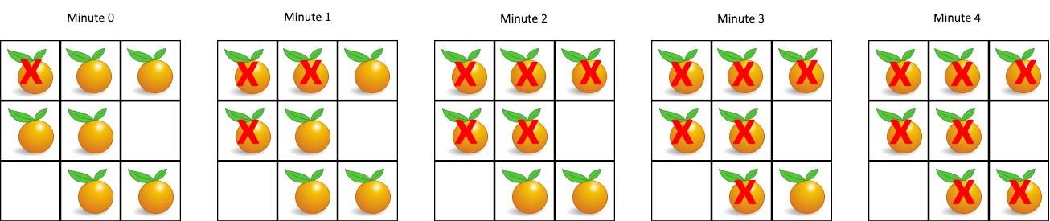

**Input:** grid = [[2,1,1],[1,1,0],[0,1,1]]

**Output:** 4

**Example 2:**

**Input:** grid = [[2,1,1],[0,1,1],[1,0,1]]

**Output:** -1

**Explanation:** The orange in the bottom left corner (row 2, column 0) is never rotten, because rotting only happens 4-directionally.

**Solution:**

**🔹 Why do we need time in Pair?**

* Imagine the grid like levels of infection spreading.
* When one **rotten orange** touches a **fresh orange**, that fresh one will become rotten **after 1 minute**.
* Then in the **next minute**, those newly rotten oranges can further rot their neighbors.
* This means: **each orange doesn’t rot immediately, but level by level, minute by minute.**

👉 That’s why we attach a time property in the Pair.  
It helps us **track at which minute a particular orange became rotten**, so at the end we know the **total time taken**.

**🧭 Approach (with BFS)**

We use **Breadth-First Search (BFS)** because:

* BFS naturally processes in **levels (minutes)**.
* All oranges rotten at minute t infect their neighbors, which rot at minute t+1.

**Steps:**

1. **Initialization:**
   * Count total number of fresh oranges (cntFresh).
   * Put all initially rotten oranges (row, col, time=0) into a queue.

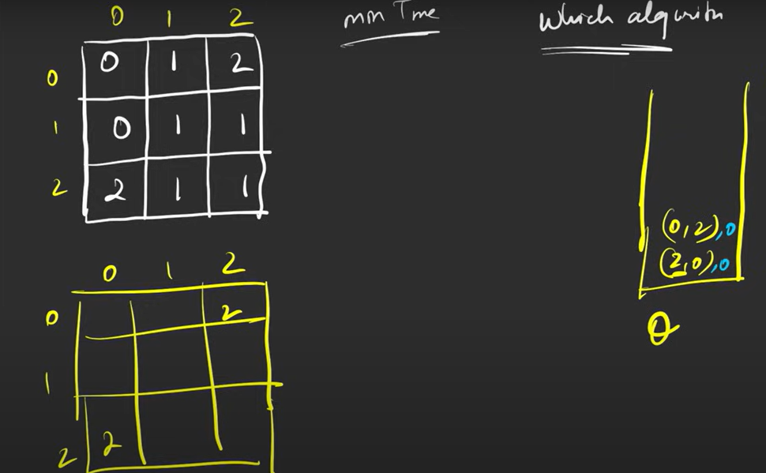

**Visited[][]**

**Here there are two init Rotton oranges**



* + Mark them visited so we don’t process them again.

1. **BFS Traversal:**
   * While the queue is not empty:
     + Take out the current rotten orange (Pair).
     + Check its 4 neighbors (up, right, down, left).
     + If neighbor is a **fresh orange (1)**:
       - Mark it rotten (visited=2).
       - Push it into the queue with time+1.
       - Increase count of fresh-to-rotten oranges (noOfFreshRotton).
   * Keep updating the time variable with the latest pair.time.

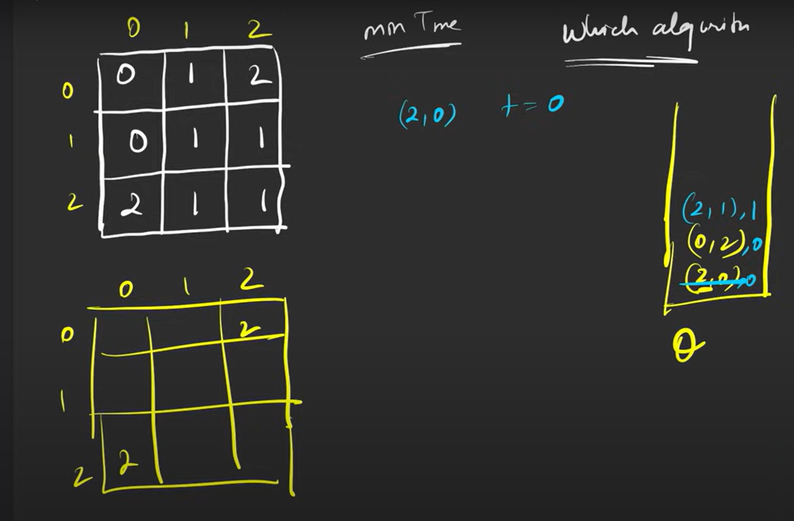



**When we found any fresh adjacent Orange we do follow**

1. **Make as visited**
2. **Put that fresh orange into queue with update time**

**Update time pair.time + 1**



1. **Final Answer:**
   * If **all fresh oranges got rotten** (cntFresh == noOfFreshRotton) → return time.
   * Otherwise → return -1.

**Code:**

class Pair{

    int row,col,time;

    Pair(int row,int col,int time)

    {

*this*.row = row;

*this*.time = time;

*this*.col = col;

    }

}

public int orangesRotting(int[][] grid) {

        int[][] visited = new int[grid.length][grid[0].length];

        int cntFresh = 0, noOfFreshRotton = 0;

        int time = 0;

        Queue<Pair> queue = new LinkedList<>();

        for(int i=0;i<grid.length;i++)        {

            for(int j=0;j<grid[0].length;j++)            {

                if(grid[i][j] == 1)

                    cntFresh++;

                else if(grid[i][j] == 2)

                {

                    visited[i][j] = 2;

                    queue.offer(new Pair(i,j,0));

                }

            }

        }

        int[] drow = {-1,0,1,0};

        int[] dcol = {0,1,0,-1};

        while (!queue.isEmpty()) {

            //poll the front

            Pair pair = queue.poll();

            for(int k=0;k<4;k++)

            {

                int nrow = pair.row + drow[k];

                int ncol = pair.col + dcol[k];

                time = pair.time;

                if(nrow >=0 && nrow<grid.length && ncol>=0 && ncol<grid[0].length && visited[nrow][ncol] != 2  && grid[nrow][ncol] == 1)

                {

                    //make the neighbour visited

                    visited[nrow][ncol] = 2;

                    //add to queue

                    queue.offer(new Pair(nrow, ncol, pair.time + 1));

                    noOfFreshRotton++;

                }

            }

        }

        return cntFresh == noOfFreshRotton ? time : -1;

}

**Detect The Cycle using BFS**

**Problem Statement:** Given an undirected graph with V vertices and E edges, check whether it contains any cycle or not.

**Example 1:**

**Input:** V = 8, E = 7

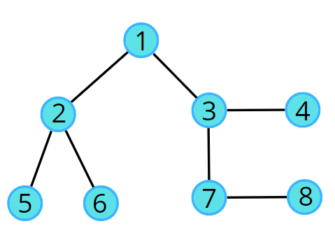

**Output:** false

**Explanation:** No cycle in the given graph.

**Example 2:**

**Input:** V = 8, E = 6

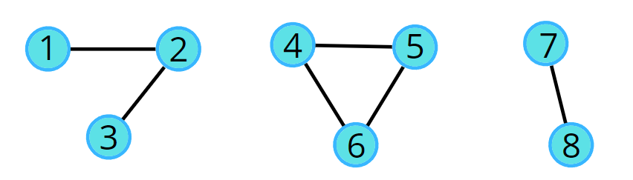

**Output:** True

**Explanation:** 4->5->6->4 is a cycle.

**Solution:**

**🔬 The core logic — how we *know* there’s a cycle**

When you explore an **undirected** graph with BFS and you encounter a neighbor that is already **visited**, two possibilities exist:

1. That visited neighbour is the **parent** (the node you came from). In an undirected graph this is normal — edges go both ways and you’ll see the parent back again. **Ignore this**.
2. That visited neighbour is **not** the parent. That means there is *another path* from the start to that neighbour that does not go through the parent. If you combine the two different paths you have a closed loop — **a cycle**. ✅

Put simply:  
**Visited neighbour + not parent = some other route back = loop = cycle.**

**🧠 Why that proves there’s a cycle (plain words)**

* Suppose you reached node X earlier by some path start → ... → X.
* Now, while visiting node Y, you see an edge Y — X. If X is already marked visited and X is *not* Y’s parent, that means you can go from start → ... → X and also start → ... → Y → X. Those two different routes meet at X and enclose a loop. That’s exactly a cycle.

This is logically the same as: two distinct simple paths between the same two nodes imply a cycle.

**🏘️ Realistic example (neighbourhood walk) — the simplest triangle**

Imagine three houses A, B, C connected by roads forming a triangle:

A

/ \

B---C

You start exploring from house A, leaving a breadcrumb at every house you enter.

**Step-by-step (BFS style):**

1. Start at A. Mark A = visited. Put (A, parent = -1) in the queue. 🧭  
   Queue: [(A,-1)], Visited: {A}
2. Dequeue (A,-1). Look at A’s neighbors: B and C.
   * B is unvisited → mark B, enqueue (B, A).
   * C is unvisited → mark C, enqueue (C, A).  
     Queue: [(B,A), (C,A)], Visited: {A, B, C}
3. Dequeue (B, A). Look at B’s neighbors: A and C.
   * Neighbor A is visited but **A == parent** (parent of B is A), so ignore.
   * Neighbor C is visited and **C != parent** (parent is A), so this is **visited & not parent → cycle found**. 🎉

That moment (B sees C as visited but not parent) is the exact condition we test in code.

**🧠 Intuition (detailed but simple words)**

**1. What exactly is a cycle?**

A **cycle** in an undirected graph means:

* You can start at a node, move along edges, and eventually return to the same node.
* Importantly: you don’t just go back immediately to the parent; you take some *different path* and come back.

Think of it like **two different roads** leading to the same house. 🚪  
If you find such a situation, you can walk around the block → that’s a cycle 🔁.

**2. Why is the parent check needed?**

* In an undirected graph, every edge is two-way.  
  Example: If there is an edge A—B, then:
  + From A, you will see B.
  + From B, you will see A again.
* If we didn’t keep track of the **parent**, we would wrongly think this is a cycle every time.

That’s why we say:

* If a neighbor is visited but it is **just the parent** → ignore.
* If a neighbor is visited but it is **NOT the parent** → this is a **cycle**. ✅

**3. The key idea in one line**

👉 If while exploring the graph, you find a neighbor that’s **already visited and not your parent**, then you’ve discovered another way to reach that node.  
**Two ways to the same node = a loop = cycle.**

**🏗️ Approach (step by step, detailed)**

**Step 1: Represent the graph**

* Use an adjacency list adj, where adj[u] contains all neighbors of node u.
* 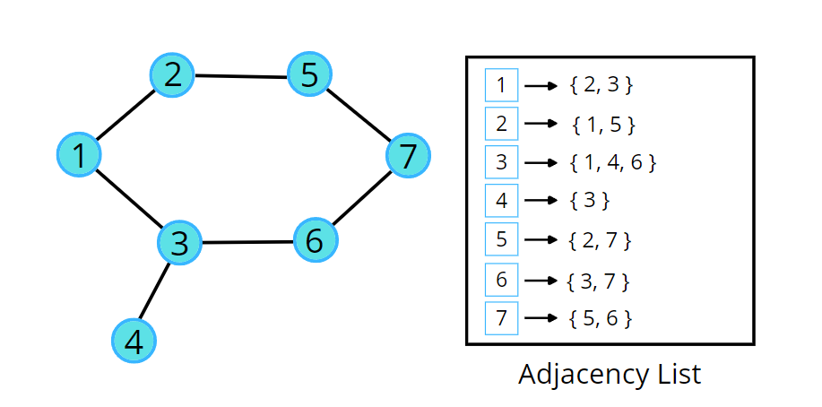This makes it easy to explore all connected nodes.

**Step 2: Track visited nodes**

* Maintain a boolean array visited[] to avoid revisiting nodes again and again.
* This ensures BFS doesn’t fall into infinite loops.

**Step 3: Use BFS with parent tracking**

* Create a queue for BFS.
* Instead of only storing the current node, store a **pair**: (currentNode, parentNode).
* Example: if you reached node 5 from node 3, push (5, 3) into the queue.

This helps us know:

* Which node we are on (currentNode)
* Where we came from (parentNode)

**Step 4: BFS neighbor exploration**

When processing a node:

* Look at all its neighbors.
* For each neighbor:
  1. If the neighbor is **not visited**:
     + Mark it visited.
     + Push (neighbor, currentNode) into the queue.
  2. If the neighbor is **already visited**:
     + If the neighbor is **not equal to parentNode**, then there’s a cycle. ✅



If video is not playing then [click](https://lh6.googleusercontent.com/fURnjlwT2vEA5qOD0tnqbAIGgRg9LhOjrLTz79syMKZp7HEPCeZkFW2AMYZN1Fo4RI0ENYdSQxwHaRlW66rwwSLC23RLtJs6-ROdZ45ApqqEejqO2KUDgOQosuXayGIrKNyk2l7vnffA8-vBjCkh4j8)

**Step 5: Handle disconnected graphs**

* Graphs might have multiple components (not all nodes are connected).
* So, loop over all nodes.
* If a node hasn’t been visited yet, start BFS from there.
* If any BFS finds a cycle → return true.

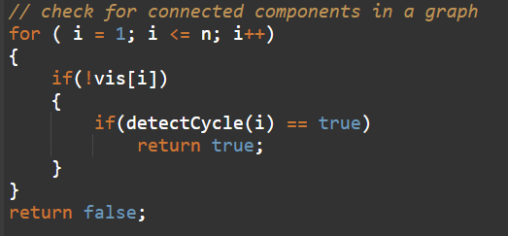

**Code:**

class Pair{

    int vertex,comeFrom;

    Pair(int vertex,int comeFrom)    {

*this*.vertex = vertex;

*this*.comeFrom = comeFrom;

    }

}

**private boolean bfs(List<Integer>[] adj,boolean[] visited,int startVertex) {**

        //create an Queue

        Queue<Pair> queue = new LinkedList<>();

        // push stratVertex

        queue.offer(new Pair(startVertex, -1));

        //make it visited

        visited[startVertex] = true;

       while (!queue.isEmpty()) {

            Pair pair = queue.poll();

            for(int i=0;i<adj[pair.vertex].size();i++)            {

                int vertex = adj[pair.vertex].get(i);

                // if visited and not comeFrom same vertex so it means someone who already visit and that create an cycle

                if(visited[vertex] && pair.comeFrom != vertex)

                    return true;

                if(!visited[vertex])   {

                    visited[vertex] = true;

                    queue.offer(new Pair(vertex, pair.vertex));

                }

            }

        }

        return false;

**}**

**public boolean isCycle(int V, List<Integer>[] adj) {**

        boolean[] visited = new boolean[V];

       for(int i=0;i<V;i++)        {

            if(!visited[i])            {

                if(bfs(adj, visited, i) == true)

                    return true;

            }

        }

        return false;

**}**

**Detect The Cycle Using DFS**

**Problem Statement:** Detect the Cycle in undirected graph.

**Example 1:**

**Input:** V = 8, E = 7



**Output:** false

**Explanation:** No cycle in the given graph.

**Example 2:**

**Input:** V = 8, E = 6



**Output:** True

**Explanation:** 4->5->6->4 is a cycle.

**Code:**

private boolean dfs(List<Integer>[] adj,boolean[] visited,int stratVertex,int comeFrom)

    {

        visited[stratVertex] = true;

        // got to depth

        for(int i=0;i<adj[stratVertex].size();i++)

        {

            int neighbourVertex = adj[stratVertex].get(i);

            if(!visited[neighbourVertex])

            {

                boolean result = dfs(adj, visited, neighbourVertex,stratVertex);

                if(result == true) return true;

            }

            else if(neighbourVertex != comeFrom)

                return true;

        }

        return false;

    }

public boolean isCycle(int V, List<Integer>[] adj) {

        boolean[] visited = new boolean[V];

        for(int i=0;i<V;i++)

        {

            if(!visited[i])

            {

                if(dfs(adj, visited, i) == true)

                    return true;

            }

        }

        return false;

    }

**0 1 Matrix**

**Problem Statement:** Given an m x n binary matrix mat, return *the distance of the nearest*0*for each cell*.

The distance between two cells sharing a common edge is 1.

**Example 1:**

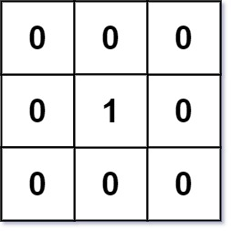

**Input:** mat = [[0,0,0],[0,1,0],[0,0,0]]

**Output:** [[0,0,0],[0,1,0],[0,0,0]]

**Example 2:**

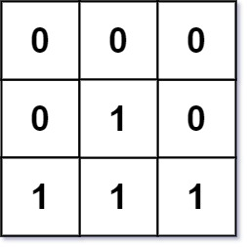

**Input:** mat = [[0,0,0],[0,1,0],[1,1,1]]

**Output:** [[0,0,0],[0,1,0],[1,2,1]]

**Solution:**

**🔑 Key Idea of the Problem**

We need to **replace every 1 in the matrix** with its **shortest distance to the nearest 0**.  
So:

* If the cell is already 0 → distance = 0.
* If the cell is 1 → find the nearest 0.

👉 This is a **shortest path problem in a grid**, where:

* Cells are **nodes**.
* 4 directions (up, down, left, right) are **edges**.
* We need the shortest path from **every 1 to the nearest 0**.

**🧠 Intuition**

1. **Instead of starting from each 1** and searching for nearest 0 (❌ very slow),  
   we **reverse the problem**:  
   🔄 Start from **all 0s** at once, and **spread outward (like ripples in water)**.
2. Each step outwards increases the distance by +1.
   * First layer = distance 0 (all original 0s).
   * Next layer = distance 1 (all 1s next to a 0).
   * Then distance 2, and so on.
3. This is exactly what **Breadth-First Search (BFS)** does → explores in **layers**, ensuring the **shortest distance** is found first.

**⚡ Why BFS and not DFS?**

🔹 **BFS (Breadth-First Search):**

* ✅ Explores in layers → guarantees **shortest path first**.
* ✅ Perfect for "minimum distance" problems in an unweighted grid.
* ✅ Efficient: each cell visited **once** → O(m × n) time.

🔹 **DFS (Depth-First Search):**

* ❌ Goes deep before exploring neighbors → does **not guarantee shortest path**.
* ❌ May revisit paths unnecessarily → slower and risk of stack overflow.
* ❌ Would require extra logic to track minimum distance manually.

👉 That’s why BFS is the **natural choice** here. 🌊

**🛠️ Approach (Step-by-Step with Icons)**

1️⃣ **Initialization** 🟢

* Create a queue and visited[][].
* Push all cells with 0 into the queue with distance 0.

📥 Queue after init: (row, col, dist) of all 0s.

2️⃣ **BFS Expansion** 🔄

* While queue not empty:
  + Pop front cell (r, c, d).
  + Check its 4 neighbors (⬆️ ➡️ ⬇️ ⬅️).

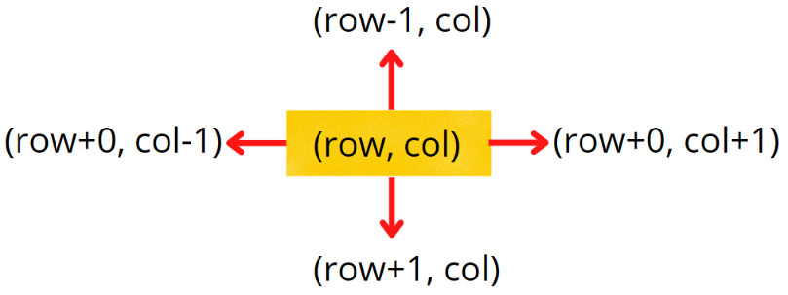

* + If neighbor is 1 and unvisited:
    - Mark visited ✅.
    - Set its distance = d + 1.
    - Push into queue.

3️⃣ **Continue Until Queue Empty** 🏁

* BFS ensures the **first time we visit a 1 is the shortest path to nearest 0**.



[Click](https://lh4.googleusercontent.com/qwCqZy-fh2piALbPFTipWPgYAagZ66uB7XtloPpz8ibMKsAzD1HbiB1NhN7asfzCxVXnZYQ_vaGnHQL_PAm1XnPockKLzer3T3Wze0dhABbjMoPGZ_d5AJwbRxGT_uheVAN6xPBLcbq3gJ6p2qNyuJfg-DdQ6PgL-Oca8LqUFEz33vAVxN5NJX3x) if video not visible

**Code:**

**class Pair{**

    int row,col,dist;

    Pair(int row,int col,int dist)

    {

*this*.row = row;

*this*.col = col;

*this*.dist = dist;

    }

**}**

**public int[][] updateMatrix(int[][] mat) {**

        boolean[][] visited = new boolean[mat.length][mat[0].length];

        //create an Queue

        Queue<Pair> queue = new LinkedList<>();

        for(int i=0;i<mat.length;i++)

        {

            for(int j=0;j<mat[0].length;j++)

            {

                if(mat[i][j] == 0)

                {

                    visited[i][j] = true;

                    queue.offer(new Pair(i, j, 0));

                }

            }

        }

        while (!queue.isEmpty()) {

            Pair pair = queue.poll();

            // explore all the four direction

            int[] drow = {-1,0,1,0};

            int[] dcol = {0,1,0,-1};

            for(int k=0;k<4;k++)

            {

                int nrow = pair.row + drow[k];

                int ncol = pair.col + dcol[k];

                //check for valid neighbour row/col

                if(nrow >=0 && nrow<mat.length && ncol >= 0 && ncol<mat[0].length && !visited[nrow][ncol] && mat[nrow][ncol] == 1)

                {

                    visited[nrow][ncol] = true;

                    mat[nrow][ncol] = pair.dist + 1;

                    queue.offer(new Pair(nrow, ncol, pair.dist + 1));

                }

            }

        }

        return mat;

**}**

**Surrounding Regions**

**Problem Statement:** You are given an m x n matrix board containing letters 'X' and 'O', capture regions that are surrounded:

* Connect: A cell is connected to adjacent cells horizontally or vertically.
* Region: To form a region connect every 'O' cell.
* Surround: The region is surrounded with 'X' cells if you can connect the region with 'X' cells and none of the region cells are on the edge of the board.

To capture a surrounded region, replace all 'O's with 'X's in-place within the original board. You do not need to return anything.

**Example 1:**

**Input: board =** [["X","X","X","X"],["X","O","O","X"],["X","X","O","X"],["X","O","X","X"]]

**Output:**

[["X","X","X","X"],["X","X","X","X"],["X","X","X","X"],["X","O","X","X"]]

**Explanation:**

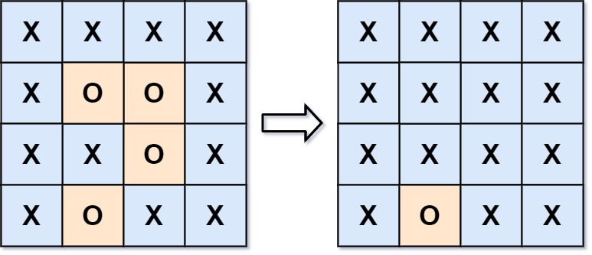

In the above diagram, the bottom region is not captured because it is on the edge of the board and cannot be surrounded.

**Example 2:**

**Input:** board = [["X"]]

**Output:** [["X"]]

**Solution:**

**🔑 Key Idea**

* In the **Surrounded Regions** problem, our task is to flip all 'O's that are **fully surrounded by 'X's** into 'X'.
* However, **not all 'O's can be flipped**:
  + 🟢 'O' on the **boundary** can never be surrounded (since it touches the outside).
  + 🟢 'O' connected to a boundary 'O' through up, down, left, right neighbors is also safe.
  + 🔴 All other 'O's (that cannot reach a boundary 'O') are **trapped** and must be flipped.

👉 Instead of checking each 'O' individually, we **reverse the perspective**:

* Start from **boundary 'O's** and spread inward (DFS/BFS).
* Mark all 'O's that are safe.
* Finally, flip the remaining 'O's to 'X'.

**🔍 Why Boundary First?**

👉 The **boundary guarantees safety**:

* A boundary 'O' can never be enclosed by 'X'.
* Any 'O' connected to it will always have a path to the outside, so it’s safe.That cannot be change to ‘X’
* By marking these first, we automatically separate **sea water** from **lake water**.

If we tried the opposite (start from inside), we’d have to check **every path** for every 'O', which is inefficient.

Boundary-first is like saying: *"Mark the safe ones first, and flip the rest."*

**💡 Intuition (Simple but Deep)**

Imagine the board as a map:

* 🌊 **Water** = 'O'
* 🟩 **Land** = 'X'

There are two kinds of water:

1. **Sea water** 🌊 → connected to the boundary. Safe!
2. **Lake water** 🏞️ → trapped inside land, not connected to the boundary. Must be filled with land ('X').

If we tried to check each 'O' separately whether it is a lake, it would be slow and complicated.  
👉 Instead, we start from the **sea (boundary water)** and mark everything connected to it as safe. Whatever is not marked is clearly a lake.

Think of it like **pouring blue dye into the ocean from the edges**:

* All cells that get colored are part of the ocean (safe).
* Any 'O' that stays uncolored must be an isolated lake.

**🛠️ Approach (Step-by-Step)**

**1️⃣ Initialization**

* Create a visited[][] matrix to track safe cells.
* Define direction arrays for DFS:
  + drow = {-1, 0, 1, 0} (up, right, down, left)
  + dcol = {0, 1, 0, -1}

**2️⃣ Start from Boundary**

* Traverse the **first row**, **last row**, **first column**, and **last column**.
* Whenever you find an 'O' on the boundary, run DFS from that cell:
  + Mark it as visited.
  + Spread to its neighbors if they are 'O'.
* This step ensures all boundary-connected 'O's are marked safe.

**3️⃣ DFS Flood Fill (Core Idea)**

DFS explores all 'O's that are connected to the boundary:

* Visit the current cell.
* For each direction, check:
  + Inside bounds?
  + Not visited yet?
  + Cell is 'O'?
* If yes → recursively DFS into that neighbor.

**4️⃣ Flip Enclosed 'O's**

* After marking safe cells, scan the board again:
  + If a cell is 'O' and not visited → flip to 'X'.
  + If visited, keep it 'O'.

**📝 Alternative Optimization (No Extra Visited Array)**

* Instead of using visited[][]:
  + During DFS, temporarily mark safe 'O's as '#'.
  + After DFS:
    - Flip all 'O' → 'X'.
    - Flip all '#' → 'O'.
* This reduces memory usage to **O(1)** (apart from recursion stack).

**Code:**

**private void dfs(char[][] board,boolean[][] visited,int row,int col)    {**

        //make the visited

        visited[row][col] = true;

        int[] drow = {-1,0,1,0};

        int[] dcol = {0,1,0,-1};

        for(int k=0;k<4;k++)        {

            int nrow = row + drow[k];

            int ncol = col + dcol[k];

            //check for surrounding

            if(nrow >=0 && nrow<board.length && ncol>=0 && ncol<board[0].length && !visited[nrow][ncol] && board[nrow][ncol] == 'O')

                dfs(board, visited, nrow, ncol);

        }

**}**

**public void solve(char[][] board) {**

        boolean[][] visited = new boolean[board.length][board[0].length];

        //first traverse the row where fixed first and last column

        for(int i=0;i<board.length;i++)

        {

            //first column

            if(!visited[i][0] && board[i][0]=='O')

                dfs(board, visited, i, 0);

            //last column

            if(!visited[i][board[0].length-1] && board[i][board[0].length - 1] == 'O')

                dfs(board, visited, i, board[0].length-1);

        }

        //travers column where fixed the first and last row

        for(int j=0;j<board[0].length;j++)

        {

            //first row

            if(!visited[0][j] && board[0][j]=='O')

            {

                dfs(board, visited, 0, j);

            }

            //last row

            if(!visited[board.length-1][j] && board[board.length-1][j] == 'O')

            {

                dfs(board, visited, board.length-1, j);

            }

        }

        for(int i=0;i<board.length;i++)

        {

            for(int j=0;j<board[0].length;j++)

            {

                if(board[i][j] == 'O' && !visited[i][j])

                    board[i][j] = 'X';

            }

        }

    }

**No Of Enclaves**

**Problem Statement:** You are given an m x n binary matrix grid, where 0 represents a sea cell and 1 represents a land cell.

A **move** consists of walking from one land cell to another adjacent (**4-directionally**) land cell or walking off the boundary of the grid.

Return *the number of land cells in* grid *for which we cannot walk off the boundary of the grid in any number of****moves***.

**Example 1:**

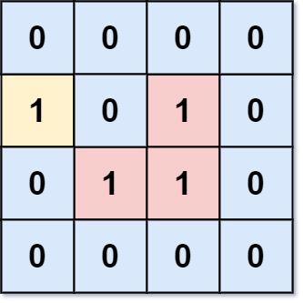

**Input:** grid = [[0,0,0,0],[1,0,1,0],[0,1,1,0],[0,0,0,0]]

**Output:** 3

**Explanation:** There are three 1s that are enclosed by 0s, and one 1 that is not enclosed because its on the boundary.

**Example 2:**

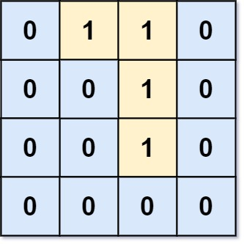

**Input:** grid = [[0,1,1,0],[0,0,1,0],[0,0,1,0],[0,0,0,0]]

**Output:** 0

**Explanation:** All 1s are either on the boundary or can reach the boundary.

**Solution:**

**🧠 Intuition**

👉 If a land cell touches the **boundary** (directly or through connected land), then it can **walk off the grid**.  
👉 So those cells are **not enclaves**.  
👉 The real enclaves are the **land cells inside the grid** that are **not connected to any boundary land**.

**💡 Key Idea**

Instead of checking each cell individually:

1. **Mark all land cells connected to the boundary** using DFS/BFS.
   * These cannot be enclaves.
2. After marking them, just **count the remaining unvisited land cells** inside.

That gives us the enclave count. ✅

**🛠️ Approach (Step by Step)**

**1️⃣ Traverse boundary**

* First row, last row, first column, last column.
* If you find a land cell (1) → do DFS/BFS from it to mark all connected land as visited.
* These are **safe lands** (they can reach boundary).

**2️⃣ Traverse the inner grid**

* For every land cell (i,j) that is **not visited**, it means:
  + It’s not connected to boundary.
  + So it’s an **enclave**.
* Count it.

**3️⃣ Return the count**

That’s the answer. 🎯



[Click](https://lh5.googleusercontent.com/SUS4Jm4wUUL4il2s1hB7xMNH8T3ZLwg6s-t5RXUH3e5x6JmHs8H06kE2uAZM8CWx7fulT3xXTbfP6jKERQW_kOx_3o-PR9yDcJy9EA_X6jIzEbTYNrCkAgZ2_qenpuTLDHepUlqaK_Grh_XCjVS7oJp3bP1NFopqj6pmepX2yzHT3Y8YHasxPA6r7w) id not visible video

**Code:**

    private void dfs(int[][] grid,boolean[][] visited,int row,int col)

    {

        // make the visited

        visited[row][col] = true;

        // got ot its depth

        int[] drow = {-1,0,1,0};

        int[] dcol = {0,1,0,-1};

        for(int k=0;k<4;k++)

        {

            int nrow = row + drow[k];

            int ncol = col + dcol[k];

            //check the condition

            if(nrow >= 0 && nrow<grid.length && ncol >=0 && ncol<grid[0].length && grid[nrow][ncol] == 1 && !visited[nrow][ncol])

                dfs(grid, visited, nrow, ncol);

        }

    }

    public int numEnclaves(int[][] grid) {

        boolean[][] visited = new boolean[grid.length][grid[0].length];

        //travverse boundary row

        for(int j=0;j<grid[0].length;j++)

        {

            //first row

            if(grid[0][j] == 1 && !visited[0][j])

                dfs(grid, visited, 0, j);

            //last row

            if(grid[grid.length-1][j] == 1 && !visited[grid.length-1][j])

                dfs(grid, visited, grid.length-1, j);

        }

        //traverse boundary column

        for(int i=0;i<grid.length;i++)

        {

            if(grid[i][0] == 1 && !visited[i][0])

                dfs(grid, visited, i, 0);

            if(grid[i][grid[0].length-1] == 1 && !visited[i][grid[0].length-1])

                dfs(grid, visited, i, grid[0].length-1);

        }

        int cnt = 0;

        for(int i=1;i<grid.length-1;i++)

        {

            for(int j=1;j<grid[0].length-1;j++)

            {

                if(grid[i][j] == 1 && !visited[i][j])

                    cnt++;

            }

        }

        return cnt;

    }

**No of Distinct Island**

**Problem Statement:** You are given a two-dimensional array/list of integers consisting of 0s and 1s. In the list, 1 represents land and 0 represents water.

The task is to find the number of distinct islands where a group of connected 1s(horizontally or vertically) forms an island.

**Note:** Two islands are considered to be the same if and only if one island is equal to another (not rotated or reflected) i.e if we can translate one island on another without rotating or reflecting then it would be considered as the same islands.

**Example - 1:**

1 1 0

0 0 1

0 0 1

**o/p:**2

In this example, we have two islands and they would be considered as distinct islands as we can not translate them on one another even if they have the same no of 1's.

**For example :**

1 1 0 0 0

1 1 0 0 0

0 0 0 1 1

0 0 0 1 1

**o/p:**1

In this example, we have two islands and they are the same as we can translate one island onto another island, so our answer should be 1.

**HashSet:**

**1️⃣ How HashSet Works Internally**

* HashSet is based on a **hash table**.
* It decides **uniqueness** in **two steps**:
  1. **hashCode()** → finds the "bucket".
  2. **equals()** → compares actual contents in that bucket.

✅ Rule of thumb:

Two objects are considered the same in a HashSet **only if**  
hashCode() is equal **AND** equals() is true.

**2️⃣ ArrayList<String> in a HashSet**

* ArrayList **overrides** both hashCode() and equals().
* **hashCode** = generated from all elements (order matters).
* **equals** = compares element by element.

**ArrayList<Pair> in a HashSet**

* If you use your own class Pair(row, col), by default it inherits Object.equals() and Object.hashCode() → which check **memory address**.

👉 That means:

new Pair(0,0).equals(new Pair(0,0)) // false ❌ (different objects)

⚠️ If you don’t override, every island shape will look unique even if contents are same → wrong answer

**🔹 Final Uniqueness Process for HashSet<ArrayList<String>>**

1. **HashSet** calls hashCode() of the ArrayList<Pair>.
2. **ArrayList.hashCode()** = based on each element’s (Pair) hashCode.
3. Each string already has its own **content-based hashCode** (computed from characters)..
4. The list then **combines** all those string hashCodes:
5. ArrayList.equals() → compares size + checks each element with Pair.equals().
6. If all Pair.equals() return true → the two lists are considered same.

**Solution:**

**💡 Key Idea**

👉 If we just count islands, that’s easy (DFS/BFS).  
👉 But here we need to know if one island is the **same shape** as another.

So the trick is:

1. Every time we discover an island, we **record its shape** in a **normalized way**.
2. Store all shapes in a **HashSet** → duplicates are automatically removed.
3. Answer = size of the HashSet. ✅

**🧠 Key Intuition**

* If I find an island starting at (i,j), let’s call that the **base point**.
* Every land cell (row, col) of this island can be expressed **relative to the base point**:
* relativeRow = row - baseRow
* relativeCol = col - baseCol
* Now the island shape becomes a **list of relative coordinates**.
* Example:
* Island at (1,1),(1,2),(2,2)
* Base = (1,1)
* Shape = [(0,0), (0,1), (1,1)]
* Another island at (3,4),(3,5),(4,5) will also reduce to the **same relative shape**. 🎯
* **We fix one land cell as a base, store every other cell as its difference from the base. That way, the same-shaped islands always give the same pattern of differences, no matter where they are located. And we keep those island that are not rotated and reflected and using this technique we eliminate**

**🛠️ Approach (Step by Step with Icons)**

**1️⃣ Traverse the grid**

* For every cell (i,j):
  + If it’s land (1) and not visited → new island found.

**2️⃣ DFS/BFS to explore the island**

* Perform DFS to visit all land cells of this island.
* Mark visited cells ✅.
* For each land cell, store its **relative position** (row - baseRow, col - baseCol) in a vector vec.

**3️⃣ Store shape**

* Once an island is fully explored, vec = full shape.
* Add this vec into a HashSet<ArrayList<String>>.
  + HashSet ensures only **unique shapes** are kept.

**4️⃣ Answer**

* The number of distinct islands = set.size(). 🎉

**Code:**

**private static void dfs(int[][] arr,boolean[][] visited,int row,int col,int baseRow,int baseCol,ArrayList<String> vec) {**

        visited[row][col] = true;

        vec.add((row - baseRow) + "," + (col - baseCol));

        int drow[] = {-1,0,1,0};

        int dcol[] = {0,1,0,-1};

        for(int k=0;k<4;k++)

        {

            int nrow = row + drow[k];

            int ncol = col + dcol[k];

            // check for valid and neighbour is land

            if(nrow >=0 && nrow<arr.length && ncol>=0 && ncol < arr[0].length  &&  !visited[nrow][ncol] && arr[nrow][ncol] == 1)

                dfs(arr, visited, nrow, ncol,baseRow,baseCol,vec);

        }

**}**

**public static int distinctIsland(int [][] arr, int n, int m)     {**

        boolean[][] visited = new boolean[n][m];

        HashSet<ArrayList<String>> set = new HashSet<>();

        for(int i=0;i<n;i++)

        {

            for(int j=0;j<m;j++)

            {

                if(arr[i][j] == 1 && !visited[i][j])

                {

                    ArrayList<String> vec = new ArrayList<>();

                    dfs(arr, visited, i, j,i,j,vec);

                    set.add(vec);

                }

            }

        }

        return set.size();

**}**

**Bipartite Graph**

**Problem Statement:** There is an undirected graph with n nodes, where each node is numbered between 0 and n - 1. You are given a 2D array graph, where graph[u] is an array of nodes that node u is adjacent to. More formally, for each v in graph[u], there is an undirected edge between node u and node v. The graph has the following properties:

* There are no self-edges (graph[u] does not contain u).
* There are no parallel edges (graph[u] does not contain duplicate values).
* If v is in graph[u], then u is in graph[v] (the graph is undirected).
* The graph may not be connected, meaning there may be two nodes u and v such that there is no path between them.

A graph is bipartite if the nodes can be partitioned into two independent sets A and B such that every edge in the graph connects a node in set A and a node in set B.

Return true*if and only if it is bipartite*.

**Simple Understanding:** If we are able to colour a graph with two colours such that no adjacent nodes have the same colour, it is called a bipartite graph.

**Example 1:**

**Input:**

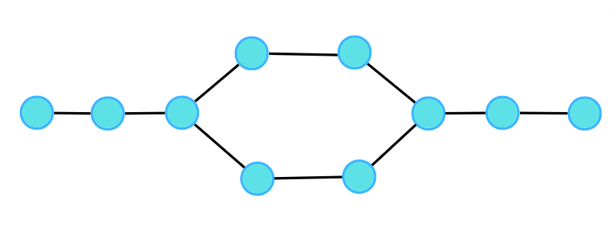

**Output:  1**

**Explanation:**

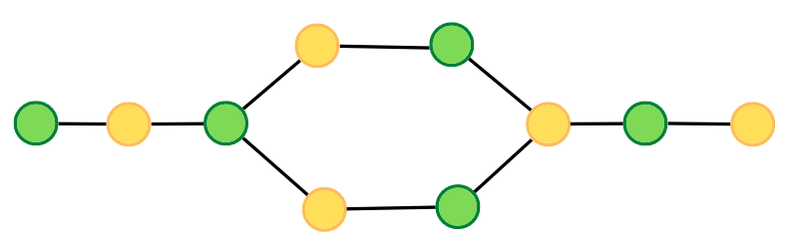

**Example 2:**

**Input:**

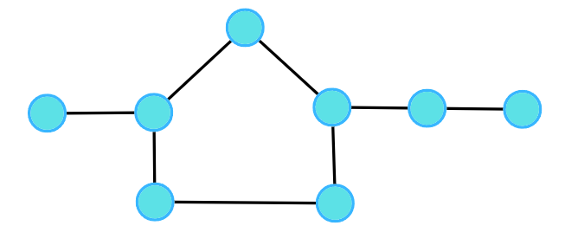

**Output:  0**

**Explanation:**

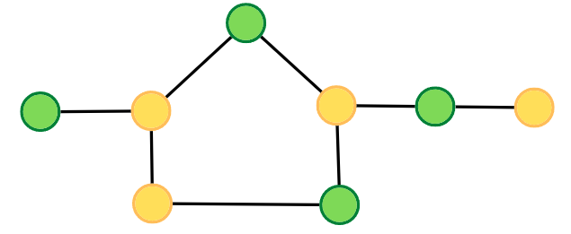

**Here adjacent with same color but we want with different color**



**Solution:**

**🌟 Key Idea**

* A graph is bipartite if you can color it using two colors (say Red & Blue OR 0 & 1) such that no two adjacent nodes have the same color.
* If such a coloring is possible → graph is bipartite ✅
* If you ever find two adjacent nodes with the same color → graph is not bipartite ❌

**🛠️ Approach**

**🟦 BFS approach — in-depth**

Idea: BFS discovers nodes by levels; nodes at even distance from the start get one color, odd distance the other.

Algorithm (high-level)

1. For each uncolored start node s:
   1. queue = [s], color[s] = 0.
   2. While queue not empty:
      * u = queue.poll()
      * For each neighbor v of u:
        + If color[v] == -1: set color[v] = 1 - color[u] and queue.offer(v)
        + Else if color[v] == color[u]: return false (conflict)
2. After all nodes processed, return true.

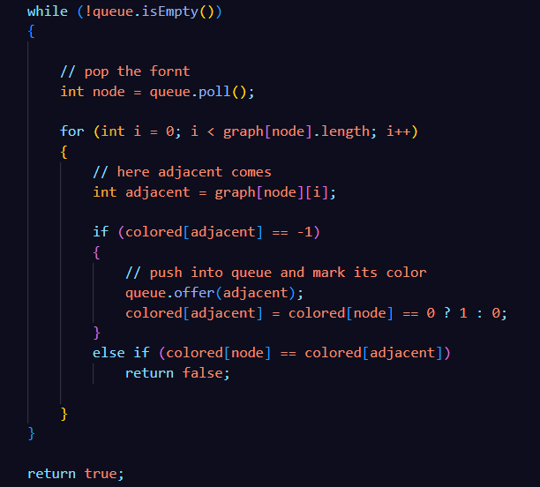

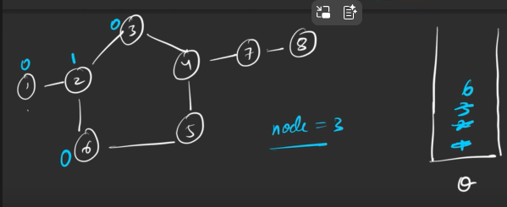

**Adready Colord  
 and src and adjacent color are different**

**No Color so we color to 1 opposite of src**



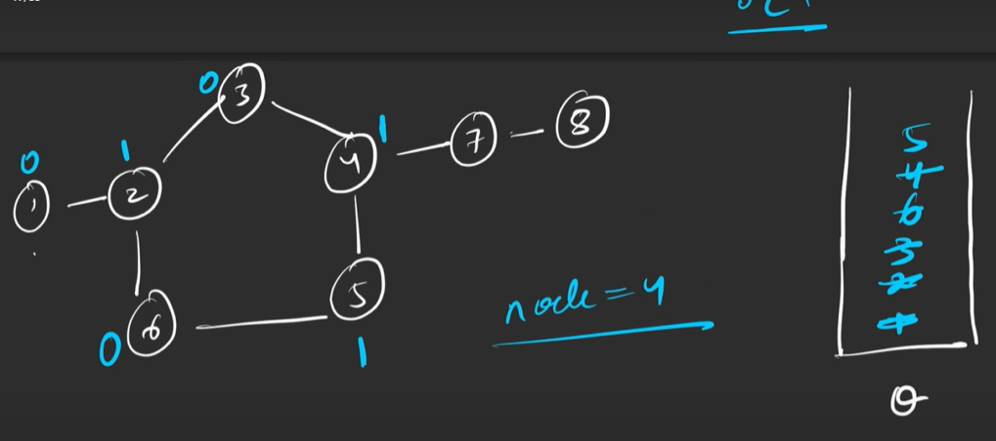

**Invalid both have same color return false as answer**

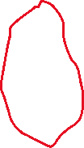

Key invariants & why it’s safe

* Color as soon as node is discovered (when pushing into queue) — prevents multiple pushes and ensures neighbor color comparisons are meaningful.
* Because BFS explores by increasing distance from s, if there is an edge connecting two nodes of same parity distance, it must be within the same or adjacent BFS levels; that is exactly where conflict appears.

**🟥 DFS approach — in-depth**

**Idea:** recursively (or with a stack) try to color a node and its subtree with alternating colors. If you ever see a neighbor with the same color → conflict.

**Recursive DFS algorithm (high-level)**

1. For each node s uncolored: call dfs(s, color=0).
2. In dfs(u, c):
   * color[u] = c
   * for each neighbor v:
     + if color[v] == -1: if dfs(v, 1 - c) returns false → return false
     + else if color[v] == c: return false
   * return true

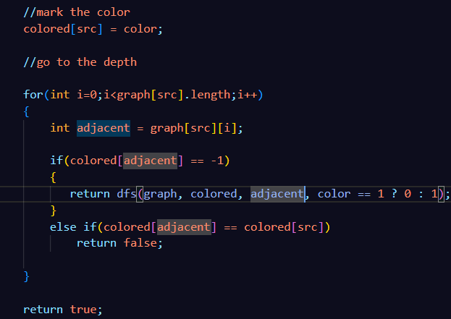



[Click](https://lh4.googleusercontent.com/J9Vyk4nnbbe_cI5vVRYe0GHJv_WKJMqBqfGsvgq8n-hRHMpIiJlpONzTkZu_UhbmaefsvCLOVkyLiMhrrdmSWiiuIzT_bYdwteoz8qtzZSX0XuAu2LALdFVANSXkcSvqB_awJUvTBlQxCFQNh-ZD2QHRG_pdZec1Dbt-qP88OtZ4q2qptG4VSPvQPw) if video is not play

**Code:**

**private boolean dfs(int[][] graph,int[] colored,int src,int color)    {**

        //mark the color

        colored[src] = color;

        //go to the depth

        for(int i=0;i<graph[src].length;i++)        {

            int adjacent = graph[src][i];

            if(colored[adjacent] == -1)            {

               return dfs(graph, colored, adjacent, color == 1 ? 0 : 1);

            }

            else if(colored[adjacent] == colored[src])

                return false;

        }

        return true;

**}**

**private boolean bfs(int[][] graph, Queue<Integer> queue, int[] colored,int src)    {**

        // push the first node

        queue.offer(src);

        // mark the color

        colored[src] = 0;

        while (!queue.isEmpty())

        {

            // pop the fornt

            int node = queue.poll();

            for (int i = 0; i < graph[node].length; i++)

            {

                // here adjacent comes

                int adjacent = graph[node][i];

                if (colored[adjacent] == -1)

                {

                    // push into queue and mark its color

                    queue.offer(adjacent);

                    colored[adjacent] = colored[node] == 0 ? 1 : 0;

                }

                else if (colored[node] == colored[adjacent])

                    return false;

            }

        }

        return true;

**}**

**public boolean isBipartite(int[][] graph) {**

        int n = graph.length;

        Queue<Integer> queue = new LinkedList<>();

        int colored[] = new int[n];

        Arrays.fill(colored, -1);

        for(int i=0;i<n;i++)

        {

            if(colored[i] == -1)

            {

                if(dfs(graph, colored, i, 0) == false)

                    return false;

                // if(bfs(graph, queue, colored,i) == false)

                //     return false;

            }

        }

        return true;

**}**

**Detetch the Loop in Directed Graph**

**Problem Statement:** Given a directed graph with V vertices and E edges, check whether it contains any cycle or not.

Given a Directed Graph with **V** vertices (Numbered from **0** to **V-1**) and **E** edges, check whether it contains any **cycle**or not.  
The graph is represented as a 2D vector **edges[][]**, where each entry **edges[i] = [u, v]** denotes an edge from verticex **u** to **v.**

**Example 1:**

**Input: N = 10, E = 11**

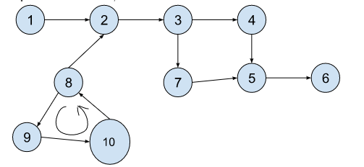

**Output:** true

**Explanation:** 8->9->10 is a cycle.

**Example 2:**

**Input Format:** N = 10, E = 10

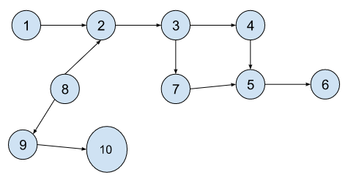

**Result:** false

**Explanation:** No cycle detected.

**Solution:**

**🔑 1. Why do we need pathVisited?**

👉 visited[] only tells us whether we have visited a node **at least once in the whole DFS traversal**.But for cycle detection, that’s not enough!

Imagine this case:

0 → 1 → 2 → 3

↑ |

└─────--┘

* Here, a cycle exists: 1 → 2 → 3 → 1.
* If we only used visited[], when we reach node 1 again, it will already be true (because visited earlier), but **we need to know if we reached it again in the same path**.
* That’s why we need pathVisited[].

✔️ pathVisited[] means:

* **"Is this node currently active in the recursion stack (i.e., current path of DFS)?"**
* If yes, and we encounter it again → **cycle exists**.
* **When we explore all the adjacent of src node then remove from the stack(pathVisited[src] = false).**

🔎 Example trace:

* Start at 1, mark pathVisited[1] = true.
* Go to 2, mark pathVisited[2] = true.
* Go to 3, mark pathVisited[3] = true.
* From 3, go back to 1. Now visited[1] is already true, **but importantly, pathVisited[1] is also true** → means we returned to a node in the current path → **cycle found!**

📌 **So key difference:**

* visited[] → "Have we seen this node in any DFS run?"
* pathVisited[] → "Is this node part of the current DFS path?".That’s why both are needed 💡.

**🌟 Key Idea**

We do a DFS traversal for each unvisited node.  
👉 While exploring, we mark nodes as:

* visited[node] = true (seen at least once overall)
* pathVisited[node] = true (currently in path)

👉 If we find an edge to a node that is already pathVisited[] == true, then:

* It means we are trying to go back to a node in the **same path** → **cycle exists**.

👉 After finishing DFS from a node, we backtrack and unmark pathVisited[node] = false.

**🛠️ Approach**

1. **Graph input:**  
   We are given edges in edges[][] form, where each row is [u, v] meaning there is a directed edge u → v.
2. **DFS Logic:**
   * Start DFS from each unvisited node.
   * For each node src:
     + Mark visited[src] = true and pathVisited[src] = true.
     + Look at all edges (u, v) in the edges array.
     + If u == src (means edge goes out from current node):
       - If v is not visited → recursively DFS.
       - If v is already pathVisited → cycle detected.
3. **Backtracking:**  
   After processing all edges for src, set pathVisited[src] = false (important to avoid false cycle detection for other DFS paths).

**4. Why check entire edges array?**

👉 Because input is given as an **edge list** (not adjacency list).  
👉 That means we don’t directly know the neighbors of a node.  
👉 So inside DFS, we scan all edges:

for (int i = 0; i < edges.length; i++) {

int u = edges[i][0];

int v = edges[i][1];

if (u == src) {

// means this edge goes out from 'src' → explore v

}

}

✔️ This way we only process neighbors of src.  
✔️ In adjacency list we wouldn’t need this loop, but since we are using edge list, it’s necessary.

**Code:**

**private boolean dfs(int[][] edges, boolean[] visited, boolean[] pathVisited, int src) {**

        // make the visited

        visited[src] = true;

        // mark the path visited

        pathVisited[src] = true;

        // go to depth

        for (int i = 0; i < edges.length; i++) {

            int u = edges[i][0];

            int v = edges[i][1];

            if (u == src) {

                if (!visited[v]) {

                    if (dfs(edges, visited, pathVisited, v))

                        return true;

                }

else if (pathVisited[v])

                    return true;

            }

        }

        // when path is finished from an src so then mark as false

        pathVisited[src] = false;

        return false;

**}**

**public boolean isCyclic(int V, int[][] edges) {**

        boolean[] visited = new boolean[V];

        boolean[] pathVisited = new boolean[V];

        // code here

        for (int i = 0; i < V; i++) {

            if (!visited[i]) {

                if (dfs(edges, visited, pathVisited, i) == true)

                    return true;

            }

        }

        return false;

**}**

**[Find Eventual Safe States](https://leetcode.com/problems/find-eventual-safe-states/)**

**Problem Statement:** There is a directed graph of n nodes with each node labeled from 0 to n - 1. The graph is represented by a 0-indexed 2D integer array graph where graph[i] is an integer array of nodes adjacent to node i, meaning there is an edge from node i to each node in graph[i].

A node is a terminal node if there are no outgoing edges**. A node is a safe node if every possible path starting from that node leads to a terminal node (or another safe node).**

Return *an array containing all the safe nodes of the graph*. The answer should be sorted in ascending order.

**Example 1:**

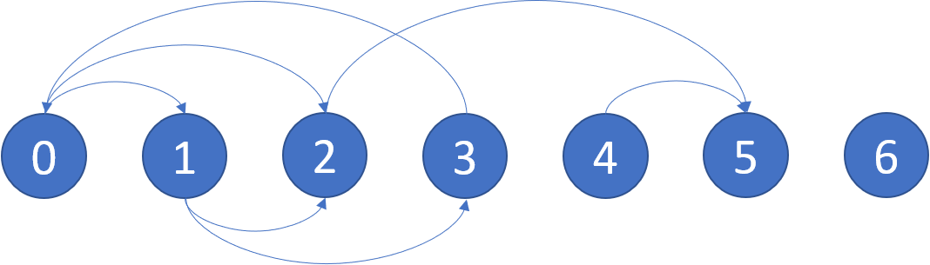

**Input:** graph = [[1,2],[2,3],[5],[0],[5],[],[]]

**Output:** [2,4,5,6]

**Explanation:** The given graph is shown above. Nodes 5 and 6 are terminal nodes as there are no outgoing edges from either of them. Every path starting at nodes 2, 4, 5, and 6 all lead to either node 5 or 6.

**Example 2**:

**Input Format**: N = 4, E = 4

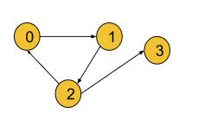

**Result**: {3}

**Explanation**: Node 3 itself is a terminal node and it is a ***safe node*** as well. But all the paths from other nodes do not lead to a terminal node. So they are excluded from the answer.

**🧐 What does “every path leads to a terminal node” mean?**

* **Terminal node** = node with **no outgoing edges**.
* If you start from a node, and *no matter what path you choose* you eventually reach a terminal node, then the starting node is **safe**.
* If from a node you can reach a cycle, that node is **not safe** (because you can go infinitely around the cycle).

👉 **Key takeaway**: A node is safe **if it never reaches a cycle**.

**Solution:**

**💡 Key Idea**

* The problem is all about figuring out which nodes are safe.
* A safe node is one from which every possible path eventually ends at a terminal node (or another safe node).
* If there exists even one path that goes into a cycle, the starting node becomes unsafe.
* So, the core idea is:
  + Detect cycles in the graph.
  + Any node that is part of a cycle or can reach a cycle is unsafe.
  + All others are safe.
* To achieve this, we use DFS with recursion stack to detect cycles while exploring paths.

👉 In short: *“Safe nodes are the nodes that never reach a cycle.”*

**🎯 Intuition**

* Think of walking along the graph from a node:
  + If you eventually stop at a terminal node, you are safe.
  + If you get stuck going around in a cycle, you are unsafe.
* During DFS, we keep track of:
  + **Visited nodes** (already processed, don’t repeat work).
  + **PathVisited (recursion stack)** (nodes in the current exploration path).
* If we ever revisit a node that’s already in the **recursion stack**, it means we’ve found a **back edge → cycle**.
* If DFS for a node finishes without hitting a cycle, that node is **safe**.
* Once we know a node is safe, we don’t need to check it again — that saves time.
* This logic ensures we can **classify every node as safe or unsafe**.

👉 Intuition picture:

* Nodes in cycles ❌ unsafe.
* Nodes leading into cycles ❌ unsafe.
* Nodes leading only to terminals ✅ safe.

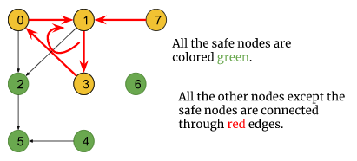

**⚙️ Approach (Step by Step)**

1. **Setup**
   * Create two boolean arrays:
     + visited[] → marks if a node has been explored before.
     + pathVisited[] → marks if a node is currently in recursion stack.
   * Create a list safeNodes to collect safe nodes.
2. **DFS Traversal**
   * For each node i (from 0 to n-1):
     + If visited[i] == false, run DFS starting at i.
3. **DFS Function Logic**
   * Mark current node as visited[src] = true and pathVisited[src] = true.
   * For each neighbor of src:
     + If neighbor not visited → recursively call DFS.
       - If DFS returns **true (cycle found)** → propagate unsafe status.
     + If neighbor is already on the recursion stack (pathVisited[neighbor] == true) → cycle detected → return true.
   * After exploring all neighbors:
     + Reset pathVisited[src] = false (backtrack).
     + **Since no cycle was found, mark node as safe → add to safeNodes.**
     + Return false (no cycle from this node).
4. **After DFS**
   * Once all nodes are processed, sort safeNodes (because the problem asks for ascending order).
   * Return the sorted list.

**🔑 Simple Reason Why Cycle Detection Works**

* A node is **unsafe** if **any path starting from it can keep going forever**.
* The **only way to keep going forever** in a finite graph is if you get **stuck in a cycle**.
  + If DFS detects a **cycle** → that node (and all nodes that can reach it) are unsafe.
  + If DFS does **not** detect a cycle → all paths eventually end at a **terminal node**, so the node is safe.

👉 **In short**:

* **Cycle = possibility of infinite path → unsafe.**
* **No cycle = every path ends → safe**

**Code:**

**private boolean dfs(int[][] graph,boolean[] visited,boolean[] pathVisited,List<Integer> safeNodes,int src) {**

        //make it visited

        visited[src] = true;

        pathVisited[src] = true;

        //go to depth

        for(int i=0;i<graph[src].length;i++)

        {

            int adjacent = graph[src][i];

            if(!visited[adjacent])

            {

                if(dfs(graph, visited, pathVisited, safeNodes,adjacent)== true)

                    return true;

            }

            else if(pathVisited[adjacent])

            {

                //here we found an loop

                //safe node means a node that can not lead to loop

                //this is not a safeNode

                return true;

            }

        }

        //reset the pathVisited

        pathVisited[src] = false;

        //if there is no futher child and we did not detect any loop so that node is also an safe node

        safeNodes.add(src);

        return false;

**}**

**public List<Integer> eventualSafeNodes(int[][] graph) {**

        int n = graph.length;

        boolean[] visited = new boolean[n];

        boolean[] pathVisited = new boolean[n];

        List<Integer> safeNodes = new ArrayList<>();

        for(int i=0;i<n;i++)

        {

            if(!visited[i])

            {

                dfs(graph, visited, pathVisited,safeNodes, i);

            }

        }

        Collections.sort(safeNodes);

        return safeNodes;

**}**

**Word Ladder 1**

**Problem Statement**: A transformation sequence from word beginWord to word endWord using a dictionary wordList is a sequence of words beginWord -> s1 -> s2 -> ... -> sk such that:

* Every adjacent pair of words differs by a single letter.
* Every si for 1 <= i <= k is in wordList. Note that beginWord does not need to be in wordList.
* sk == endWord

Given two words, beginWord and endWord, and a dictionary wordList, return *the number of words in the shortest transformation sequence from* beginWord *to* endWord*, or*0*if no such sequence exists.*

**Example 1:**

**Input:** beginWord = "hit", endWord = "cog", wordList = ["hot","dot","dog","lot","log","cog"]

**Output:** 5

**Explanation:** One shortest transformation sequence is "hit" -> "hot" -> "dot" -> "dog" -> cog", which is 5 words long.

**Example 2:**

**Input:** beginWord = "hit", endWord = "cog", wordList = ["hot","dot","dog","lot","log"]

**Output:** 0

**Explanation:** The endWord "cog" is not in wordList, therefore there is no valid transformation sequence.

**Solution:**

💡 **Key Idea — What the Word Ladder Problem Is About**

The Word Ladder problem is all about **transforming one word into another**, changing **only one letter at a time**, and ensuring that **each intermediate word** exists in a given list of valid words.  
Your goal is to find the **shortest possible transformation sequence** — that’s why we use **Breadth-First Search (BFS)** here.

* Two words have an **edge** between them if they differ by exactly **one letter** (e.g. "hot" ↔ "dot").
* The shortest transformation from beginWord → endWord is just the **shortest path** in this unweighted graph → use **BFS** (breadth-first search) because BFS explores level-by-level and returns the shortest number of edges (steps).
* The answer returned is the number of words in the path (not edges) — typically you start counting beginWord as step 1.

**🌟 Intuition Behind the Word Ladder Problem**

Imagine you’re standing at the word **“hit”**, and your goal is to reach **“cog”**.  
But you can only move forward by **changing one letter at a time**,  
and every new word you form must be a **valid word** present in your dictionary (wordList).

For example:

hit → hot → dot → dog → cog ✅

Each word here is just **one letter away** from the previous one.

Now the question becomes:

“What is the minimum number of steps (transformations) needed to go from beginWord to endWord?”

This sounds very much like a **shortest path problem**, right?

**🧠 Intuitive Thought Process**

💬 Think of each **word as a city**, and you can only travel between two cities if their names differ by **exactly one letter**.

So:

* “hit” can go to “hot” → ✅ (one letter different)
* “hit” cannot go to “dot” → ❌ (two letters different)

That’s how **connections** (edges) are formed.  
Now your **wordList** becomes a **graph of words**, where edges represent single-letter transformations.

**⚙️ Why We Use a Graph**

The **graph** helps us store these connections efficiently.  
It tells us:

“From this word, which other words can I move to in one step?”

This is why we represent it using a **map** (HashMap) — because we want **fast access**.

**🏗️ How the Graph Is Created in Your Code**

Let’s break this down carefully — your graph creation logic is inside the ladderLength() method.

**🧩 Step 1 — Ensure beginWord Is in the List**

if (!wordList.contains(beginWord))

wordList.add(beginWord);

Why?  
Because you start your journey from beginWord, so it must exist in the graph.

**🧩 Step 2 — Initialize the Graph Structure**

Map<String, ArrayList<String>> adj = new HashMap<>();

for (int i = 0; i < n; i++) {

adj.put(wordList.get(i), new ArrayList<String>());

}

Here’s what’s happening:

* You create a **map**, where each key = word
* Each value = list of connected (neighbor) words
* Example initially:
* {
* "hit": [],
* "hot": [],
* "dot": [],
* "dog": [],
* "cog": [],
* "lot": [],
* "log": []
* }

Think of this like creating **empty rooms** (each word has its own room).  
We’ll soon fill those rooms with their “neighbor” words.

**🧩 Step 3 — Connecting Words (Creating Edges)**

for (int i = 0; i < n - 1; i++) {

for (int j = i + 1; j < n; j++) {

String w1 = wordList.get(i);

String w2 = wordList.get(j);

if (differByOneLet(w1, w2)) {

adj.get(w1).add(w2);

adj.get(w2).add(w1);

}

}

}

This double loop compares **every pair of words**:

* If they differ by exactly one letter → connect them both ways
* Because the relationship is **bidirectional** (you can go from hit → hot and also hot → hit)

That’s why you use

⚙️ **Approach**

🔹 **Step 1 — Representing the Graph**  
We use a **Map<String, ArrayList<String>>** where

* Each **key** → represents a word
* Each **value (list)** → represents all words that are **one letter different**

This way, you can quickly find all neighbors (words you can jump to in one transformation).

For example,

hit → [hot]

hot → [hit, dot, lot]

dot → [hot, dog]

dog → [dot, cog]

cog → [dog]

So this map (adj) acts like your **graph adjacency list**.

🔹 **Step 2 — Building the Graph**  
To build the graph, you compare every pair of words:

* If two words differ by **exactly one letter**, they’re connected.
* The helper function differByOneLet() checks this condition.

Internally, this function:

* Compares both words letter by letter
* Counts how many letters differ
* Returns true if exactly one character is different

This ensures only valid single-step transformations form edges in your graph.

🔹 **Step 3 — Applying BFS for the Shortest Path**  
Once the graph is ready, BFS is performed starting from the **beginWord**:

* You use a **queue** to explore level by level
* Each queue element stores a **Pair(word, stepCount)**
* For each word, visit all its neighbors
* If you find the **endWord**, return the number of steps (step + 1)

Because BFS always explores in increasing order of distance,  
the first time you find the endWord, that’s guaranteed to be the **shortest transformation**.

🔹 **Step 4 — Handling Edge Cases**  
✅ If the beginWord is not already in the list, add it — this ensures it exists in the graph.  
✅ Use a **visited set** to avoid cycles or revisiting words.  
✅ If you never reach endWord, return 0 — meaning no valid transformation exists.

💭 **Why BFS and Not DFS?**

* DFS explores deeper paths first, which might not be the shortest.
* BFS explores all words at distance 1, then distance 2, and so on.
* So, BFS naturally gives the **minimum number of transformations**.

**Code:**

class Pair

{

    String str;

    int step;

    Pair(String str,int step)    {

*this*.str = str;

*this*.step = step;

    }

**}**

**private boolean differByOneLet(String str1,String str2) {**

        //check for smaller length

        int len = Math.min(str1.length(),str2.length());

        int cnt = 0;

        for(int i=0;i<len;i++)

        {

            if(str1.charAt(i) != str2.charAt(i))

                cnt++;

            if(cnt > 1)

                return false;

        }

        return cnt == 1;

    }

    private int bfs(Map<String,ArrayList<String>> adj,List<String> wordList,String beginWord,String endWord)

    {

        Set<String> visited = new HashSet<>();

        Queue<Pair> queue = new LinkedList<>();

        //push the beginWord

        queue.offer(new Pair(beginWord, 1));

        visited.add(beginWord);

        //visit one level neighbour

        while (!queue.isEmpty()) {

            Pair pair = queue.poll();

            String str = pair.str;

            int step = pair.step;

            for(int i=0;i<adj.get(str).size();i++)

            {

                String adjacent = adj.get(str).get(i);

                if(adjacent.equals(endWord))

                    return step + 1;

                //if not same then push adjacent

                if(!visited.contains(adjacent))

                {

                    visited.add(adjacent);

                    queue.offer(new Pair(adjacent, step + 1));

                }

            }

        }

        return 0;

**}**

**public int ladderLength(String beginWord, String endWord, List<String> wordList) {**

        //add beginWord at start of wordList

        if(!wordList.contains(beginWord))

            wordList.add(beginWord);

        int n = wordList.size();

        //first of all we have to create an graph

        //here we have an string so we need an map for direct access string

        Map<String,ArrayList<String>> adj = new HashMap<>();

        for(int i=0;i<n;i++)

        {

            adj.put(wordList.get(i), new ArrayList<String>());

        }

        for(int i=0;i<n-1;i++)

        {

            for(int j=i+1;j<n;j++)

            {

                String w1 = wordList.get(i);

                String w2 = wordList.get(j);

                if (differByOneLet(w1, w2))

                {

                    adj.get(w1).add(w2);

                    adj.get(w2).add(w1);

                }

            }

        }

        return bfs(adj, wordList, beginWord, endWord);

**}**

**Topological Sort**

**Problem Statement:** Implement topological sort

**Example 1**:

**Input:** V = 6, E = 6

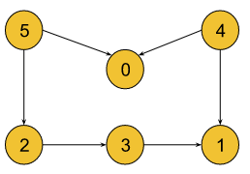

**Output:** 5, 4, 2, 3, 1, 0

**Explanation**: A graph may have multiple topological sortings. The result is one of them. The necessary conditions

for the ordering are:

* According to edge **5 -> 0,** node 5 must appear before node 0 in the ordering.
* According to edge **4 -> 0,** node 4 must appear before node 0 in the ordering.
* According to edge **5 -> 2,** node 5 must appear before node 2 in the ordering.
* According to edge **2 -> 3,** node 2 must appear before node 3 in the ordering.
* According to edge **3 -> 1,** node 3 must appear before node 1 in the ordering.
* According to edge **4 -> 1,** node 4 must appear before node 1 in the ordering.

The above result satisfies all the necessary conditions.

[4, 5, 2, 3, 1, 0] is also one such topological sorting

that satisfies all the conditions.

**Solution:**

**🔑 What is Topological Sort?**

A **topological sort** of a Directed Acyclic Graph (DAG) is a linear ordering of vertices such that for every directed edge u -> v, u appears **before** v in the order.  
Think: “do u before v” — ordering tasks so all prerequisites are done first.

**🧭 Why is it required?**

* Scheduling tasks with dependencies (build systems, course prerequisites, job pipelines).
* Ordering compilation steps, task execution, or any dependency resolution.
* Many algorithms need a linear ordering that respects dependency directions

**🧠 Key idea & intuition (simple words)**

* Each directed edge u -> v means **v depends on u** (u must come earlier).
* In DFS-based topo sort, we perform DFS and **when we finish** a node (i.e., finished exploring all nodes reachable from it), we **push it onto a stack**.
* At the end, we pop from the stack — that yields an ordering where every node appears before the nodes that depend on it.

Why push **after** exploring?  
Because when you finish a node, you have already finished (and pushed) everything that should come **after** it. Reversing the finish order gives the correct dependency order.

**🧩 Role of the Stack (exactly)**

* The stack records vertices in **order of their finishing times** (postorder).
* Nodes that have **no outgoing edges** (sinks) finish earliest and are pushed first.
* When you pop the stack, those sinks come last in the final list — exactly where they should be (since sinks have no dependents before them).
* More generally: if there's an edge u -> v, v will be finished (and thus pushed) **before** u — so popping gives u before v.  
  → **Stack reverses finish times**, producing a valid topological order.

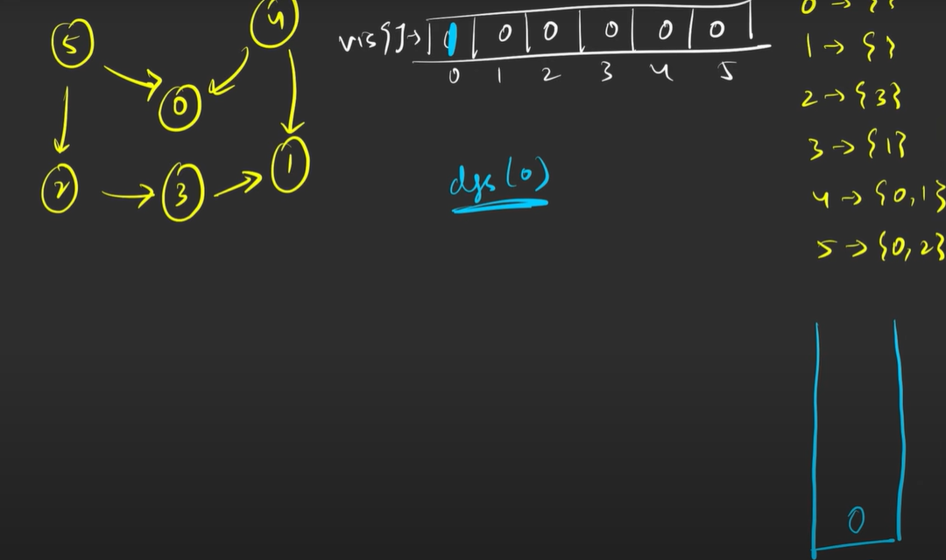



Mark as visited

No future adjacent so push into stack

No future adjacent so push into stack



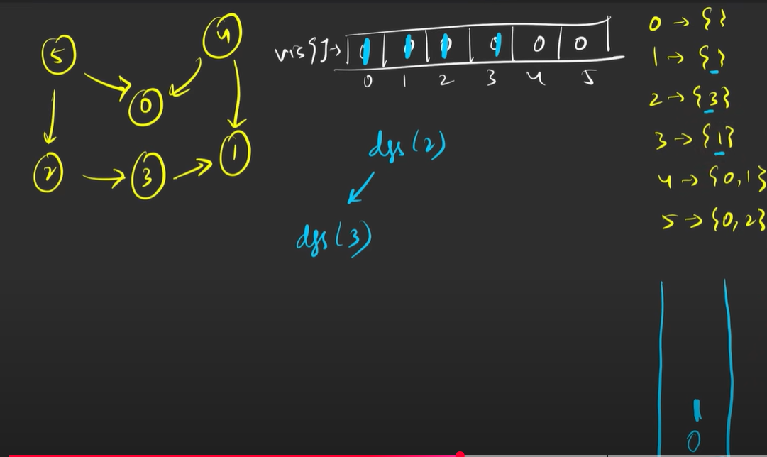

**🛠️ Step-by-step DFS approach (clean)**

1. Build adjacency list adj.
2. visited[] = false for all nodes.
3. For each vertex i from 0..V-1, if not visited → dfs(i):
   * mark i visited
   * for each neighbor nbr in adj[i]:
     + if not visited: dfs(nbr)
   * **push i onto stack** (important: *after* exploring neighbors)
4. After all DFS calls, pop all items from stack to form the topological order.

**Code:**

**static void dfs(ArrayList<ArrayList<Integer>> adj,boolean[] visited,Stack<Integer> stack,int src)    {**

        //make as visited

        visited[src] = true;

        //go to depth

        for(int adjacent : adj.get(src))

        {

            if(!visited[adjacent])

            {

                dfs(adj, visited, stack, adjacent);

            }

        }

        // once depth finish push into stack

        stack.push(src);

**}**

**public static ArrayList<Integer> topoSort(int V, int[][] edges) {**

        //we use an stack to maintain the order it means we store an elememt first that have least dependenacy(no outgoinf edges)

        //here we have an edges array in unorder so we use an adjList for optimize result

        ArrayList<ArrayList<Integer>> adj = new ArrayList<>();

        for(int i=0;i<V;i++) adj.add(new ArrayList<>());

        for(int[] edge : edges) adj.get(edge[0]).add(edge[1]);

        boolean[] visited = new boolean[V];

        Stack<Integer> stack = new Stack<>();

        ArrayList<Integer> res = new ArrayList<>();

        for(int i=0;i<V;i++)

        {

            if(!visited[i])

                dfs(adj, visited, stack, i);

        }

        //once we complete just pop from stack

        while (!stack.isEmpty()) {

            res.add(stack.pop());

        }

        return res;

**}**

**Kahn’s Algorithm for Topological Sort**

**Problem Statement**:  Given a [Directed Acyclic Graph (DAG)](https://takeuforward.org/graph/introduction-to-graph/) with V vertices and E edges, Find any Topological Sorting of that Graph.

Note:*In topological sorting, node u will always appear before node v if there is a directed edge from node u towards node v(u -> v). Use BFS* approach(kahn’s algo)

**Example 1:**

**Input Format:** V = 6, E = 6

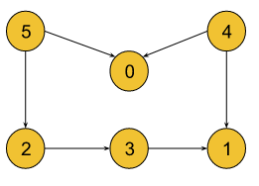

**Result:** 5, 4, 0, 2, 3, 1

**Explanation:** A graph may have multiple topological sortings.

The result is one of them. The necessary conditions for the ordering are:

* According to edge 5 -> 0, node 5 must appear before node 0 in the ordering.
* According to edge 4 -> 0, node 4 must appear before node 0 in the ordering.
* According to edge 5 -> 2, node 5 must appear before node 2 in the ordering.
* According to edge 2 -> 3, node 2 must appear before node 3 in the ordering.
* According to edge 3 -> 1, node 3 must appear before node 1 in the ordering.
* According to edge 4 -> 1, node 4 must appear before node 1 in the ordering.

[4, 5, 2, 3, 1, 0] and [4, 5, 0, 2, 3, 1] are also such

topological sortings that satisfy all the conditions.

**Solution:**

**💡 Key Idea (Detailed & Intuitive)**

* Topological Sorting means ordering nodes so that every directed edge u → v has u before v in the order.
* 🔑 The core observation:
  + Every node in a DAG depends on its incoming edges (prerequisites).
  + If we track how many edges are coming into each node (this is called indegree), we know whether that node is ready to be processed.
* Indegree = 0 → “Free Node” 🎉
  + A node with indegree 0 has no dependencies → we can safely put it into the topological order immediately.
  + Once we process it, we can remove its outgoing edges, which may reduce the indegree of its neighbors.
  + If a neighbor’s indegree also drops to 0, it becomes the next free node.
* ⚡ Stack vs Queue Difference:
  + In DFS approach, we rely on a stack to backtrack and push nodes after exploring dependencies.
  + In Kahn’s Algorithm, we rely on a queue that grows dynamically with all nodes that are “ready” (indegree 0).
* 🔄 The process continues until all nodes are processed, ensuring dependencies are always respected.

**🛠 Approach (Step-by-Step, In Depth)**

**Step 1: Compute Indegree**

* Traverse the entire adjacency list.
* For each edge u → v, increment indegree[v].
* This gives us a **count of how many prerequisites each node has**.

👉 Example:  
If 1 → 2, then indegree[2]++.  
So node 2 can only be processed after 1.

**Step 2: Initialize Queue with Indegree = 0 nodes**

* Scan the indegree[] array.
* For every node i where indegree[i] == 0, push it into the queue.

👉 Meaning:  
These nodes **don’t depend on anyone** and can appear first in the topological order.

**Step 3: Process Nodes using BFS-like Traversal**

* While queue is not empty:
  1. Pop (poll) a node → add it to the result.
  2. For each neighbor of that node:
     + Reduce its indegree (indegree[neighbor]--), since one dependency is now resolved.
     + If neighbor’s indegree becomes 0, enqueue it (it is now ready).

👉 This ensures that **we never process a node before its dependencies** are completed.

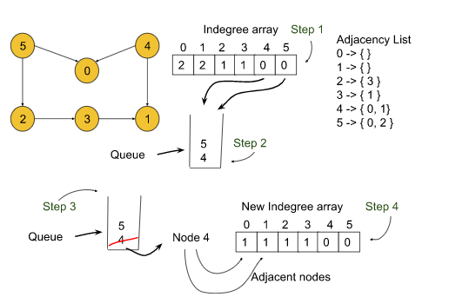



**Decrease the indegree value**



**Step 4: Collect Result**

* Continue until queue is empty.
* The order in which nodes were dequeued is the **topological ordering**.

**Code:**

**static void bfs(List<List<Integer>> adj, Queue<Integer> queue, int[] indegree, int[] res, int ind) {**

        while (!queue.isEmpty()) {

            int src = queue.poll();

            // add src to res array

            res[ind++] = src;

            for (int i = 0; i < adj.get(src).size(); i++) {

                --indegree[adj.get(src).get(i)];

                if (indegree[adj.get(src).get(i)] == 0)

                    queue.offer(adj.get(src).get(i));

            }

        }

**}**

**public int[] topoSort(int V, List<List<Integer>> adj) {**

        // find indegree

        int[] indegree = new int[V];

        for (int i = 0; i < adj.size(); i++) {

            for (int j = 0; j < adj.get(i).size(); j++) {

                ++indegree[adj.get(i).get(j)];

            }

        }

        Queue<Integer> queue = new LinkedList<>();

        for (int i = 0; i < V; i++) {

            if (indegree[i] == 0) // independent node

                queue.offer(i);

        }

        int[] res = new int[V];

        // apply BFS once (no need for visited[])

        bfs(adj, queue, indegree, res, 0);

        return res;

**}**

**Detect the Cycle in Directed Graph(khan’s algorithm or BFS)**

**Problem Statement:** Given a directed graph with V vertices and E edges, check whether it contains any cycle or not.

Given a Directed Graph with **V** vertices (Numbered from **0** to **V-1**) and **E** edges, check whether it contains any **cycle**or not.  
The graph is represented as a 2D vector **edges[][]**, where each entry **edges[i] = [u, v]** denotes an edge from verticex **u** to **v.**

**Example 1:**

**Input: N = 10, E = 11**



**Output:** true

**Explanation:** 8->9->10 is a cycle.

**Example 2:**

**Input Format:** N = 10, E = 10



**Result:** false

**Explanation:** No cycle detected.

**Solution:**

**🔑 Key Idea**

Kahn’s algorithm (BFS-based topological sort) tries to build a **topological ordering** of the graph:

* If the graph has **no cycle**, we will be able to build a **toposort of length N** (where N = number of nodes).
* If the graph has a **cycle**, then at least one node is “trapped” in that cycle and never reaches indegree 0. This means we cannot process all nodes, so the **toposort length < N** → cycle exists. ✅

**🧠 Intuition**

Think of **indegree** as the number of prerequisites a node has.

* A node with indegree == 0 is “free to take” because all its prerequisites are done.
* Once we take it, we reduce the indegree of its neighbors (because one prerequisite is gone).
* If neighbors’ indegree becomes 0, they become free to take next.

🔄 We keep doing this.

* If there’s no cycle, eventually every node will become free → we get a full toposort of N nodes.
* If there’s a cycle, some nodes always depend on each other and never reach indegree 0. They never enter the queue, so we end up with fewer than N nodes in our result.

This is exactly why **“toposort length < N” means cycle**.

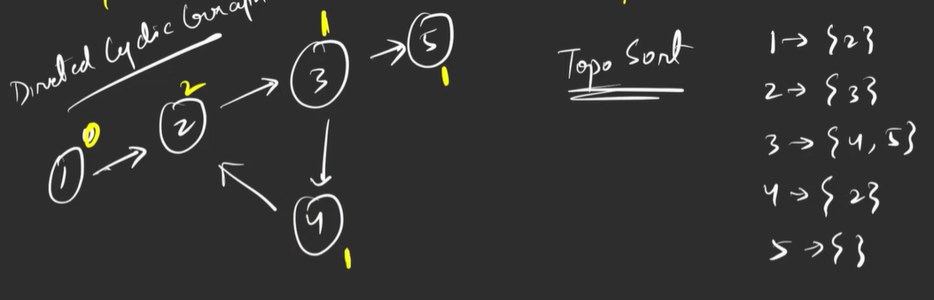

**This is indegree of nodes**

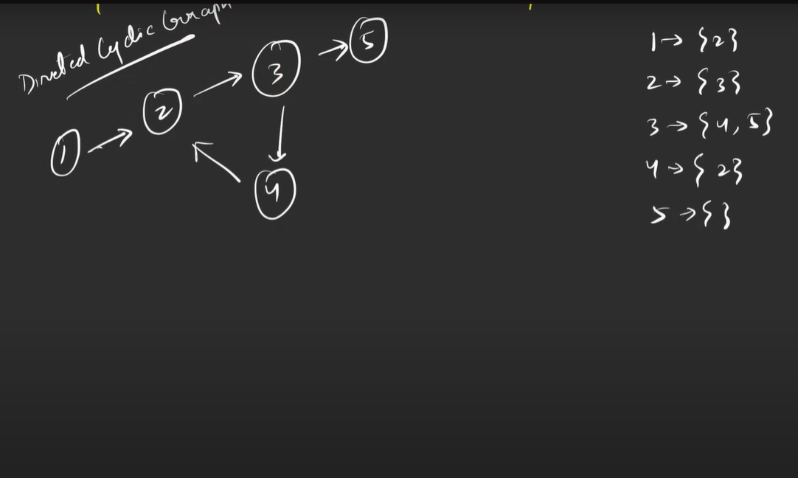

**If toposort.length != N then**

**Cycle**

**Else**

**No Cycle**

**Here after popping from front and reduce the indegree now we have not any future node with indegree is zero so that indicate there is cycle**



**🛠️ Approach (Step-by-Step)**

1. **Calculate indegree**
   * For each edge u → v, do indegree[v]++.
   * This tells how many edges point into each node.
2. **Initialize queue**
   * Push all nodes with indegree == 0 into a queue.
   * These are the starting points of toposort (no prerequisites).
3. **Process nodes (BFS)**
   * While queue is not empty:
     + Pop a node u, add it to the toposort (processedCount++).
     + For each neighbor v of u, decrement indegree[v]--.
     + If indegree[v] == 0, push v into queue.
4. **Check result**
   * If processedCount == N → all nodes included → **no cycle**.
   * If processedCount < N → some nodes could not be included → **cycle exists**.

**Code:**

**private int bfs(List<List<Integer>> adj, Queue<Integer> queue, int[] indegree, int[] res, int ind) // ✅ return new index {**

        while (!queue.isEmpty()) {

            // poll the front

            int src = queue.poll();

            res[ind++] = src;   // ✅ now safe, since ind starts from 0

            // visit the neighbour

            for (int i = 0; i < adj.get(src).size(); i++) {

                // reduce the indegree

                indegree[adj.get(src).get(i)]--;

                if (indegree[adj.get(src).get(i)] == 0)

                    queue.offer(adj.get(src).get(i));

            }

        }

        return ind; // ✅ return how many nodes were processed

**}**

    public boolean isCyclic(int N, List<List<Integer>> adj) {

        Queue<Integer> queue = new LinkedList<>();

        // find indegree

        int[] indegree = new int[N];

        for (int i = 0; i < adj.size(); i++) {

            for (int j = 0; j < adj.get(i).size(); j++) {

                indegree[adj.get(i).get(j)]++;

            }

        }

        for (int i = 0; i < N; i++) {

            if (indegree[i] == 0)

                queue.offer(i);

        }

        int[] res = new int[N];

        int processedCount = bfs(adj, queue, indegree, res, 0);

        return processedCount != N;

**}**

**Course Schedule I**

**Problem Statement:** There are a total of numCourses courses you have to take, labeled from 0 to numCourses - 1. You are given an array prerequisites where prerequisites[i] = [ai, bi] indicates that you must take course bi first if you want to take course ai.

* For example, the pair [0, 1], indicates that to take course 0 you have to first take course 1.

**For I:** Return true if you can finish all courses. Otherwise, return false.

**For II:** Return *the ordering of courses you should take to finish all courses*. If there are many valid answers, return **any** of them. If it is impossible to finish all courses, return **an empty array**.

**Example 1:**

**Input:** numCourses = 2, prerequisites = [[1,0]]

**Output:** true (for course schedule I)

**Explanation:** There are a total of 2 courses to take.

To take course 1 you should have finished course 0. So it is possible.

**Example 2:**

**Input:** numCourses = 4, prerequisites = [[1,0],[2,0],[3,1],[3,2]]

**Output:** [0,2,1,3] (for course schedule II)

**Explanation:** There are a total of 4 courses to take. To take course 3 you should have finished both courses 1 and 2. Both courses 1 and 2 should be taken after you finished course 0.

So one correct course order is [0,1,2,3]. Another correct ordering is [0,2,1,3].

**Solution:**

**🔑 Key idea (one-liner)**

Use Kahn’s algorithm (BFS/topological sort): if you can produce a topological ordering that contains all numCourses nodes, there is no cycle and you can finish every course. If the topological ordering has fewer nodes, some nodes are stuck in a cycle → cannot finish all courses.

DirectedGraphCycleDetectionBFS

**🧠 Intuition (why this works)**

* indegree[x] is the number of incoming edges to node x — think of it as the number of remaining prerequisites for course x.
* A node with indegree == 0 has no unmet prerequisites → it can be taken now. Once you “take” it, you remove its outgoing edges, which may reduce indegree of other nodes and free them up.
* If some set of nodes are in a cycle, every node in that cycle has at least one incoming edge from within the cycle — none of them ever reach indegree 0. They never enter the queue, so you never process them. Thus the processed count < numCourses indicates a cycle.

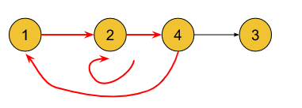

DirectedGraphCycleDetectionBFS

**🛠️ Approach**

1. **Step 1 — Build indegree array**
   * For every directed edge u → v, increase indegree[v]++.
   * This tells us how many prerequisites each node has.
2. **Step 2 — Initialize queue with indegree = 0 nodes**
   * Traverse through the indegree[] array.
   * Push every node with indegree[i] == 0 into the queue.
   * These nodes have **no incoming dependencies** → safe to process first.
3. **Step 3 — BFS processing (topological ordering)**
   * While queue is not empty:
     + Pop src = queue.poll().
     + Put it into the res[ind++] array (this builds topo order).
     + For each neighbor v of src:
       - Reduce indegree[v]--.
       - If indegree[v] == 0, push it into the queue.
   * This ensures we only process nodes **after their prerequisites are done**.
4. **Step 4 — Check cycle condition**
   * After BFS finishes:
     + If we successfully placed **all N nodes** into res[] (i.e., ind == N) → no cycle.
     + Else, if ind < N → some nodes could not be processed because their indegree never became 0 → **cycle exists**.

**For case II we have to return toposort**

**Code:**

private int bfs(List<List<Integer>> adj,int[] indegree,Queue<Integer> queue,int[] res)

{

        int cnt = 0;

        while (!queue.isEmpty()) {

            //pop the front

            int src = queue.poll();

            res[cnt] = src;

            cnt++;

            //visit 1 level neighbour

            for(int i=0;i<adj.get(src).size();i++)

            {

                --indegree[adj.get(src).get(i)];

                if(indegree[adj.get(src).get(i)] == 0)

                    queue.offer(adj.get(src).get(i));

            }

        }

        return cnt; // for case I return cnt and for case II return res(toposort)

**}**

**public boolean canFinish(int numCourses, int[][] prerequisites) {**

        //create an adjacentcy list

        List<List<Integer>> adj = new ArrayList<>();

        for(int i=0;i<numCourses;i++)

            adj.add(new ArrayList<>());

        //find an indegree

        int[] indegree = new int[numCourses];

        for(int[] edge : prerequisites ) {

            adj.get(edge[0]).add(edge[1]);

            ++indegree[edge[1]];

        }

        Queue<Integer> queue = new LinkedList<>();

        for(int i=0;i<numCourses;i++)        {

            if(indegree[i] == 0)

                queue.offer(i);

        }

        int[] res = new int[numCourses];

        return bfs(adj, indegree, queue,res) == numCourses ? true : false;

**}**

**Course Schedule 2**

**Problem Statement:** There are a total of numCourses courses you have to take, labeled from 0 to numCourses - 1. You are given an array prerequisites where prerequisites[i] = [ai, bi] indicates that you must take course bi first if you want to take course ai.

* For example, the pair [0, 1], indicates that to take course 0 you have to first take course 1.

Return *the ordering of courses you should take to finish all courses*. If there are many valid answers, return any of them. If it is impossible to finish all courses, return an empty array.

**Example 1:**

**Input:** numCourses = 2, prerequisites = [[1,0]]

**Output:** [0,1]

**Explanation:** There are a total of 2 courses to take. To take course 1 you should have finished course 0. So the correct course order is [0,1].

**Example 2:**

**Input:** numCourses = 4, prerequisites = [[1,0],[2,0],[3,1],[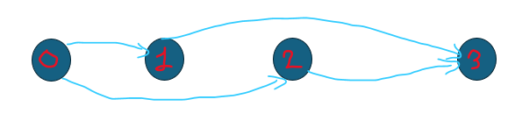

**Output:** [0,2,1,3]

**Explanation:** There are a total of 4 courses to take. To take course 3 you should have finished both courses 1 and 2. Both courses 1 and 2 should be taken after you finished course 0.

So one correct course order is [0,1,2,3]. Another correct ordering is [0,2,1,3].

**Example 3:**

**Input:** numCourses = 1, prerequisites = []

**Output:** [0]

**Solution:**

**🔑 Key idea**

Represent courses as nodes in a directed graph. A prerequisite pair [a, b] means a directed edge b → a.

Compute the indegree (number of incoming edges) for each node. Start with all nodes that have indegree 0 (no prerequisites). Repeatedly remove one indegree-0 node, append it to the result, and decrement indegree of its neighbors. If you process all nodes, you have a valid ordering; otherwise there’s a cycle and it’s impossible.

**💡 Intuition (Why this problem is graph + topo sort)**

Think of each course as a node.  
Each prerequisite [a, b] means edge b → a (you must complete b before a).

So we now have a directed graph.

* Some courses have no prerequisites → they can be taken immediately.
* Some courses depend on others → they can only be taken after their prerequisites are done.
* If there’s a cycle (e.g., course A needs B, and B needs A), you can never complete all → answer = [].

👉 This is exactly what topological sorting solves:  
It arranges nodes of a directed acyclic graph (DAG) such that every edge u → v means u comes before v.

**🧭 Approach (Step-by-Step Kahn’s Algorithm)**

**1. Build Graph**

* Use adjacency list adj.  
  For [a, b], add edge b → a.  
  → Meaning: If I complete b, then I can unlock a.

**2. Compute indegrees**

* indegree[x] = number of prerequisites for course x. here reverse compare to CourseSchedule1
* Example: if [3,1], [3,2], then indegree[3] = 2 because it needs both 1 and 2.

**3. Start with courses that have no prerequisites**

* Any course with indegree == 0 can be taken immediately.
* Put all such courses into a queue.

**4. Process using BFS**

* Pop a course from queue → add it to result order.
* For each neighbor (course dependent on this one), reduce its indegree--.
* If neighbor’s indegree becomes 0, it means all its prerequisites are completed → push it into queue.
* Repeat until queue is empty.

**5. Check cycle condition**

* If we processed exactly numCourses courses, success → return the result order.
* If not, it means some courses were never unlocked (they’re in a cycle) → return [].

**Code:**

**private int bfs(ArrayList<ArrayList<Integer>> adj,Queue<Integer> queue,int[] indegree,int[] res)    {**

        int ind=0;

        while (!queue.isEmpty()) {

            int src = queue.poll();

            res[ind++] = src;

            //reduce indegree for  first level depth

            for(int i=0;i<adj.get(src).size();i++)

            {

                --indegree[adj.get(src).get(i)];

                if(indegree[adj.get(src).get(i)] == 0)

                    queue.offer(adj.get(src).get(i));

            }

        }

        return ind;

**}**

**public int[] findOrder(int numCourses, int[][] prerequisites) {**

        ArrayList<ArrayList<Integer>> adj = new ArrayList<>();

        for(int i=0;i<numCourses;i++)

            adj.add(new ArrayList<>());

        //find the indegree

        int[] indegree = new int[numCourses];

        for(int[] edge : prerequisites)

        {

            ++indegree[edge[0]]; // here like [0,1] means first complete 1 then take 0 like reverse dependency

            adj.get(edge[1]).add(edge[0]);

        }

        Queue<Integer> queue = new LinkedList<>();

        for(int i=0;i<numCourses;i++)

        {

            if(indegree[i] == 0)

                queue.offer(i);

        }

        int[] res = new int[numCourses];

        return bfs(adj, queue, indegree, res) == numCourses ? res : new int[0];

**}**

**Alien Dictionary**

**Problem Statement:** You have been given a sorted (lexical order) dictionary of an alien language.

Write a function that returns the order of characters as a string in the alien language. This dictionary will be given to you as an array of strings called *'dictionary'*, of size *'N'*.

**Example 1:**

**Input:** N = 5, K = 4

dict = {"baa","abcd","abca","cab","cad"}

**Output**: b d a c

**Explanation:**

We will analyze every consecutive pair to find out the order of the characters.

The pair “baa” and “abcd” suggests ‘b’ appears before ‘a’ in the alien dictionary.

The pair “abcd” and “abca” suggests ‘d’ appears before ‘a’ in the alien dictionary.

The pair “abca” and “cab” suggests ‘a’ appears before ‘c’ in the alien dictionary.

The pair “cab” and “cad” suggests ‘b’ appears before ‘d’ in the alien dictionary.

So, [‘b’, ‘d’, ‘a’, ‘c’] is a valid ordering.

**Example 2:**

**Input:** N = 3, K = 3

dict = {"caa","aaa","aab"}

**Output**: c a b

**Explanation:** Similarly, if we analyze the consecutive pair for this example, we will figure out [‘c’, ‘a’, ‘b’] is a valid ordering.

**Solution:**

**🔑 Key idea**

* You are given a list of words sorted by an unknown alphabet. From this sorted list we **extract relative order constraints** between characters.
* Compare each adjacent pair of words s1 and s2: the **first position** where they differ tells you that char_in_s1 must come **before** char_in_s2 in the unknown alphabet.
* Collect all such relations as directed edges u -> v in a graph (u before v), then find a **topological order** of the graph. That topological order is a valid alphabet ordering (if it exists).
* If the graph has a **cycle**, or if you discover an invalid prefix case (e.g., s1 = "abcd" and s2 = "ab"), then a valid ordering does not exist.

**💡 Intuition (simple terms & why it works)**

* Think of each character as a task and an edge a -> b as “task a must happen before task b.”
* Comparing s1 and s2:
  + Walk characters left → right.
  + If at index j s1[j] != s2[j], you know s1[j] comes before s2[j] in the unknown alphabet. **Stop** there — later characters don’t matter for the order between s1 and s2.
  + If there's **no differing character** up to the length of the shorter word:
    - If s1.length() <= s2.length() → OK (no new info).
    - If s1.length() > s2.length() → **invalid** dictionary (longer word appears before its prefix) — no valid order.

Example pairwise intuition:

* s1 = "abcx", s2 = "abdy":
  + Compare index 0: a == a, index 1: b == b, index 2: c != d. So c -> d. We stop — x and y later are irrelevant for this pair.
* Prefix example:
  + s1 = "abcd", s2 = "ab": we've compared first len = min(4,2)=2 chars, all same. Since s1 is longer, s1 cannot appear before s2 in a valid lexicographic ordering — **invalid**.

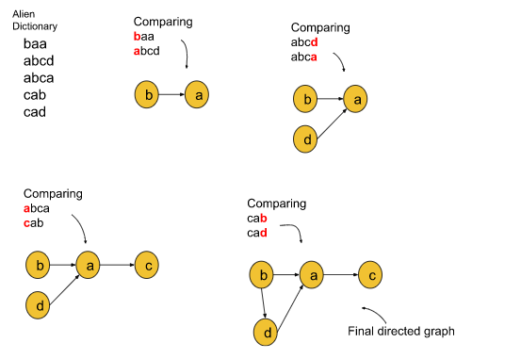

Here we sure about

**B before D**

Here we sure about

**A before C**

Here we sure about

**B before A**

Here we sure about

**D before A**



Once a graph is generated then we apply an topological sort

To further simplify the problem, we will denote the alphabet with numbers like: ‘a’ with 0, ‘b’ with 1, ‘c’ with 2, and so on. For example, if the letter is ‘z’, we will denote it using 25. Finally, the directed graph will look like the following illustration:

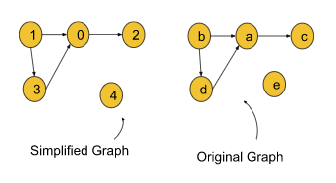

**🧭 Approach**

1. **Initialize**
   * Create adjacency list adj for k characters (0..k-1).
   * Maintain indegree[k] = {0}.
   * (Optional but recommended) Use edgeExists[u][v] (boolean matrix) or Set<Integer>[] to prevent adding duplicate edges and incorrectly incrementing indegree.
2. **Build graph by comparing adjacent words**
   * For each i from 0 to N-2:
     + s1 = dictionary[i], s2 = dictionary[i+1]
     + len = Math.min(s1.length(), s2.length()) ← **important** (fixes StringIndexOutOfBounds)
     + Loop j = 0..len-1:
       - If s1.charAt(j) != s2.charAt(j):
         * u = s1.charAt(j) - 'a', v = s2.charAt(j) - 'a'
         * If edge u->v not already recorded:

adj.get(u).add(v), indegree[v]++, mark edgeExists[u][v] = true

* + - * + break the inner loop (first difference is all we need)
    - After loop, if j == len (no difference found) and s1.length() > s2.length():
      * **Invalid** ordering → return "" (or whatever invalid marker the problem requires)

1. **Topological sort (Kahn’s algorithm)**
   * Initialize queue with all nodes x where indegree[x] == 0.
   * While queue not empty:
     + u = queue.poll()
     + append u to result order
     + for each v in adj.get(u):
       - indegree[v]--
       - if indegree[v] == 0 → queue.offer(v)
   * If result length != k → cycle exists → invalid → return ""
   * Else convert node indices to chars (e.g. (char)(node + 'a')) and return the string
2. **Edge cases & clarifications**
   * Characters not appearing in any word still must be included in final alphabet. They will have indegree 0 and end up in the result.
   * Multiple valid alphabets may exist — topological sort returns one possible valid order.
   * Prevent duplicate edges (or indegree will be inflated and break Kahn).
   * Use Math.min(...) for comparing lengths to avoid the runtime error you saw.

**Code:**

**static ArrayList<Integer> kahnTopoAlgo(ArrayList<ArrayList<Integer>> adj,int[] indegree,int k)    {**

        ArrayList<Integer> res = new ArrayList<>();

        Queue<Integer> queue = new LinkedList<>();

        for(int i=0;i<k;i++)

        {

            if(indegree[i] == 0)

                queue.offer(i);

        }

        while (!queue.isEmpty()) {

            int src = queue.poll();

            res.add(src);

            for(int i=0;i<adj.get(src).size();i++)

            {

                --indegree[adj.get(src).get(i)];

                if(indegree[adj.get(src).get(i)] == 0)

                    queue.offer(adj.get(src).get(i));

            }

        }

        return res;

**}**

**public static String getAlienLanguage(String []dictionary, int k) {**

        int N = dictionary.length;

        ArrayList<ArrayList<Integer>> adj = new ArrayList<>();

        int[] indegree = new int[k];

        for(int i=0;i<k;i++)

            adj.add(new ArrayList<>());

        for(int i=0;i<N-1;i++)

        {

            String s1 = dictionary[i];

            String s2 = dictionary[i+1];

            int len = Math.min(s1.length(), s2.length());

            for(int j=0;j<len;j++)

            {

                if(s1.charAt(j) != s2.charAt(j))

                {

                    // here we can say s1.charAt(j) comes before s2.charAt(j)

                    adj.get(s1.charAt(j) - 'a').add(s2.charAt(j) - 'a');

                    ++indegree[s2.charAt(j) - 'a'];

                    break;

                }

            }

        }

        String res = "";

        for(int it : kahnTopoAlgo(adj, indegree, k))

        {

            res = res + (char)(it + (int)'a');

        }

        return res;

**}**

**Shortest Path in Undirected Graph**

**Problem Statement:** Given an Undirected Graph having unit weight, find the shortest path from the source to all other nodes in this graph. In this problem statement, we have assumed the source vertex to be ‘0’. If a vertex is unreachable from the source node, then return -1 for that vertex.

**Example 1:**

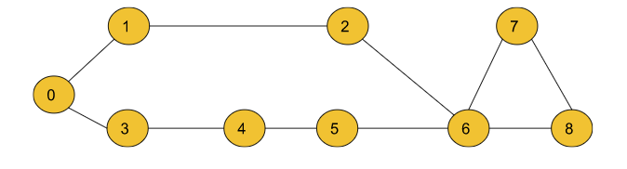

**Input**: n = 9, m = 10

edges = [[0,1],[0,3],[3,4],[4 ,5],[5, 6],[1,2],[2,6],[6,7],[7,8],[6,8]]

src=0

**Output:** 0 1 2 1 2 3 3 4 4

**Explanation:**

The above output array shows the shortest path to all

the nodes from the source vertex (0), Dist[0] = 0,

Dist[1] = 1 , Dist[2] = 2 , …. Dist[8] = 4

Where Dist[node] is the shortest path between src and

the node. For a node, if the value of Dist[node]= -1,

then we conclude that the node is unreachable from the src node.

**Example 2:**

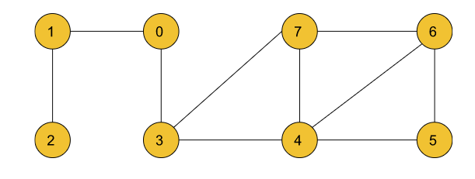

**Input:**

n = 8, m = 10

Edges =[[1,0],[2,1],[0,3],[3,7],[3,4],[7,4],[7,6],[4,5],[4,6],[6,5]]

src=0

**Output:** 0 1 2 1 2 3 3 2

**Explanation:**

The above output list shows the shortest path to all the

nodes from the source vertex (0), Dist[0] = 0,

Dist[1] = 1, Dist[2] = 2,.....Dist[7] = 2

**Solution:**

**🔑 Key Idea**

* In an **unweighted graph**, the **shortest path is determined only by the number of edges**, not by weights.
* **BFS (Breadth-First Search)** naturally explores the graph **level by level**:
  + Level 0 → source node
  + Level 1 → neighbors at distance 1
  + Level 2 → nodes at distance 2 … and so on.
* So, BFS ensures the **first time we reach a node → it’s the shortest distance** from the source.

✅ **Simplest Reason (one-liner):**  
We use **BFS** for the shortest path in an **unweighted graph** because **BFS explores level by level**. The first time we reach a node, it is guaranteed to be via the shortest path.

❌ **DFS fails** because it goes **deep first** and may reach a node with a longer path before discovering the shorter one.

🔹 **Think like this (real-world example):**

* Imagine you want to find the shortest number of stops to reach a bus station.
* **BFS** = you check *all nearby stations (level 1)*, then *all stations reachable with 2 stops (level 2)*, and so on. The first time you reach your destination, that’s the shortest path.
* **DFS** = you just keep taking one bus route until you get far, maybe reaching the destination after 10 stops. Later, you might realize there was a direct 2-stop route — but DFS already "committed" to going deep.

**💡 Intuition**

Think about this like **ripples in water** 🌊:

* You drop a stone at the source node.
* The ripples spread outward evenly in all directions.
* Each ripple layer corresponds to +1 distance.
* The moment a ripple touches a node → that’s the **shortest path** to it (since no smaller ripple could have reached earlier).

👉 Compare BFS vs DFS here:

* **BFS (Good for shortest path):** Always expands outward level by level, guaranteeing minimal distance.
* **DFS (Not good for shortest path):** Goes deep along one path, might reach a far node first, even though a shorter path exists.

**🛠️ Approach (Step by Step)**

**1️⃣ Initialization**

* Create a distance array shortPath[], fill with ∞ (unreachable).
* Set shortPath[src] = 0 because the source is distance 0.
* Use a queue to manage BFS order.

int[] shortPath = new int[adj.size()];

Arrays.fill(shortPath, Integer.MAX_VALUE);

shortPath[src] = 0;

Queue<Pair> queue = new LinkedList<>();

queue.offer(new Pair(src, 0));

**2️⃣ BFS Traversal**

* While the queue is not empty:
  + Pop a node.
  + For each neighbor:
    - If not visited → assign distance = parentDist + 1.
    - Push into queue.



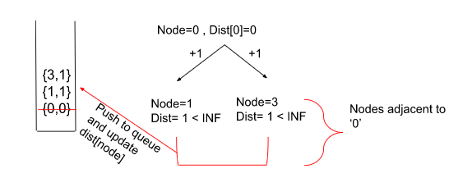



👉 Why does this work?

* Because the **first time we assign distance to a node, it’s guaranteed shortest** (since BFS goes level by level).

**3️⃣ Handle Unreachable Nodes**

* After BFS, if any node is still ∞, mark it as -1.
* This way, we clearly differentiate reachable vs unreachable nodes.

for (int i = 0; i < adj.size(); i++) {

if (shortPath[i] == Integer.MAX_VALUE) {

shortPath[i] = -1;

}

}

**🔍 Example Dry Run**

Graph:

0 -- 1 -- 3 -- 4

\

2

* Start: src = 0
* Initial: dist = [0, ∞, ∞, ∞, ∞]

➡️ BFS Waves:

* From 0 → set dist[1] = 1, dist[2] = 1
* From 1 → set dist[3] = 2
* From 3 → set dist[4] = 3

✅ Final dist = [0, 1, 1, 2, 3]

**Code:**

class Pair{

    int node,dist;

    Pair(int node,int dist)

    {

*this*.node = node;

*this*.dist = dist;

    }

}

public class ShortestPathUG {

    public int[] shortestPath(ArrayList<ArrayList<Integer>> adj, int src) {

        int[] shortPath = new int[adj.size()];

        Arrays.fill(shortPath, Integer.MAX_VALUE);

        //create an Queue

        Queue<Pair> queue = new LinkedList<>();

        //push the src

        queue.offer(new Pair(src, 0));

        shortPath[src] = 0;

        while (!queue.isEmpty()) {

            Pair pair = queue.poll();

            //visit node first level neighbour

            for(int i=0;i<adj.get(pair.node).size();i++)

            {

                int adjacent = adj.get(pair.node).get(i);

                if((shortPath[adjacent] == Integer.MAX_VALUE) || (shortPath[adjacent] > pair.dist + 1))

                {

                    shortPath[adjacent] = pair.dist + 1;

                    queue.offer(new Pair(adjacent, shortPath[adjacent]));

                }

            }

        }

        // Replace unreachable nodes with -1

        for (int i = 0; i < adj.size(); i++) {

            if (shortPath[i] == Integer.MAX_VALUE) {

                shortPath[i] = -1;

            }

        }

        return shortPath;

    }

}

**Shortest Path in DAG**

**Problem Statement:** Given a Directed Acyclic Graph of V vertices from 0 to n-1 and a 2D Integer array(or vector) edges[ ][ ] of length E, where there is a directed edge from edge[i][0] to edge[i][1] with a distance of edge[i][2] for all i.

Find the shortest path from src(0) vertex to all the vertices and if it is impossible to reach any vertex, then return -1 for that vertex.

**Example 1:**

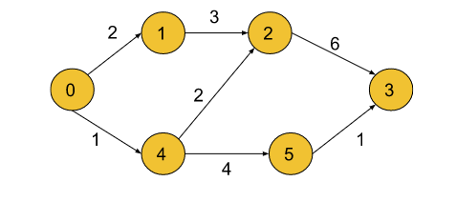

**Input:** n = 6, m= 7

**edges =** [[0,1,2],[0,4,1],[4,5,4],[4,2,2],[1,2,3],[2,3,6],[5,3,1]]

**Output:** 0 2 3 6 1 5

**Explanation:** The above output list shows the shortest path to all the nodes from the source vertex (0),

Dist[0] = 0  Dist[1] = 2  Dist[2] = 3  Dist[3] = 6

Dist[4] = 1 Dist[5] = 5

**Example – 2**

**Input:** V = 4, E = 2, edges = [[0,1,2], [0,2,1]]

**Output:** [0, 2, 1, -1] **Explanation:** Shortest path from 0 to 1 is 0->1 with edge weight 2. Shortest path from 0 to 2 is 0->2 with edge weight 1. There is no way we can reach 3, so it's -1 for 3.

**Solution:**

**🎯 Key idea (short)**

* A **DAG** has no cycles, so we can order nodes so every node appears **after** all its predecessors.
* Process nodes in that **topological order** and relax each outgoing edge once — that gives correct shortest paths in **one pass**.
* Do **not** use plain BFS: BFS only guarantees shortest paths when **every edge has equal weight** (unweighted graphs).

**🧠 Intuition (very simple)**

* Think: “**Do prerequisites first.**”  
  If A → B, compute A before B so B can use A’s final shortest distance.
* Topological sort gives that “prerequisite” order. When you relax edges in that order, every update is final.

**⚠️ Why *not* simple BFS (like in undirected, unweighted graphs)**

* **BFS** works when every edge weight = 1. Then the first time you visit a node, that’s the shortest path (level-by-level).
* In a **weighted DAG** edges have different weights. The first path you see to a node might not be the shortest.  
  If you treat “first visit = final” (like BFS usually does), you can get wrong answers.

**🧪 Example that shows BFS *can* fail (simple to remember)**

Graph (directed):

0 → 1 (weight 5)

0 → 2 (weight 2)

2 → 1 (weight 1)

* Shortest to 1 is via 2: 0 → 2 → 1 = 2 + 1 = 3 (correct answer = 3).
* If BFS enqueues neighbor 1 before 2 and marks it visited, you lock 1 at 5 and never update to 3 → wrong.
* **Conclusion:** BFS’s “first visit is final” assumption breaks when weights differ.

(If you *allow* re-updating and re-enqueueing when you find a better distance, you essentially move toward Bellman-Ford / Dijkstra-like behavior — but then you lose BFS’s guarantees & simplicity. Topo + single pass is cleaner for DAG.)

**✅ Why topological sort is perfect for DAGs**

* Topological order guarantees: for any edge u → v, u appears **before** v.
* So when we process u, we have the final shortest distance to u. We relax u → v, and that candidate distance for v is valid.
* Because all predecessors of v were already processed, after the single pass v’s distance is final. No re-processing needed.

**🛠️ The practical detail you must include (very important)**

When you relax edges, **always check** that the source node's distance is not Integer.MAX_VALUE (i.e., not unreachable).  
If you skip this check, adding a weight to Integer.MAX_VALUE will overflow and produce negative garbage numbers like -2147483643.

**✔️ The required if condition:**

// only relax if src already has a finite distance

if (shortPath[src] != Integer.MAX_VALUE &&

shortPath[adj.dest] > shortPath[src] + adj.weight) {

shortPath[adj.dest] = shortPath[src] + adj.weight;

}

* 🔁 shortPath[src] != Integer.MAX_VALUE prevents overflow.
* ⚠️ Without it, Integer.MAX_VALUE + w wraps negative and breaks comparisons.

**🛠️ Approach (Step-by-Step with DFS Toposort)**

**🧩 Step 1: Build the Graph**

We create an adjacency list of pairs (destination, weight):

adj.get(u).add(new Pair(v, weight));

📘 Each node stores where it leads and the cost to reach there.

**🌲 Step 2: Perform Topological Sort (Using DFS)**

**Goal:** Find an order of nodes such that  
each node appears **after all its incoming neighbors** are processed.

**⚙️ DFS Process:**

1. Keep a visited[] array to avoid revisiting nodes.
2. For each node i:
   * If not visited → call toposort(i).
   * Inside toposort:
     + Mark node as visited.
     + Recursively call for all unvisited neighbors.
     + Push the node into a **stack** (after visiting all its neighbors).

🧱 Why push at the end?  
Because nodes with no dependencies come first (bottom of the stack).

✅ After this step, the **stack** holds the nodes in **topological order** (top → last dependency).

**🚀 Step 3: Initialize Distances**

int[] shortPath = new int[V];

Arrays.fill(shortPath, Integer.MAX_VALUE);

shortPath[0] = 0; // source node = 0

📘 All nodes are initially unreachable (∞), except the source (0 distance).

**⚡ Step 4: Process Nodes in Topological Order**

While stack not empty:

1. Pop the top node (say src).
2. **Only process if reachable:**
3. if (shortPath[src] != Integer.MAX_VALUE)

👉 This check prevents overflow like Integer.MAX_VALUE + weight (which becomes negative).

1. Relax all its neighbors:
2. if (shortPath[dest] > shortPath[src] + weight) {
3. shortPath[dest] = shortPath[src] + weight;
4. }

📘 Meaning:  
If the new distance (via current node) is smaller → update it.

**🧾 Step 5: Replace Unreachable Nodes**

After relaxation:

for (int i = 0; i < V; i++) {

if (shortPath[i] == Integer.MAX_VALUE)

shortPath[i] = -1;

}

📘 This means: -1 represents nodes that cannot be reached from the source.

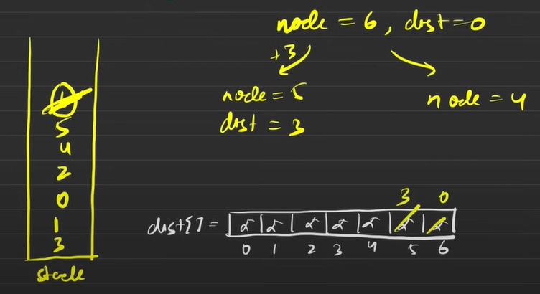



**Code:**

**class Pair{**

    int weight,dest;

    Pair(int dest,int weight)

    {

*this*.dest = dest;

*this*.weight = weight;

    }

**}**

**private void toposort(ArrayList<ArrayList<Pair>> adj,Stack<Integer> stack,boolean[] visited,int src)**

**{**

        //mark as visited

        visited[src] = true;

        //visit it all neighbour

        for(int i=0;i<adj.get(src).size();i++)

        {

            int adjacent = adj.get(src).get(i).dest;

            if(!visited[adjacent])

                toposort(adj,stack, visited, adjacent);

        }

        //push the src into stack

        stack.push(src);

**}**

**public int[] shortestPath(int V, int E, int[][] edges) {**

        // for int[][] edges

        //where there is a directed edge from edge[i][0] to edge[i][1] with a distance of edge[i][2] for all i.

        int[] shortPath = new int[V];

        Arrays.fill(shortPath, Integer.MAX_VALUE);

        //create an adjacency List

        ArrayList<ArrayList<Pair>> adj = new ArrayList<>();

        for(int i=0;i<V;i++)

   adj.add(new ArrayList<>());

        for(int i=0;i<E;i++)

        {

            int src = edges[i][0];

            int dest = edges[i][1];

            int weight = edges[i][2];

            adj.get(src).add(new Pair(dest, weight));

        }

        Stack<Integer> stack = new Stack<>();

        boolean[] visited = new boolean[V];

        for(int i=0;i<V;i++)

        {

            if(!visited[i])

                toposort(adj, stack, visited, i);

        }

        shortPath[0] = 0;

        while (!stack.isEmpty()) {

            int src = stack.pop();

            if (shortPath[src] != Integer.MAX_VALUE) {

                for(int i=0;i<adj.get(src).size();i++)

                {

                    Pair adjacentPair = adj.get(src).get(i);

                    if(shortPath[adjacentPair.dest] > (shortPath[src] + adjacentPair.weight))

                    {

                        shortPath[adjacentPair.dest] = shortPath[src] + adjacentPair.weight;

                    }

                }

            }

        }

        for(int i=0;i<V;i++)

        {

            if(shortPath[i] == Integer.MAX_VALUE)

                shortPath[i] = -1;

        }

        return shortPath;

**}**

**Dijkstra Algorithm Priority Queue**

**Problem Statement:** Given a weighted, undirected, and connected graph of V vertices and an adjacency list adj where adj[i] is a list of lists containing two integers where the first integer of each list j denotes there is an edge between i and j, second integers corresponds to the weight of that edge. You are given the source vertex S and You have to Find the shortest distance of all the vertex from the source vertex S. You have to return a list of integers denoting the shortest distance between each node and Source vertex S.

Note: The Graph doesn’t contain any negative weight cycle

**Example -1:**

**Input:**

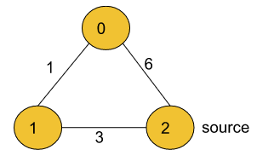

V = 3, E = 3

adj = {{{1, 1}, {2, 6}}, {{2, 3}, {0, 1}}, {{1, 3}, {0, 6}}}

S = 2

**Output:** 4 3 0

**Explanation:**

For nodes 2 to 0, we can follow the path 2-1-0.

This has a distance of 1+3 = 4, whereas the path 2-0

has a distance of 6. So, the Shortest path from 2 to 0 is 4.

The shortest distance from 0 to 1 is 1.

**Solution:**

**💡 Real-World Scenario (Easy to Remember)**

Imagine you're using **Google Maps** 🚗 to find the shortest route from your home 🏠 to every place in your city.  
At each step, you always check **which place is closest so far** (smallest travel time) — not the one you *added first*.

👉 A **Priority Queue** helps the algorithm behave exactly like that —  
it always picks the **next nearest city (node)** to explore.  
A **normal queue (FIFO)** would check places in the order they were discovered, not by distance — and that can lead to wrong routes. ❌

**🔑 Key Idea**

Dijkstra’s algorithm is a **greedy algorithm**.  
At each step, it selects the **node with the smallest known distance** and finalizes it — meaning, once that node is processed, its shortest distance won’t change.

So we need a data structure that can:

* 📦 Keep all nodes we’ve discovered
* ⬇️ Quickly give us the one with **minimum distance**  
  ➡️ That’s why we use a **Priority Queue (Min Heap)** instead of a normal queue.

**🧠 Intuition (Think Like a Human GPS)**

Imagine 3 cities connected like this:

A --10--> B

A --3--> C

C --4--> B

If you start from A:

* You first see B (cost 10) and C (cost 3).
* The **closest** city is C, not B.  
  👉 So visit C first.
* From C, you find a better route to B (3 + 4 = 7).
* If you used a **simple queue**, you’d visit B first (cost 10) before discovering the shorter route via C. ❌

So:  
🧭 **Priority Queue ensures we always move along the shortest path known so far.**

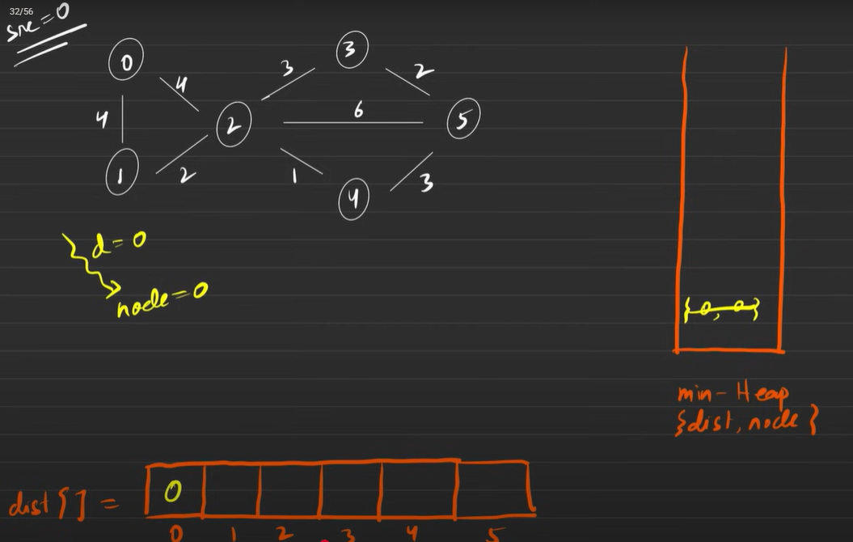



**To reach 1 node  
distance = 0(distance till src) + 4(weight) = 4  
and**

**If(dist[1] > distance)**

**Update dist[1] & push**



**⚙️ Approach (Step-by-Step with Icons)**

**🧱 Step 1: Build Adjacency List**

Create a graph structure from all edges so that for every node, you can access its neighbors easily.  
📘 adj.get(u).add(new Pair(v, w));

**🎯 Step 2: Initialize Distances**

Create a distance array (like a travel-time table 🗺️) and fill it with ∞ (Integer.MAX_VALUE).  
Set the distance of the **source** node to 0 because it’s our starting point.  
💬 shortestPath[src] = 0;

**⚡ Step 3: Create Priority Queue**

Use a **min-heap priority queue** that sorts nodes by their current shortest distance.  
PriorityQueue<Pair> pq = new PriorityQueue<>((x,y) -> x.weight - y.weight);  
📦 Add (src, 0) → source node with distance 0.

**🏁 Step 4: Process Nodes in Order of Minimum Distance**

While the queue isn’t empty:

* Pick the node with **smallest distance** (pq.poll() 🎯)
* That node’s distance is now *finalized*.

**🔁 Step 5: Relax Edges (Explore Neighbors)**

For each neighbor:

* Check if going through the current node gives a **shorter path**.
* If yes, **update** and push that neighbor back into the PQ with the new smaller distance.  
  💬 if(shortestPath[v] > distance + weight) { update; pq.offer(new Pair(v, newDist)); }

**✅ Step 6: Repeat Until Queue is Empty**

When the queue is empty, every node’s shortest path is finalized.  
You now have the shortest distance from the source to all nodes.

**Code:**

**class Pair{**

    int node,weight;

    Pair(int node,int weight)

    {

*this*.node = node;

*this*.weight = weight;

    }

**}**

**public class DijkstraPriorityQueue {**

    public int[] dijkstra(int V, int[][] edges, int src) {

        //create adjacent List

        ArrayList<ArrayList<Pair>> adj = new ArrayList<>();

        for(int i=0;i<V;i++)

        {

            adj.add(new ArrayList<>());

        }

        for(int i=0;i<edges.length;i++)

        {

            int u = edges[i][0];

            int v = edges[i][1];

            int w = edges[i][2];

            adj.get(u).add(new Pair(v, w));

        }

        int[] shortestPath = new int[V];

        Arrays.fill(shortestPath, Integer.MAX_VALUE);

        PriorityQueue<Pair> pQueue = new PriorityQueue<Pair>((x,y) ->  x.weight - y.weight);

        pQueue.offer(new Pair(src, 0));

        shortestPath[src] = 0;

        while (!pQueue.isEmpty()) {

            Pair pair = pQueue.poll();

            int source = pair.node;

            int distance = pair.weight;

            //visit first level adjacent

            for(int i=0;i<adj.get(source).size();i++)

            {

                Pair adjacentPair = adj.get(source).get(i);

                if(shortestPath[adjacentPair.node] > (distance + adjacentPair.weight))

                {

                    shortestPath[adjacentPair.node] = distance + adjacentPair.weight;

                    pQueue.offer(new Pair(adjacentPair.node, shortestPath[adjacentPair.node]));

                }

            }

        }

        return shortestPath;

    }

**}**

**Why Priority Queue instead of Simple Queue**

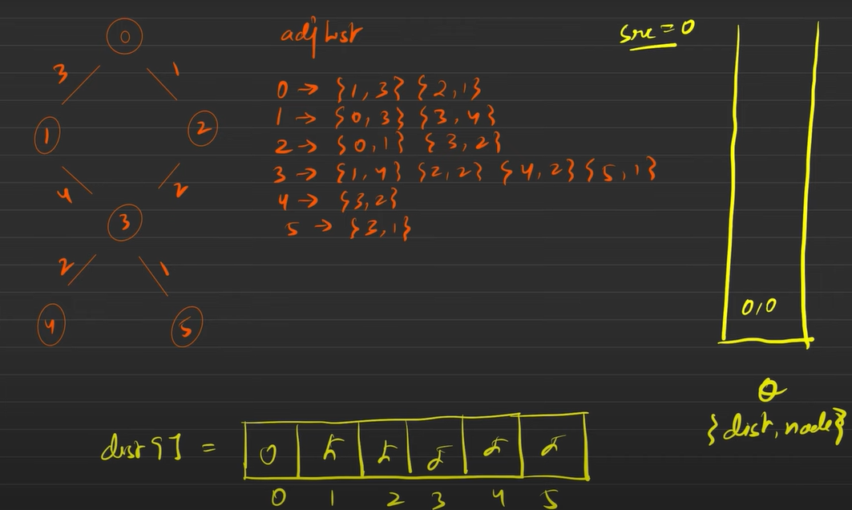

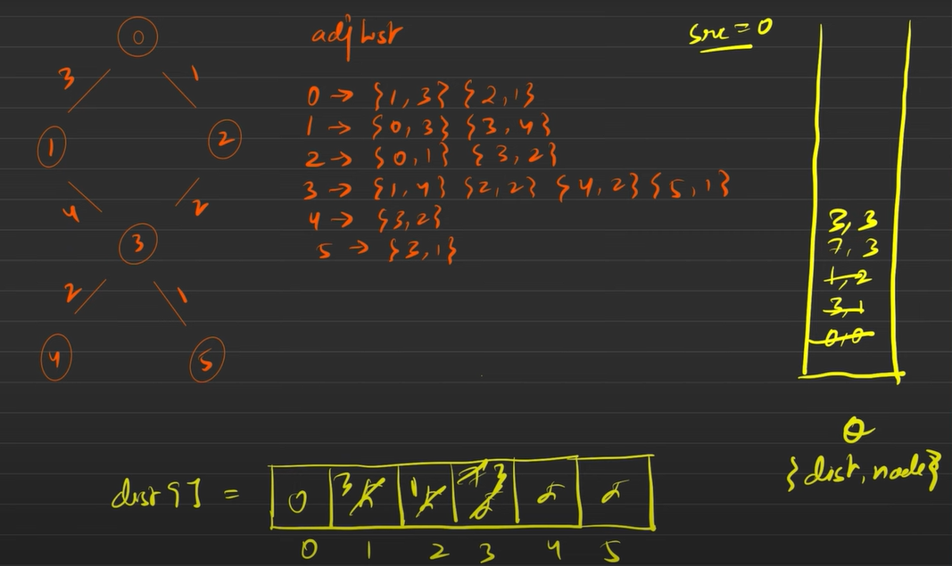



**Here {7(dist),3(node)} explore first although we have an shorter version to reach node 3 due to simple Queue**

**Using Priority Queue (min Heap) we always explore shorter distance first so here we explore {3(dist),3(node)} and this is shorter so rest of other connected node ‘s distance is also shorter as compare to {7,3}**



**⚙️ Case 1: If We Use a Simple Queue (like BFS)**

Let’s simulate step-by-step 👇

**🧱 Step 1: Start from source**

Queue: {0}  
dist = [0, ∞, ∞, ∞, ∞, ∞]

**🏁 Step 2: Visit all neighbors of 0**

From 0 we can go to:

* 1 with cost 3
* 2 with cost 1

So we push them **in discovery order** (FIFO):  
Queue → {1, 2}  
dist → [0, 3, 1, ∞, ∞, ∞]

**⚠️ Step 3: Process node 1 next (since it was pushed first)**

From 1, you can go to:

* 3 with cost 4  
  Total cost via path 0 → 1 → 3 = **3 + 4 = 7**

So, dist for node 3 becomes **7**  
Queue → {2, 3}  
dist → [0, 3, 1, 7, ∞, ∞]

**🚨 Step 4: Now process node 2**

From 2, you can go to:

* 3 with cost 2  
  Total cost via path 0 → 2 → 3 = **1 + 2 = 3**

That’s **a shorter path to 3**! ✅  
But notice what happened:  
We already pushed (3) earlier into the queue with cost 7.

So, when we now find a better distance (3), we’ll have to either:

* Reorder the queue manually (hard with a simple queue), or
* Keep (3) twice and process both (inefficient).

This is where the **Simple Queue fails** — it doesn’t automatically reorder by smallest distance.

**💥 Problem:** The Simple Queue processes nodes in the order they were *discovered*, not in order of *minimum distance*.  
So node 3 (with distance 7) gets processed **before** we discover the shorter route (3).  
That leads to **extra processing** or even **wrong results** if you finalize too early.

**🧠 Case 2: Using a Priority Queue (Min-Heap)**Let’s repeat with a **Priority Queue** that sorts by distance.

**🧱 Step 1: Start**

PQ = {(0,0)}  
dist = [0, ∞, ∞, ∞, ∞, ∞]

**🏁 Step 2: Pop (0,0) → Visit its neighbors**

Add (1,3) and (2,1)  
PQ = {(2,1), (1,3)}  
dist = [0, 3, 1, ∞, ∞, ∞]

✅ The PQ keeps them sorted by smallest distance automatically.

**⚡ Step 3: Pop (2,1) next (because 1 < 3)**

Now check neighbors of 2:

* For node 3 → new distance = 1 + 2 = 3  
  Push (3,3) into PQ.  
  PQ = {(3,3), (1,3)}

dist = [0, 3, 1, 3, ∞, ∞]

**🎯 Step 4: Pop (3,3) next**

Because it has the **smallest distance**.  
Now all further relaxations from node 3 will be based on **the true shortest path**.

**🌈 Conclusion (Intuition Recap)**

| **Queue Type** | **Order of Processing** | **Result** |
| --- | --- | --- |
| 🧺 Simple Queue (FIFO) | Based on discovery order | ❌ May process longer paths first |
| 🪜 Priority Queue (Min-Heap) | Based on smallest distance | ✅ Always correct,fast |

**Print the shortest Path**

**Problem Statement:** 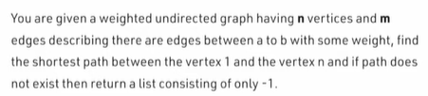

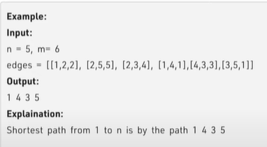

**Solution:**

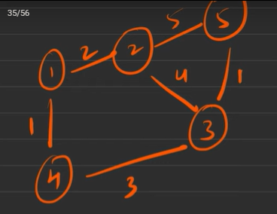

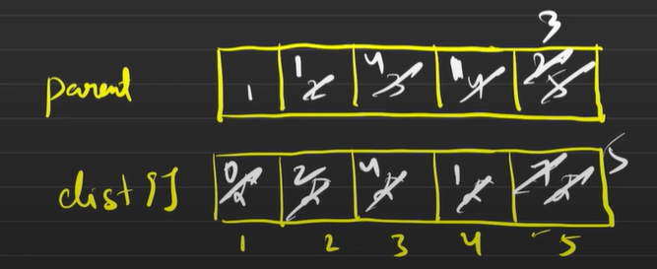

**💡 Key Idea — Parent Array in Dijkstra’s Algorithm**

🧭 **Core Concept:**  
The **parent array** is used to **remember the path** we took to reach each node in the shortest way possible.

When Dijkstra’s algorithm updates a distance for a node (because we found a smaller one), it also records **where we came from**.  
That "where we came from" is stored in the **parent array**.

**🔑 Example:**

If you found that  
👉 distance[3] can be minimized by going through node 2,  
then you write:

parent[3] = 2;

So later, when you want to **reconstruct the shortest path**,  
you just trace back:

n → parent[n] → parent[parent[n]] → ... → 1

**🧠 Intuition — Why We Need the Parent Array**

✨ Imagine you are navigating a map from **city 1 to city n**.  
Every time you find a **shorter route** to a city, you not only record the **new shortest distance**, but also **who guided you** there.

* Think of each node as a **checkpoint**.
* The parent[] array works like a **breadcrumb trail** — marking which checkpoint you came from.

So once Dijkstra finishes:

1. You already have the **shortest distances** to all nodes.
2. You can **follow the parent chain backward** from destination to source to build the exact path.

**⚙️ Approach (Step-by-Step)**

**🪄 Step 1: Initialization**

* Create an adjacency list to store graph edges.
* Set shortestPath[i] = ∞ for all nodes.
* Set parent[i] = i for the source node (means “I came from myself”).
* Push (source, 0) into a **priority queue** (min-heap).

**🚦 Step 2: Relaxation (Main Dijkstra Loop)**

* While priority queue is not empty:
  1. Pick the node with the **smallest distance**.
  2. For each of its neighbors:
     + If going through the current node gives a **smaller distance**,  
       ➤ update the distance  
       ➤ record the current node as the **parent** of that neighbor  
       ➤ push that neighbor into the queue with the new distance

**🧭 Step 3: Path Reconstruction**

* Start from node = n
* Repeatedly follow the chain node = parent[node]
* Stop when you reach the source (where parent[node] == node)
* Reverse the list to get the path from 1 → n

**🏁 Step 4: Output Format**

Finally, the problem requires:

[ totalWeight, node1, node2, ..., nodeN

**Code:**

**class Pair {**

  int node,weight;

    Pair(int node,int weight)    {

*this*.node = node;

*this*.weight = weight;

    }

**}**

**private void dijkstra(ArrayList<ArrayList<Pair>> adj,int src,int[] shortestPath,int[] parent)    {**

        //create an Priority Queue

        PriorityQueue<Pair> pQueue = new PriorityQueue<>((x,y)-> x.weight - y.weight);

        pQueue.add(new Pair(src, 0));

        shortestPath[src] = 0;

        parent[src] = src;

        while (!pQueue.isEmpty()) {

            Pair pair = pQueue.poll();

            int source = pair.node;

            int distance = pair.weight;

            for(int i=0;i<adj.get(source).size();i++)

            {

                Pair adjacentPair = adj.get(source).get(i);

                if(shortestPath[adjacentPair.node] > (distance + adjacentPair.weight))

                {

                    //here i found shortest path like where i coming from

                    //here we need to update the parent of adjacent

                    parent[adjacentPair.node] = source;

                    shortestPath[adjacentPair.node] = (distance + adjacentPair.weight);

                    pQueue.offer(new Pair(adjacentPair.node, shortestPath[adjacentPair.node]));

                }

            }

        }

**}**

**public List<Integer> shortestPath(int n, int m, int edges[][]) {**

        ArrayList<Integer> path = new ArrayList<>();

        int[] shortestPath = new int[n+1];

        int[] parent = new int[n+1];

        //create an Adjacency List

        ArrayList<ArrayList<Pair>> adj = new ArrayList<>();

        for(int i=0;i<=n;i++)

        {

            adj.add(new ArrayList<>());

            shortestPath[i] = Integer.MAX_VALUE;

        }

        for(int i=0;i<m;i++)

        {

            int src = edges[i][0];

            int dest = edges[i][1];

            int weight = edges[i][2];

            adj.get(src).add(new Pair(dest, weight));

            adj.get(dest).add(new Pair(src, weight));

        }

        dijkstra(adj, 1, shortestPath, parent);

        if(shortestPath[n] == Integer.MAX_VALUE)

        {

            path.add(-1);

            return path;

        }

        int node = n;

        while (parent[node] != node) {

            path.add(0, node);

            node = parent[node];

        }

        //insert src

        path.add(0, 1);

        return path;

**}**

**Shortest Distance in a Binary Maze**

**Problem Statement:** Given an n x n binary matrix grid, return *the length of the shortest clear path in the matrix*. If there is no clear path, return -1.

A clear path in a binary matrix is a path from the top-left cell (i.e., (0, 0)) to the bottom-right cell (i.e., (n - 1, n - 1)) such that:

* All the visited cells of the path are 0.
* All the adjacent cells of the path are 8-directionally connected (i.e., they are different and they share an edge or a corner).

The length of a clear path is the number of visited cells of this path.

**Example 1:**

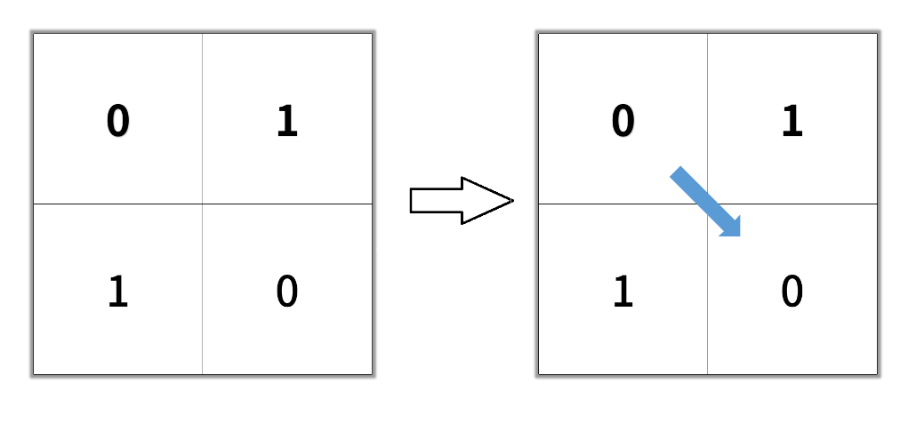

**Input:** grid = [[0,1],[1,0]] **Output:** 2

**Example 2:**

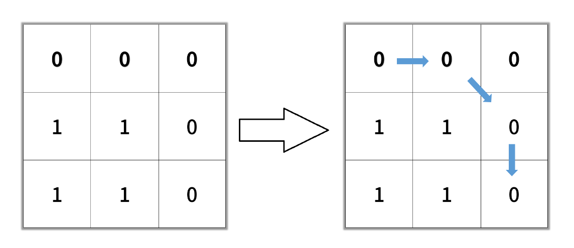

**Input:** grid = [[0,0,0],[1,1,0],[1,1,0]] **Output:** 4

**Solution:**

**🧠 Key Idea**

The main idea is to treat the **binary matrix as a weighted graph** where:

* Each cell is a **node**.
* Each valid movement to a neighbor (in 8 directions) represents an **edge** with weight **1**.

Now, our objective becomes:

**Find the minimum cost (distance)** to travel from the top-left node (0,0) to the bottom-right node (n-1, n-1).

This is conceptually similar to **Dijkstra’s algorithm**, where we always choose the **next cell with the smallest current distance** and then relax its neighbors.

However, since each edge here has the same weight (1), this can also be thought of as a **Breadth-First Search (BFS)** — which spreads level by level — naturally ensuring that the **first time we visit a cell, it’s via the shortest path**.

**💡 Intuition**

Let’s break down the thought process behind the algorithm intuitively 👇

**🧩 1. Visualizing the Grid as a Network**

Imagine every 0 cell as an **intersection (node)** and every move to an adjacent cell as a **road (edge)** of equal cost (1 unit distance).  
Our task is to travel from the **top-left intersection** to the **bottom-right** through the open roads only.

If there were only four directions (up, down, left, right), this would already resemble BFS traversal on a 2D matrix.  
But here, we have **8 directions**, which means more potential paths — diagonals included — making the search broader and faster in many cases.

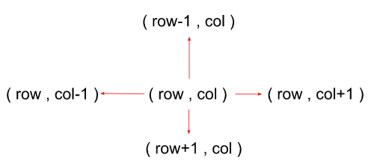

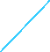

**⚖️ 2. Why We Use a Distance Matrix**

The shortestPath[][] array keeps track of the **minimum distance** to reach each cell.

Initially, we set all distances to infinity (Integer.MAX_VALUE), meaning no cell is reachable yet.  
When we find a path to a new cell that’s **shorter than what we knew before**, we update it.

This concept is called **relaxation**, just like in Dijkstra’s algorithm

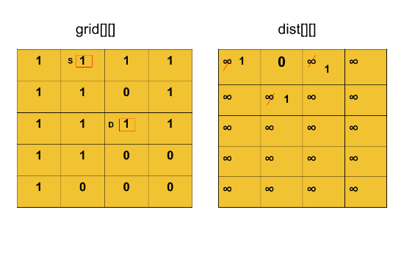

**🚦 3. Role of Priority Queue**

The **priority queue (min-heap)** ensures that the cell with the **smallest current distance** is processed first.  
This is important because:

* Once we pop a cell from the queue, we know we have already found the **shortest path** to that cell.
* Then, we “relax” its 8 neighboring cells (check if we can reach them faster through the current one).

So, the algorithm keeps expanding in **rings of increasing distance**, similar to how ripples expand outward in water when you drop a stone.

**🎯 4. Reaching the Destination**

When the bottom-right cell (n-1, n-1) is popped from the queue, it means:

* We’ve found the minimum distance to reach it.
* Any other possible route would be equal or longer.

Hence, we can **immediately return the distance** when we reach that cell.

**⚙️ Approach (Step-by-Step Based on Code)**

**🔹 Step 1: Initialize Required Data Structures**

* We define two arrays, drow and dcol, to represent the **8 possible directions** we can move in a grid (up, down, left, right, and 4 diagonals).
* int[] drow = {-1,0,1,0,-1,-1,1,1};
* int[] dcol = {0,1,0,-1,-1,1,1,-1};

➤ This helps us easily move to all neighbors of any given cell.

* We create a **Priority Queue (Min-Heap)** that stores (row, col, weight) where
  + row, col → cell position
  + weight → current distance (steps taken so far)
* PriorityQueue<Pair> pQueue = new PriorityQueue<>((x, y) -> x.weight - y.weight);

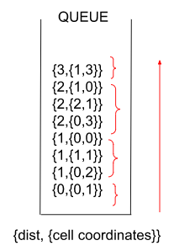



**🔹 Step 2: Push the Starting Point**

* We check if the **top-left cell** (0,0) is open (i.e., grid[0][0] == 0).
  + If yes, we push it into the queue with distance 0.
  + Also, set shortestPath[0][0] = 0 to mark that distance to start cell is zero.
* if(grid[0][0] == 0)
* {
* pQueue.offer(new Pair(0, 0, 0));
* shortestPath[0][0] = 0;
* }

➤ This is our **starting point** for the search.

**🔹 Step 3: Process the Priority Queue**

* While the queue is not empty, we do the following:
* Pair pair = pQueue.poll();

➤ We pick the cell having the **smallest current distance (weight)** — this ensures we always process the most promising (shortest) path first.

**🔹 Step 4: Explore All 8 Neighbors**

For each neighbor in the 8 possible directions:

int nrow = pair.row + drow[i];

int ncol = pair.col + dcol[i];

Then we check:

1. Is it **inside the grid**?  
   nrow >= 0 && nrow < grid.length && ncol >= 0 && ncol < grid.length
2. Is it **an open cell (0)**?  
   grid[nrow][ncol] == 0
3. Does this path offer a **shorter distance** than what we already know?
4. shortestPath[nrow][ncol] > shortestPath[pair.row][pair.col] + 1

If all these conditions are true →  
✅ We **update the shortest distance** for that neighbor  
✅ Push it into the priority queue for future exploration

shortestPath[nrow][ncol] = shortestPath[pair.row][pair.col] + 1;

pQueue.offer(new Pair(nrow, ncol, shortestPath[nrow][ncol]));

**🔹 Step 5: Check for Destination**

* After exploring all neighbors, we check if the current cell is the **bottom-right cell (destination)**:
* if(pair.row == grid.length - 1 && pair.col == grid.length - 1)
* {
* return shortestPath[pair.row][pair.col] + 1;
* }

➤ We add +1 because path length = number of visited cells (including start).

**🔹 Step 6: No Path Found**

* If the queue becomes empty and we never reach (n-1, n-1), it means there’s no valid path.
* return -1;

**🔹 Step 7: Initialization of Distance Matrix**

Before calling Dijkstra:

for(int i=0;i<n;i++)

{

Arrays.fill(shortestPath[i], Integer.MAX_VALUE);

}

This ensures every cell initially has a **maximum distance** (unreachable) until we find a shorter one.

**Code:**

class Pair{

    //here we have an matrix so it should be row and column

    int row,col,weight;

    Pair(int row,int col,int weight)    {

*this*.row = row;

*this*.col = col;

*this*.weight = weight;

    }

}

**private int dijkstra(int[][] grid,int[][] shortestPath)    {**

        int[] drow = {-1,0,1,0,-1,-1,1,1};

        int[] dcol = {0,1,0,-1,-1,1,1,-1};

        //create an priority Queue

        PriorityQueue<Pair> pQueue = new PriorityQueue<>((x,y)-> x.weight - y.weight);

        //push if top left is 0

        if(grid[0][0] == 0)

        {

            pQueue.offer(new Pair(0, 0, 0));

            shortestPath[0][0] = 0;

        }

        while (!pQueue.isEmpty()) {

            //poll the front

            Pair pair = pQueue.poll();

            //visit first level neighbour in 8 direction

            for(int i=0;i<8;i++)

            {

                int nrow = pair.row + drow[i];

                int ncol = pair.col + dcol[i];

                //check for valid neighbours

                if(nrow >= 0 && nrow < grid.length && ncol >=0 && ncol < grid.length && grid[nrow][ncol] == 0 && (shortestPath[nrow][ncol] > (shortestPath[pair.row][pair.col] + 1)))

                {

                    //update the shotest path

                    shortestPath[nrow][ncol] = (shortestPath[pair.row][pair.col] + 1);

                    pQueue.offer(new Pair(nrow, ncol, shortestPath[nrow][ncol]));

                }

            }

            //if pair node is bottom rigth node

            if( (pair.row == grid.length-1 && pair.col == grid.length-1) )

            {

                return shortestPath[pair.row][pair.col] + 1;

            }

        }

        return -1;

**}**

**public int shortestPathBinaryMatrix(int[][] grid) {**

        int n = grid.length;

        int[][] shortestPath = new int[n][n];

        for(int i=0;i<n;i++)        {

            Arrays.fill(shortestPath[i], Integer.MAX_VALUE); // or any default value

        }

        return dijkstra(grid, shortestPath);

**}**

**Path with minimum effort**

**Problem Statement:** You are a hiker preparing for an upcoming hike. You are given heights, a 2D array of size rows x columns, where heights[row][col] represents the height of cell (row, col). You are situated in the top-left cell, (0, 0), and you hope to travel to the bottom-right cell, (rows-1, columns-1) (i.e., 0-indexed). You can move up, down, left, or right, and you wish to find a route that requires the minimum effort.

A route's effort is the maximum absolute difference in heights between two consecutive cells of the route.

Return *the minimum effort required to travel from the top-left cell to the bottom-right cell.*

**Example 1:**

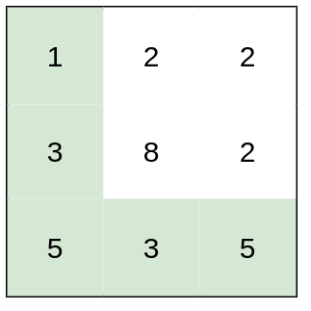

**Input:** heights = [[1,2,2],[3,8,2],[5,3,5]]

**Output:** 2

**Explanation:** The route of [1,3,5,3,5] has a maximum absolute difference of 2 in consecutive cells.

This is better than the route of [1,2,2,2,5], where the maximum absolute difference is 3.

**Example 2:**

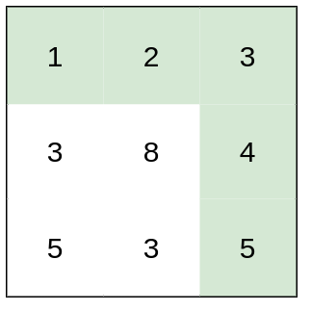

**Input:** heights = [[1,2,3],[3,8,4],[5,3,5]]

**Output:** 1

**Explanation:** The route of [1,2,3,4,5] has a maximum absolute difference of 1 in consecutive cells, which is better than route [1,3,5,3,5].

**Example 3:**

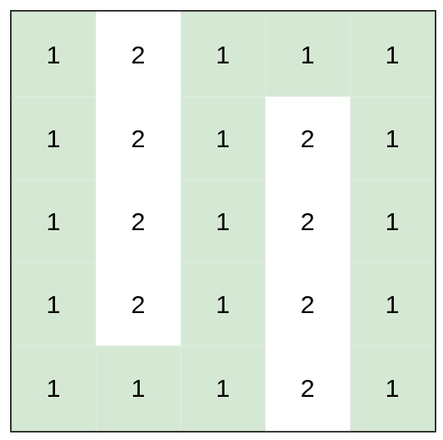

**Input:** heights = [[1,2,1,1,1],[1,2,1,2,1],[1,2,1,2,1],[1,2,1,2,1],[1,1,1,2,1]]

**Output:** 0

**Explanation:** This route does not require any effort.

**Solution:**

✅ **Let’s first make the problem statement crystal clear — especially this confusing line:**

“A route’s effort is the maximum absolute difference in heights between two consecutive cells of the route. Return the minimum effort required to travel from the top-left to the bottom-right.”

**🧭 Simplified meaning (in very easy words):**

When you move on the grid:

* Each step between two cells has a *height difference* → abs(heights[current] - heights[next]).
* That difference is like the **effort for that step** — how hard it is to climb or descend.

Now, for a **complete path**, you may take many steps:

* Some steps are easy (small difference),
* Some steps are tough (big difference).

But the **route’s effort** is **not the sum** of all those differences —  
👉 It is the **maximum** difference among all steps on that route.

You can think of it as:

“What is the toughest single step you’ll face on that route?”

Then, among all possible routes, we want:

The path where the **toughest step** (maximum difference) is **as small as possible**.

So “minimum effort” = “choose the path that avoids large height jumps.”

**🎢 Example to visualize:**

Heights:

1 2 2

3 8 2

5 3 5

Imagine two possible paths from top-left → bottom-right:

**Path A:**  
(1 → 2 → 2 → 2 → 5)  
Differences = [1, 0, 0, 3] → **max = 3**

**Path B:**  
(1 → 3 → 8 → 5)  
Differences = [2, 5, 3] → **max = 5**

✅ Path A has smaller *maximum* step = **3**,  
❌ Path B has bigger *maximum* step = **5**,  
So, **minimum effort = 3.**

That’s why the statement says:

“A route’s effort is the maximum absolute difference … Return the minimum effort.”

We’re minimizing the “hardest step” along the way.

**💡 Key Idea**

🧱 **Think of each cell as a node** and each move (up, down, left, right) as an **edge** whose weight = height difference.

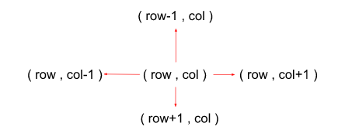

We need a path from start to destination such that the **largest edge** on the path is as small as possible.

🧮 Instead of minimizing total distance (like normal Dijkstra),  
we minimize the **maximum edge weight** along the path.

So:

* At each step, calculate → newEffort = max(currentEffort, absDiff)
* Update only if this newEffort is smaller than the stored one.
* Use a **Priority Queue (Min Heap)** to always explore the cell with the smallest current effort first.

**🧠 Intuition (Step by Step with Icons)**

🔹 **🎯 Goal:** reach the destination with the smallest “hardest climb.”  
🔹 **🧍 Start:** begin from (0,0) with effort = 0.  
🔹 **🔄 Process:**

* From each cell, move in 4 directions.
* Compute the effort to that neighbor = max(currentEffort, |height difference|).
* If that path offers a smaller effort, update it and push to PQ.  
  🔹 **🏔️ Expansion:**
* Always pick the cell with the *least effort so far* (min-heap property).  
  🔹 **☀️ End:**
* Once we pop the destination cell, its effort is the minimum possible.

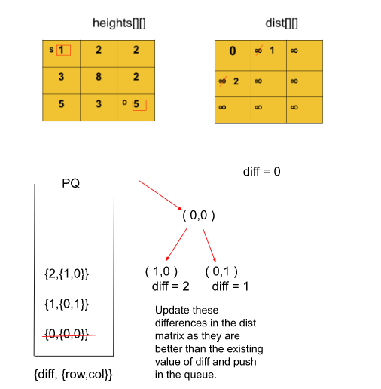

**🧩 Approach**

**1️⃣ Initialization**

* Create a 2D array shortestPathEffort[][] (your “effort matrix”) of the same size as heights[][].
* Initialize every cell with Integer.MAX_VALUE, except:
* shortestPathEffort[0][0] = 0;

since starting point needs no effort initially.

* Create a **Min-Heap (PriorityQueue)** that stores elements of type Pair(row, col, diff)  
  where:
  + row, col → cell coordinates
  + diff → minimum effort to reach that cell so far  
    and order them by smallest diff first:
* **PriorityQueue<Pair> pQueue = new PriorityQueue<>((x,y) -> x.diff - y.diff);**

**2️⃣ Push Starting Cell**

Push the starting position (0,0) with effort 0 into the priority queue:

pQueue.offer(new Pair(0, 0, 0));

**3️⃣ Extract Minimum-Effort Cell**

While the priority queue isn’t empty:

Pair pair = pQueue.poll();

This gives you the cell that currently requires the **least effort** to reach.

**4️⃣ Explore Its 4 Neighbors**

For each of the 4 possible directions:

int[] drow = {-1, 0, 1, 0};

int[] dcol = {0, 1, 0, -1};

Compute the new coordinates:

int nrow = row + drow[i];

int ncol = col + dcol[i];

Check if the neighbor is **valid** (inside grid bounds).

**5️⃣ Calculate the Effort for Neighbor**

Now calculate:

int absDiff = Math.abs(heights[row][col] - heights[nrow][ncol]);

int effort = Math.max(diff, absDiff);

* absDiff → cost for this step
* effort → maximum effort along the path so far (we take max because effort = hardest step on path)

**6️⃣ Relaxation Step (Core of Dijkstra)**

If this effort is **less** than the currently stored effort for that neighbor:

if (effort < shortestPathEffort[nrow][ncol]) {

shortestPathEffort[nrow][ncol] = effort;

pQueue.offer(new Pair(nrow, ncol, effort));

}

This means we found a **better path (smaller max effort)** to reach (nrow, ncol).

**7️⃣ Repeat Until All Nodes Processed**

The loop continues until all reachable cells are processed.  
Since we always expand the cell with the **smallest effort first**, by the time we reach the **destination cell**, it already holds the **minimum possible effort**.

**8️⃣ Return the Result**

After the while loop ends:

return shortestPathEffort[heights.length - 1][heights[0].length - 1];

This is your **minimum effort path** to reach the bottom-right corner.

**Code:**

class Pair{

    int row,col,diff;

    Pair(int row,int col,int diff)

    {

*this*.row = row;

*this*.col = col;

*this*.diff = diff;

    }

}

**private void dijkstra(int[][] heights,int[][] shortestPathEffort)    {**

        int[] drow = {-1,0,1,0};

        int[] dcol = {0,1,0,-1};

        PriorityQueue<Pair> pQueue = new PriorityQueue<>((x,y)-> x.diff - y.diff);

        //here source is top left

        pQueue.offer(new Pair(0, 0, 0));

        shortestPathEffort[0][0] = 0;

        //visit it first level neighbour

        while (!pQueue.isEmpty()) {

            Pair pair = pQueue.poll();

            int row = pair.row;

            int col = pair.col;

            int diff = pair.diff;

            //check in four direction

            for(int i=0;i<4;i++)

            {

                int nrow = row + drow[i];

                int ncol = col + dcol[i];

                //check for valid neighbour

                if(nrow >=0 && nrow < heights.length && ncol >=0 && ncol < heights[0].length)

                {

                    int absDiff = Math.abs(heights[row][col]-heights[nrow][ncol]);

                    /*

                     * A route's effort is the maximum absolute difference in heights between two consecutive cells of the route. so we keep an max(diff,absDiff)

                     * Return the minimum effort required to travel from the top-left cell to the bottom-right cell.

                     */

                    //^ first we find an maximum effort

                    int effort = Math.max(diff,absDiff);

                    //^ second check for that effort is minimum

                    if(effort < shortestPathEffort[nrow][ncol])

                    {

                        shortestPathEffort[nrow][ncol]  = effort;

                        pQueue.offer(new Pair(nrow, ncol, shortestPathEffort[nrow][ncol]));

                    }

                }

            }

        }

**}**

**public int minimumEffortPath(int[][] heights) {**

        int[][] shortestPathEffort = new int[heights.length][heights[0].length];

        for(int i=0;i<heights.length;i++)

        {

            for(int j=0;j<heights[0].length;j++)

            {

                shortestPathEffort[i][j] = Integer.MAX_VALUE;

            }

        }

        dijkstra(heights, shortestPathEffort);

        return shortestPathEffort[heights.length-1][heights[0].length-1];

**}**

**Cheapest flights within k stops**

**Problem Statement:** There are n cities connected by some number of flights. You are given an array flights where flights[i] = [fromi, toi, pricei] indicates that there is a flight from city fromi to city toi with cost pricei.

You are also given three integers src, dst, and k, return *the cheapest price from*src*to*dst*with at most*k*stops.*If there is no such route, return-1.

**Example 1:**

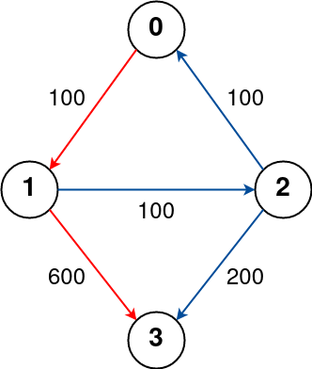

Input: n = 4, flights = [[0,1,100],[1,2,100],[2,0,100],[1,3,600],[2,3,200]], src = 0, dst = 3, k = 1

Output: 700

Explanation:

The graph is shown above.

The optimal path with at most 1 stop from city 0 to 3 is marked in red and has cost 100 + 600 = 700.

Note that the path through cities [0,1,2,3] is cheaper but is invalid because it uses 2 stops.

**Example 2:**

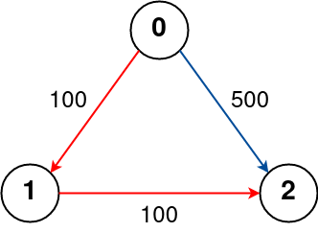

Input: n = 3, flights = [[0,1,100],[1,2,100],[0,2,500]], src = 0, dst = 2, k = 1

Output: 200

Explanation:

The graph is shown above.

The optimal path with at most 1 stop from city 0 to 2 is marked in red and has cost 100 + 100 = 200.

**Example 3:**

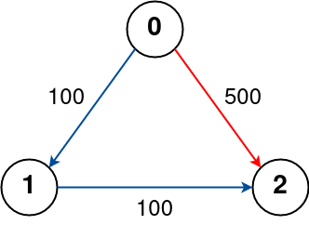

Input: n = 3, flights = [[0,1,100],[1,2,100],[0,2,500]], src = 0, dst = 2, k = 0

Output: 500

Explanation:

The graph is shown above.

The optimal path with no stops from city 0 to 2 is marked in red and has cost 500.

**Solution:**

**🔎 Problem in one line**

Find the **cheapest cost** to go from src to dst using at most k stops (i.e., at most k+1 flights). If no route exists under that constraint, return -1.

**🧭 Key idea (short)**

* Model cities as nodes and flights as directed weighted edges.
* We want the **minimum total cost** subject to a **limit on the number of stops**.
* Because the number of stops is constrained, we must consider the **number-of-edges** dimension as part of the state (cost alone is not enough).
* Use a level-by-level exploration (BFS-like / k-limited relaxations) or dynamic programming (Bellman–Ford style for exactly k relaxations) to respect the stop limit.

(Icon: ✈️ nodes = cities, edges = flights)

**🧠 Why not plain Dijkstra?**

* **Dijkstra** finds the shortest path in terms of cost when there is **no constraint on the number of edges** and when you always expand the currently cheapest node (priority queue).
* But Dijkstra’s greedy choice (expand global cheapest) can lead to paths that have more stops than allowed. The cheapest-so-far path might use many stops and still get expanded — which violates the k-stops constraint for our answer.
* Therefore we cannot just use standard Dijkstra (priority-queue by cost) and stop when we pop dst — because the popped dst might come from a path with >k stops, or earlier cheaper path might use more stops than allowed.

(Icon: ❌ Dijkstra for stop-limited shortest path)

**🚶‍♂️ Why BFS-like / level approach works here**

* Each extra *stop* increases the path length by 1 (in edges). If we explore by **levels** where level 0 = src (0 stops used), level 1 = nodes reachable with 1 flight, ..., level k = nodes reachable with k stops, we guarantee we only consider paths with ≤ k stops.
* At each level we relax outgoing edges from nodes discovered in the previous level and compute candidate costs for the next level.
* This level-by-level relaxation is equivalent to doing up to k+1 iterations of Bellman–Ford (but each iteration only uses distances from previous iteration), and it enforces the stop constraint cleanly.

(Icon: 🧱 level-by-level = stop-limited)

**BFS-like queue with step tracking (your current idea)**

* Use a queue of (node, cost, stepUsed).
* Start with (src, 0, 0).
* While queue not empty, pop an element; if stepUsed <= k, relax outgoing edges:
  + For each edge u->v with price w, newCost = cost + w
  + If newCost < best[v], update best[v] = newCost and push (v, newCost, stepUsed + 1).
* This works if you *only expand nodes whose stepUsed ≤ k* and you only push step+1 entries (so expansions never exceed allowed stops).
* Complexity: worst-case may revisit nodes multiple times, but each push only happens when best[v] improves and step <= k, so it remains bounded and practical.

Important subtlety: in-place updates of best[] can allow a cheaper cost found at a deeper step to be used earlier — but we guard expansion with step so no path violating the stop bound is expanded. Many solutions using BFS/queue in contests use this and it works.

(Icon: 🔁 queue + steps)

**🛠 Step-by-step approach (mapping to code)**

1. **Build adjacency list**  
   adj.get(u) returns list of (price, v) for edges u -> v.
2. **Distance array init**  
   shortestPrice[i] = INF for all i. Set shortestPrice[src] = 0.
3. **Queue / level processing**
   * Use Queue<StepPair> where StepPair(node, price, stepUsed).
   * offer(src, 0, 0).
4. **While queue not empty**
   * pair = poll(); if pair.step > k continue (or skip expanding).
   * For each (costEdge, v) in adj.get(node):
     + newPrice = pair.price + costEdge
     + If newPrice < shortestPrice[v]:
       - shortestPrice[v] = newPrice
       - offer(v, newPrice, pair.step + 1)
5. **Return**
   * If shortestPrice[dst] == INF return -1 else return shortestPrice[dst].

Your code follows this pattern; it is valid. See the *subtle improvement* below.

(Icon: 🧩 algorithm → code)

**Code:**

**class Pair {**

    int price, node;

    Pair(int price, int node) {

*this*.price = price;

*this*.node = node;

    }

**}**

**class StepPair {**

    int node, price, step;

    StepPair(int node, int price, int step) {

*this*.node = node;

*this*.step = step;

*this*.price = price;

    }

**}**

**private void dijkstra(ArrayList<ArrayList<Pair>> adj, int[] shortestPrice, int src, int dst, int k) {**

        // create Queue

        //! here we use simple queue because we sort based on step and in bfs stop increase by liner like 1 at every level we increase step by 1 thats why we need an queue not priorityQueue

        Queue<StepPair> queue = new LinkedList<>();

        queue.offer(new StepPair(src, 0, 0));

        shortestPrice[src] = 0;

        while (!queue.isEmpty()) {

            StepPair pair = queue.poll();

            int source = pair.node;

            int step = pair.step;

            int price = pair.price;

            //first check for within step

            if (step <= k)

            {

                for (Pair adjacentPair : adj.get(source)) {

                    int newPrice = price + adjacentPair.price;

                    if (newPrice < shortestPrice[adjacentPair.node] && step <= k)

                    {

                        shortestPrice[adjacentPair.node] = newPrice;

                        queue.offer(new StepPair(adjacentPair.node, newPrice,step+1));

                    }

                }

            }

        }

**}**

**public int findCheapestPrice(int n, int[][] flights, int src, int dst, int k) {**

        int[] shortestPrice = new int[n];

        // create an adjaecncy list

        ArrayList<ArrayList<Pair>> adj = new ArrayList<>();

        for (int i = 0; i < n; i++) {

            shortestPrice[i] = Integer.MAX_VALUE;

            adj.add(new ArrayList<>());

        }

        for (int i = 0; i < flights.length; i++) {

            int source = flights[i][0];

            int destination = flights[i][1];

            int price = flights[i][2];

            adj.get(source).add(new Pair(price, destination));

        }

        dijkstra(adj, shortestPrice, src, dst, k);

        return shortestPrice[dst] == Integer.MAX_VALUE ? -1 : shortestPrice[dst];

**}**

**Minimum Multiplications to reach End**

**Problem Statement:** Given start, end and an array arr of n numbers. At each step, start is multiplied with any number in the array and then mod operation with 100000 is done to get the new start.

Your task is to find the minimum steps in which end can be achieved starting from start. If it is not possible to reach end, then return -1.

**Example 1:**

**Input:** arr[] = {2, 5, 7}  **start** = 3**, end** = 30

**Output:** 2

**Explanation:**

Step 1: 3*2 = 6 % 100000 = 6

Step 2: 6*5 = 30 % 100000 = 30

**Example 2:**

**Input:** arr[] = {3, 4, 65}  **start =** 7**, end =** 66175

**Output:** 4

**Explanation:**

Step 1: 7*3 = 21 % 100000 = 21

Step 2: 21*3 = 63 % 100000 = 63

Step 3: 63*65 = 4095 % 100000 = 4095

Step 4: 4095*65 = 266175 % 100000 = 66175

**Solution:**

**🔎 Problem in one line**

Start from start. In each step multiply the current value by any arr[i], take % 100000, and that becomes the next state. Find the **minimum number of multiplications** (steps) to reach end, or -1 if impossible.

**🧭 Why BFS? (main idea)**

* Each value (after modulo) is a **node** in an implicit directed graph (states 0..99,999).
* From node x, there are edges to nodes (x * arr[i]) % 100000 for every i.
* All edges have **equal weight = 1** (one multiplication step). When edges are unweighted (or equal weight), the shortest path in terms of number of edges is found by **Breadth-First Search (BFS)**.
* BFS explores nodes layer-by-layer: first all nodes reachable in 1 step, then 2 steps, etc. The first time BFS reaches end it is guaranteed to be at minimum steps.
* Using BFS avoids expensive repeated exploration and gives the minimal-step answer efficiently.

(Icon: 🚶‍♂️ level-by-level traversal = BFS)

**🎯 why it’s *not* a DP problem**

Cyclic dependencies (DP breaks)

Because we use % 100000, the state space “wraps around.”  
That means you could come back to the same number through different paths.

BFS fits perfectly because…

BFS is designed for shortest path in unweighted graphs.  
Here, every multiplication step is 1 unit cost → perfectly unweighted.

* DP is good for *optimal substructure* with clear ordering.
* BFS is good for *minimum distance* in graphs (even implicit ones).

We’re not “building up” from subproblems;  
we’re exploring a graph to find the minimum distance from start → end.

**💡 Key idea (compact)**

* Treat each modulo value as a node.
* Use a queue to perform BFS from start.
* Keep an array dist[] (size 100000) initialized to ∞ to store minimum steps to each node.
* For each node popped from queue, generate its neighbours by multiplying with each element of arr, taking modulo, and if we find a shorter distance update and push to queue.
* Stop early if end is reached.

(Icon: 🧩 graph of states + queue)

**🧠 Intuition (why this works)**

* Since multiplying and then modulo maps any value into the finite set 0..99999, the entire search space is finite (≤100000 states). BFS will eventually explore all reachable states.
* BFS ensures that states discovered at distance d are processed before those at distance d+1, so the first time we see end is the minimal number of multiplications.
* We use a dist (or shortestPath) array to avoid revisiting states with no improvement — this prevents exponential blow-up and ensures termination.

(Icon: 🔁 finite states + visited pruning)

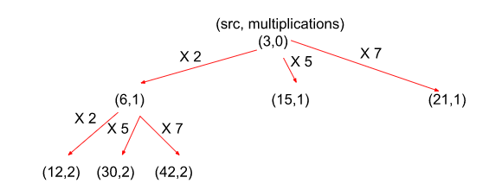

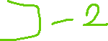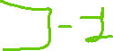

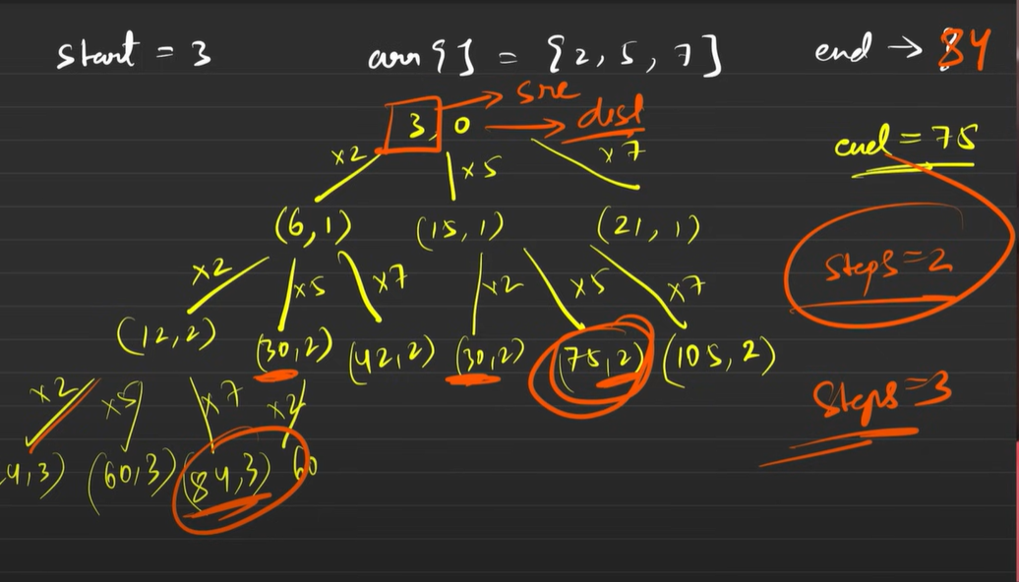

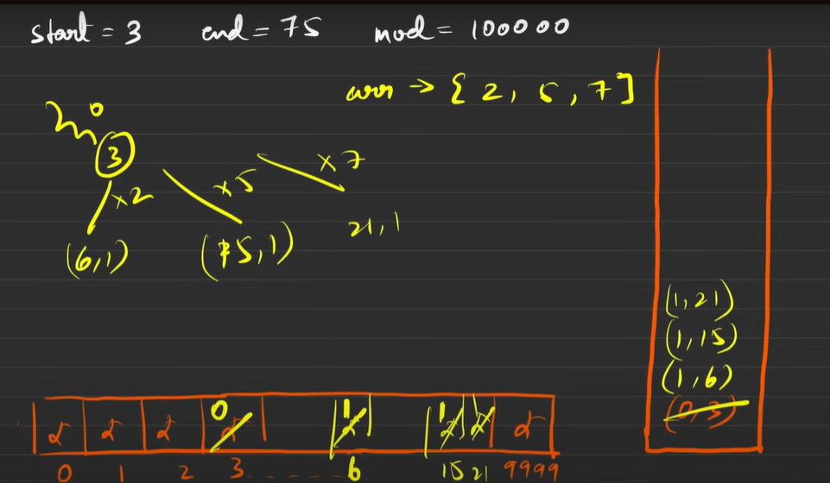

**🛠️ Detailed approach (step-by-step) — mapped to your code**

1. **Initialization**
   * Create shortestPath[] length 100000, fill with Integer.MAX_VALUE (represents unreachable).
   * Use a Queue<Pair> (where Pair(node, step)) to run BFS.
   * Push start with step = 0 and set shortestPath[start] = 0.

(Your code: Arrays.fill(shortestPath, Integer.MAX_VALUE); queue.offer(new Pair(start,0)); shortestPath[start] = 0;)

1. **BFS loop**
   * While queue not empty:
     + Pop pair = queue.poll() → node, step.
     + For every value a in arr:
       - Compute adjacentNode = (node * a) % 100000.
       - If shortestPath[adjacentNode] > step + 1:
         * Update shortestPath[adjacentNode] = step + 1.
         * queue.offer(new Pair(adjacentNode, step + 1)).
       - If adjacentNode == end → you can return immediately (early exit).

(Your code implements exactly this.)

1. **Result**
   * After BFS (or early return), return shortestPath[end] if finite, else -1.

(Your code: return shortestPath[end] != Integer.MAX_VALUE ? shortestPath[end] : -1;)

**Code:**

**class Pair{**

    int node,step;

    Pair(int node,int step)

    {

*this*.node = node;

*this*.step = step;

    }

**}**

**void dijkstra(int[] arr,int[] shortestPath,int start,int end)    {**

        //create an Queue

        Queue<Pair> queue = new LinkedList<>();

        queue.offer(new Pair(start, 0));

        shortestPath[start] = 0;

        while (!queue.isEmpty()) {

            Pair pair = queue.poll();

            int node = pair.node;

            int step = pair.step;

            //visit first level neighbour by multiply pair.node with every value of arr

            for(int i=0;i<arr.length;i++)

            {

                int adjacentNode = (arr[i] * node) % 100000;

                if(shortestPath[adjacentNode] > (step + 1))

                {

                    shortestPath[adjacentNode] = (step + 1);

                    queue.offer(new Pair(adjacentNode, (step + 1)));

                }

                if(adjacentNode == end)

                    return;

            }

        }

**}**

**int minimumMultiplications(int[] arr, int start, int end) {**

        if(end >= 100000)

            return -1;

        int[] shortestPath = new int[100000];

        Arrays.fill(shortestPath, Integer.MAX_VALUE);

        dijkstra(arr, shortestPath, start, end);

        return shortestPath[end] != Integer.MAX_VALUE ? shortestPath[end] : -1;

**}**

**Number of ways to arrive at destination**

**Problem Statement**: You are in a city that consists of n intersections numbered from 0 to n - 1 with bi-directional roads between some intersections. The inputs are generated such that you can reach any intersection from any other intersection and that there is at most one road between any two intersections.

You are given an integer n and a 2D integer array roads where **roads[i] = [ui, vi, timei] means that there is a road between intersections ui and vi that takes timei minutes to travel. You want to know in how many ways you can travel from intersection 0 to intersection n - 1 in the shortest amount of time.**

Return *the number of ways you can arrive at your destination in the shortest amount of time*. Since the answer may be large**, return it modulo 109 + 7**

**Example 1:**

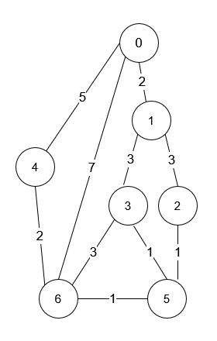

**Input:** n = 7, roads = [[0,6,7],[0,1,2],[1,2,3],[1,3,3],[6,3,3],[3,5,1],[6,5,1],[2,5,1],[0,4,5],[4,6,2]]

**Output:** 4

**Explanation:** The shortest amount of time it takes to go from intersection 0 to intersection 6 is 7 minutes.

The four ways to get there in 7 minutes are:

- 0 ➝ 6

- 0 ➝ 4 ➝ 6

- 0 ➝ 1 ➝ 2 ➝ 5 ➝ 6

- 0 ➝ 1 ➝ 3 ➝ 5 ➝ 6

**Example 2:**

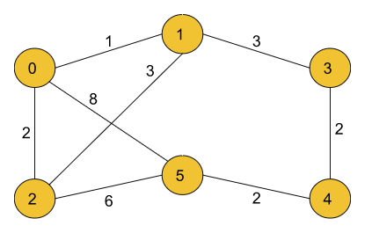



**Input:**

n=6, m=8

edges= [[0,5,8],[0,2,2],[0,1,1],[1,3,3],[1,2,3],[2,5,6],[3,4,2],[4,5,2]]

**Output:** 3

**Explanation:** The three ways to get there in 8 minutes (which is the shortest calculated time) are:

- 0 5

- 0 2 5

- 0 1 3 4 5

**Solution:**

**💡 Key Idea**

The key trick lies in **combining Dijkstra’s algorithm** (for shortest distance) with **path counting** logic.

We maintain two arrays:

1. **shortestTime[]** 🕐 — stores the minimum time needed to reach each node.
2. **ways[]** 🧮 — stores how many shortest paths reach that node.

When we explore edges:

* If we find a **shorter path**, we **update** the shortest time and **copy** the number of ways from the source node.
* If we find another path with **equal shortest time**, we **add** the number of ways (since it’s another valid route of equal distance).

**🧠 Intuition (Simple Words + Example)**

Let’s say we have this small graph:

0 --(1)--> 1

0 --(1)--> 2

1 --(1)--> 3

2 --(1)--> 3

We start from node 0, destination is 3.

|  |  |  |
| --- | --- | --- |
| Node | Shortest Time | Ways |
| 0 | 0 | 1 |
| 1 | 1 | 1 |
| 2 | 1 | 1 |
| 3 | 2 | ? |

**Step-by-step ⚙️**

1. Start from node 0 → ways[0] = 1
2. From 0 → reach 1 and 2 (both at time 1):  
   ways[1] = 1, ways[2] = 1
3. From 1 → reach 3 (time = 2):  
   shortestTime[3] = 2, ways[3] = ways[1] = 1
4. From 2 → reach 3 (time = 2):  
   Since newTime == shortestTime[3], we add:  
   ways[3] = ways[3] + ways[2] = 1 + 1 = 2

✅ Final answer: ways[3] = 2

So there are **two shortest paths**:

* 0 → 1 → 3
* 0 → 2 → 3

**🚫 Why We Can’t Just Set ways[nextNode] = 1 on Shorter Distance**

Because the node we’re coming **from** may already have **multiple shortest paths**.  
If we ignore that and just set it to 1, we’ll lose all those routes. 😢

For example,  
if there are **3 different shortest ways to reach node 1**,  
and from node 1 → node 2 is the next shortest step,  
then there must be **3 different shortest ways to reach node 2**, not 1.  
Hence, we use:

ways[nextNode] = ways[source];

to **copy** all the possible shortest ways that end at source.

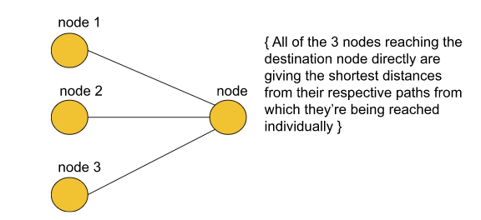

3 ways to reach dst with distance 7

3 ways to reach node with distance 5



**🧭 Approach**

**1. Initialization**

* Create shortestTime[] of size n, fill with Long.MAX_VALUE  
  (represents **unreachable** initially).
* Create ways[] of size n and fill with **0**.  
  This will store the **number of shortest paths** to each node.
* Use a **PriorityQueue<Pair>** where Pair(node, time) helps to always process the **smallest current time first** (like Dijkstra’s min-heap).
* Set starting node:
* shortestTime[0] = 0;
* ways[0] = 1;
* pQueue.offer(new Pair(0, 0));

(Means: from node 0, we start with time = 0, and there’s only 1 way to be at the start.)

**2. Dijkstra Loop**

* While the priority queue is not empty:
  + Pop the top element:
  + Pair pair = pQueue.poll();
  + int source = pair.node;
  + long time = pair.time;
  + If time > shortestTime[source],  
    → skip this node (it’s an outdated entry).

**3. Relaxation Step**

* For every adjacent node (nextNode, edgeTime) in adj.get(source):
  + Compute total time to reach neighbor:
  + long newTime = time + edgeTime;
  + **Case 1: Found a Shorter Path**
  + if (shortestTime[nextNode] > newTime) {
  + shortestTime[nextNode] = newTime;
  + ways[nextNode] = ways[source]; // inherit count
  + pQueue.offer(new Pair(nextNode, newTime));
  + }

➜ Update shortest distance  
➜ Copy the number of shortest ways from source  
➜ Push into queue for further exploration

* + **Case 2: Found Another Equal Shortest Path**
  + else if (shortestTime[nextNode] == newTime) {
  + ways[nextNode] = (ways[nextNode] + ways[source]) % MOD;
  + }

➜ If total time is the same as current shortest,  
➜ Add the number of new paths (since both routes are equally short).

**4. After the Loop Ends**

* The total number of shortest paths to destination (n-1) is:
* return ways[n - 1] % MOD;

This ensures the result fits within the range of the given modulo.

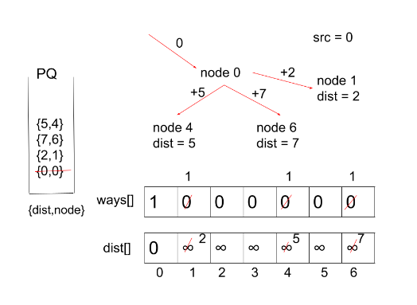

**Code:**

**class Pair {**

    int node;

    long time; // <-- use long

    Pair(int node, long time) {

*this*.node = node;

*this*.time = time;

    }

**}**

**public class NoOfWaysToReachDestination {**

    private final int MOD = (int)1e9 + 7;

    private int dijkstra(ArrayList<ArrayList<Pair>> adj, long[] shortestTime, int src, int dst) {

        int[] ways = new int[adj.size()];

        PriorityQueue<Pair> pQueue = new PriorityQueue<>((x, y) -> Long.compare(x.time, y.time));

        pQueue.offer(new Pair(src, 0));

        shortestTime[src] = 0;

        ways[src] = 1;

        while (!pQueue.isEmpty()) {

            Pair pair = pQueue.poll();

            int source = pair.node;

            long time = pair.time;

            //reduce oldtime value that is push early but shortestTime is updated before pop

            if (time > shortestTime[source]) continue; // skip stale

            for (Pair adjacePair : adj.get(source)) {

                int nextNode = adjacePair.node;

                long newTime = time + adjacePair.time; // long addition

                if (shortestTime[nextNode] > newTime) {

                    shortestTime[nextNode] = newTime;

                    ways[nextNode] = ways[source];

                    pQueue.offer(new Pair(nextNode, newTime));

                } else if (shortestTime[nextNode] == newTime) {

                    ways[nextNode] = (ways[nextNode] + ways[source]) % MOD;

                }

            }

        }

        return ways[dst] % MOD;

    }

    public int countPaths(int n, int[][] roads) {

        long[] shortestTime = new long[n]; // long array

        ArrayList<ArrayList<Pair>> adj = new ArrayList<>();

        for (int i = 0; i < n; i++) {

            adj.add(new ArrayList<>());

            shortestTime[i] = Long.MAX_VALUE;

        }

        for (int[] road : roads) {

            int src = road[0], dst = road[1];

            long time = road[2];

            adj.get(src).add(new Pair(dst, time));

            adj.get(dst).add(new Pair(src, time));

        }

        return dijkstra(adj, shortestTime, 0, n - 1);

    }

**}**

**Bellman Ford Algorithm**

**Problem Statement:**Given a weighted, directed and connected graph of V vertices and E edges, Find the shortest distance of all the vertices from the source vertex S.

Note: If the Graph contains a negative cycle then return an array consisting of only -1.

**Solution:**

**🚦 Problem Use Case**

You are given a graph that might include **negative edge weights**.  
Your goal is to find the **shortest distance** from a single source node 🏁  
to all other nodes in the graph.

But there’s a twist ⚠️ —  
some graphs might contain a **negative weight cycle** (a loop whose total weight is negative),  
which can reduce distance infinitely.

So, the algorithm must not only find shortest paths…  
but also detect if such a **negative cycle** exists. 🔍

👉 **Example:**  
If there’s a path like A → B → C → A with total weight -2,  
then by looping infinitely, cost keeps reducing forever — meaning shortest path is undefined.

***Negative Cycle:****A cycle is called a negative cycle if the sum of all its weights becomes negative. The following illustration is an example of a negative cycle:*

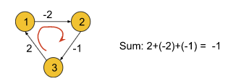

***Bellman-Ford's algorithm***successfully solves these problems. ***It works fine with negative edges*** as well as ***it is able to detect if the graph contains a negative cycle***. But this algorithm is only applicable for ***directed graphs***. In order to apply this algorithm to an undirected graph, we just need to convert the undirected edges into directed edges like the following:

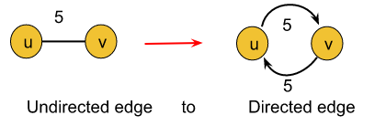

**💡 Key Idea**

🔸 Bellman-Ford works by **repeatedly relaxing all edges**.  
“Relaxing” means —

if the current known distance to v can be reduced by passing through u, then update it.

It repeats this process **(V−1)** times because:

* Any shortest path in a graph with V vertices has at most V−1 edges.
* After V−1 relaxations, all shortest paths are settled (if no negative cycle).

If after these (V−1) rounds, you can still make a shorter distance ➜  
🚨 It means there is a **negative weight cycle**.

**🧠 Intuition**

Think of each edge as a **rope** ⛓️ pulling on the next node to make its distance smaller.  
At the beginning, all nodes are far apart — distances are infinity (∞).

Every relaxation pulls distances **tighter and tighter**,  
until they can’t be improved anymore.

If someone is still being pulled even after (V−1) times —  
it means there’s a **loop that keeps pulling forever**,  
and that’s your **negative cycle** 💀

So Bellman-Ford is like this cycle of refinement:

“Try improving your neighbor’s distance if going through me helps.”

Do this for all nodes again and again —  
until everything stabilizes… or chaos (negative loop) appears. 🔄

**⚙️ Approach (in human-code style 🧩)**

Let's now rewrite the algorithm like it’s a readable pseudo-program,  
with emoji icons to indicate behavior and flow 👇

🏁 Step 1: Initialization

for (each vertex v)

shortestDistance[v] = ∞ // start assuming all are unreachable 🚫

shortestDistance[src] = 0 // distance to itself = 0 ✅

🧩 *Context:* We set all nodes to infinity because we don’t yet know any path to them.Only the source knows its distance (0).

🔁 Step 2: Relax all edges (V - 1) times

for (i = 1; i <= V - 1; i++)

{

// 🧵 Go through each edge

for (each edge (u → v) with weight w)

{

if (shortestDistance[u] == ∞)

continue; // skip unreachable nodes 🪄

int newDistance = shortestDistance[u] + w;

if (newDistance < shortestDistance[v])

shortestDistance[v] = newDistance; // found a better route 🎯

}

}

🧩 *Context:*  
This is the **heart** ❤️ of Bellman-Ford.  
You are “relaxing” edges — testing if you can get a shorter distance by taking one more step.  
After V−1 full rounds, every possible path has been tested.

⚠️ Step 3: Check for Negative Weight Cycle

for (each edge (u → v) with weight w)

{

if (shortestDistance[u] != ∞ &&

shortestDistance[u] + w < shortestDistance[v])

{

return [-1]; // 🚨 Negative cycle detected

}

}

🧩 *Context:*  
If you can still find a smaller distance now,  
it means there’s a **cycle** that keeps reducing cost forever.  
That’s a **negative weight cycle** 💣 —  
so, we return immediately.

🧮 Step 4: Handle unreachable nodes

for (each vertex v)

if (shortestDistance[v] == ∞)

shortestDistance[v] = 1e8; // mark as unreachable 🚫

🧩 *Context:*  
Nodes that never got updated were never reached.  
We assign them a large number (like 1e8) to indicate “unreachable.”

🎯 Step 5: Return the final result

return shortestDistance; // shortest distances from source to all vertices 🚀

**Code:**

**private boolean bellmanForAlgo(int[][] edges,int V,int[] shortestDistance,int src)    {**

        shortestDistance[src] = 0;

        //relax edges for n-1 time

        for(int i=1;i<=V-1;i++)

        {

            //relax the all edges

            for(int[] edge : edges)

            {

                int source = edge[0];

                int dst = edge[1];

                int weight = edge[2];

                if(shortestDistance[source] == Integer.MAX_VALUE) continue;

                int newDistance = shortestDistance[source] + weight;

                if(shortestDistance[dst] > newDistance)

                {

                    shortestDistance[dst] = newDistance;

                }

            }

        }

        ✅ Check for negative weight cycle

        for (int[] edge : edges) {

            int u = edge[0];

            int v = edge[1];

            int wt = edge[2];

            if (shortestDistance[u] != Integer.MAX_VALUE &&

                shortestDistance[u] + wt < shortestDistance[v]) // **distance is still reduce so there is negative cycle**

            {

                return true; // negative cycle detected

            }

        }

        return false;

**}**

**public int[] bellmanFord(int V, int[][] edges, int src) {**

        int[] shortestDistance = new int[V];

        Arrays.fill(shortestDistance, Integer.MAX_VALUE);

        boolean hasNegativeCycle = bellmanForAlgo(edges, V, shortestDistance, src);

        // ✅ If negative cycle found

        if (hasNegativeCycle) {

            return new int[]{-1};

        }

        // ✅ Replace unreachable distances with 1e9

        for (int i = 0; i < V; i++)

        {

            if (shortestDistance[i] == Integer.MAX_VALUE) {

                shortestDistance[i] =  (int)1e8;;

            }

        }

        return shortestDistance;

**}**

**Floyd Warshall Algorithm**

**Problem Statement**: The problem is to find the shortest distances between every pair of vertices in a given edge-weighted directed graph. The graph is represented as an adjacency matrix of size n*n. Matrix[i][j] denotes the weight of the edge from i to j. If Matrix[i][j]=-1, it means there is no edge from i to j.

**Example 1**:

**Input Format:**

matrix[][] = { {0, 2, -1, -1},

{1, 0, 3, -1},{-1, -1, 0, -1},{3, 5, 4, 0} }

**Result:**

0 2 5 -1

1 0 3 -1

-1 -1 0 -1

3 5 4 0

**Explanation**: In this example, the final matrix

is storing the shortest distances. For example, matrix[i][j] is

storing the shortest distance from node i to j.

**Example 2**:

**Input Format**:

matrix[][] = {{0,25},

{-1,0}}

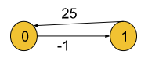

**Result:**

0 25

-1 0﻿

**Explanation:** In this example, the shortest distance

is already given (if it exists).

**Solution:**

**💡 Key Idea**

The Floyd–Warshall algorithm is used to find the **shortest distance between every pair of vertices** in a **weighted graph** (can be directed or undirected).  
It works by trying to **improve the distance between two nodes (i → j)** using **an intermediate node (via)**.

Simply put:

If the path i → via → j is shorter than the direct path i → j, then update it.

**🧠 Intuition**

Imagine you’re planning routes between cities.  
At first, you only know the **direct road distances**.  
But what if you can pass through another city that gives a shorter total route?

🗺️ Example:

* Direct route A → C = 10
* Route A → B = 3, and B → C = 4  
  ➡️ A → B → C = 7 (shorter!)

So, you update your table with the shorter route.

This process is repeated for **every possible “via” city**, ensuring you find all the **shortest possible paths**.

**⚙️ Step-by-Step Approach**

Let’s break down your code step by step 🔍

**🔹 Step 1: Initialize Matrix**

for(int i=0;i<n;i++){

for(int j=0;j<n;j++){

if(i == j)

matrix[i][j] = 0;

else if(matrix[i][j] == -1)

matrix[i][j] = (int)(1e9); // treat -1 as infinity

}

}

✅ **What’s happening:**

* Distance from a node to itself = 0.
* Distance -1 (means no direct path) is replaced with a **large number (1e9)** to simulate “infinity”.

**🔹 Step 2: Core Floyd–Warshall Update Loop**

for(int via=0;via<n;via++){

for(int i=0;i<n;i++){

for(int j=0;j<n;j++){

int newDistance = matrix[i][via] + matrix[via][j];

matrix[i][j] = Math.min(matrix[i][j], newDistance);

}

}

}

✅ **What’s happening:**

* We iterate through each node via as an **intermediate point**.
* For every pair (i, j), check if the route i → via → j gives a smaller distance than the direct route.
* If yes, we **update** matrix[i][j].

💭 Essentially,

“Can I go from i to j in a shorter way by passing through via?”

**🔹 Step 3: Restore the Matrix**

for(int i=0;i<n;i++){

for(int j=0;j<n;j++){

if(matrix[i][j] == (int)(1e9))

matrix[i][j] = -1;

}

}

✅ **What’s happening:**

* Replace 1e9 (infinity) back with -1 to indicate **no path**.

**📘 Final Output**

At the end, your matrix[i][j] will represent:

The **shortest distance** from node i to node j.

If matrix[i][j] = -1, there is **no path** between them.

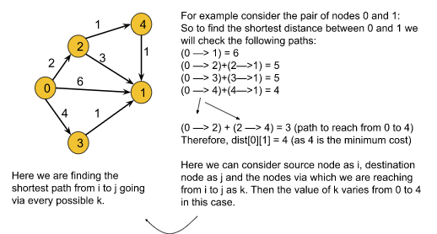

**Code:**

**public int[][] shortest_distance(int[][] matrix)    {**

        int n = matrix.length;

        for(int i=0;i<n;i++)

        {

            for(int j=0;j<n;j++)

            {

                if(i == j)

                    matrix[i][j] = 0;

                else if(matrix[i][j] == -1)

                    matrix[i][j] = (int)(1e9);

            }

        }

        //^explore all vertex and their all edges

        for(int via=0;via<n;via++)

        {

            for(int i=0;i<n;i++)

            {

                for(int j=0;j<n;j++)

                {

                    //^shortest path from i to j via some

                    int newDistance = matrix[i][via] + matrix[via][j];

                    matrix[i][j] = Math.min(matrix[i][j],newDistance);

                }

            }

        }

        for(int i=0;i<n;i++)

        {

            for(int j=0;j<n;j++)

            {

                if(matrix[i][j] == (int)(1e9))

                    matrix[i][j] = -1;

            }

        }

        return matrix;

**}**

**Find the City With the Smallest Number of Neighbors Within Threshold Distance**

**Problem Statement:** There are n cities numbered from 0 to n-1. Given the array edges where **edges[i] = [fromi, toi, weighti]** represents a bidirectional and weighted edge between cities fromi and toi, and given the integer distanceThreshold.

Return the city with the smallest number of cities that are reachable through some path **and whose distance is at most distanceThreshold, If there are multiple such cities, return the city with the greatest number.**

Notice that the distance of a path connecting cities *i* and *j* is equal to the sum of the edges' weights along that path.

**Example 1:**

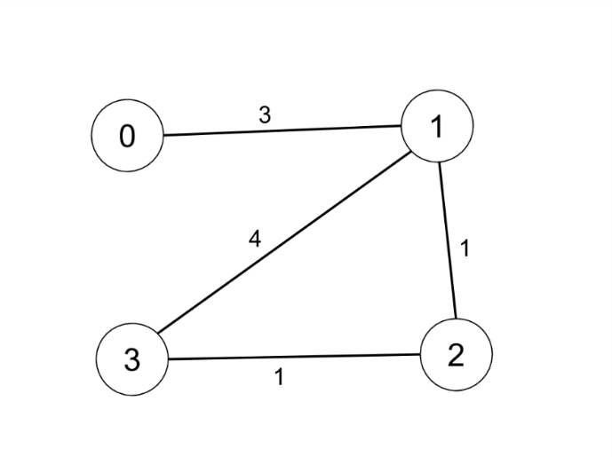

**Input:** n = 4, edges = [[0,1,3],[1,2,1],[1,3,4],[2,3,1]], distanceThreshold = 4

**Output:** 3

**Explanation:** The figure above describes the graph.

The neighboring cities at a distanceThreshold = 4 for each city are:

City 0 -> [City 1, City 2]

City 1 -> [City 0, City 2, City 3]

City 2 -> [City 0, City 1, City 3]

City 3 -> [City 1, City 2]

Cities 0 and 3 have 2 neighboring cities at a distanceThreshold = 4, but we have to return city 3 since it has the greatest number.

**Example 2:**

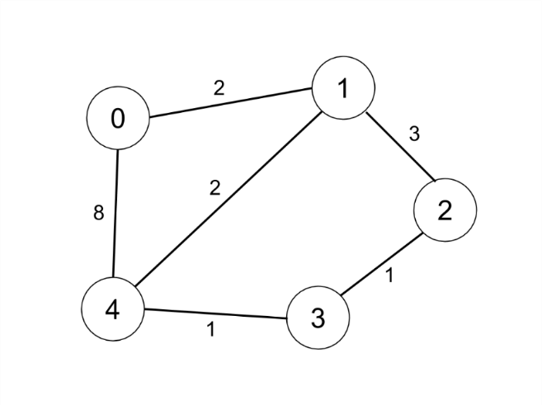

**Input:** n = 5, edges = [[0,1,2],[0,4,8],[1,2,3],[1,4,2],[2,3,1],[3,4,1]], distanceThreshold = 2

**Output:** 0

**Explanation:** The figure above describes the graph.

The neighboring cities at a distanceThreshold = 2 for each city are:

City 0 -> [City 1]

City 1 -> [City 0, City 4]

City 2 -> [City 3, City 4]

City 3 -> [City 2, City 4]

City 4 -> [City 1, City 2, City 3]

The city 0 has 1 neighboring city at a distanceThreshold = 2.

**Solution:**

**🧠 Key Idea**

Use **Floyd–Warshall Algorithm** to precompute shortest distances between all city pairs,  
then pick the city that can reach the fewest others within a given threshold distance.

**💡 Intuition**

Imagine each city as a dot connected with roads of different lengths.  
You can “travel” along roads, but only if the total travel distance ≤ threshold.

So, for **each city**, we want to know:

* How many other cities can it reach if we only allow paths shorter than or equal to distanceThreshold.

👉 To do this, we must first **find the shortest path distance between every pair of cities**.  
Once we know that, it’s easy to count reachable cities for each one.

This is exactly what **Floyd–Warshall algorithm** helps with.

**⚙️ Approach (Step-by-Step)**

**🔸 Step 1: Create an Adjacency Matrix**

We create an n × n matrix where:

* matrix[i][j] = shortest distance from city i to city j.
* Initially,
  + matrix[i][i] = 0 (distance to itself)
  + matrix[i][j] = ∞ (no path known yet)

for(int i=0;i<n;i++){

for(int j=0;j<n;j++){

if(i==j) continue;

matrix[i][j] = Integer.MAX_VALUE;

}

}

Then fill in direct edge distances:

for(int[] edge : edges){

int source = edge[0];

int dst = edge[1];

int weight = edge[2];

matrix[source][dst] = weight;

matrix[dst][source] = weight;

}

**🔸 Step 2: Apply Floyd–Warshall Algorithm 🧠**

**Idea:**  
If going from i → via → j is shorter than directly going from i → j,  
then update it!

🔁 For every city via as an intermediate node,  
update all pairs (i, j):

matrix[i][j] = Math.min(matrix[i][j], matrix[i][via] + matrix[via][j]);

We skip cases where there’s no valid path:

if(matrix[i][via] == Integer.MAX_VALUE || matrix[via][j] == Integer.MAX_VALUE)

continue;

🔹 After this, matrix[i][j] holds the **shortest distance** between every pair of cities.

**🔸 Step 3: Count Reachable Cities Within Threshold**

Now, for each city i, we count how many cities j satisfy:

if(matrix[i][j] <= distanceThreshold)

cnt++;

We track the city having the **minimum count** of reachable neighbors.

If multiple cities have the same count,  
choose the city with **larger index** (i).

**🔸 Step 4: Return the Answer**

After checking all cities, return the one with the required condition:

return city;

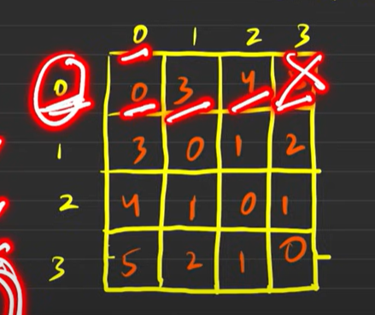



**Code:**

**private void wershallAlgo(int[][] matrix,int n)    {**

        for(int via=0;via<n;via++)        {

            for(int i=0;i<n;i++)            {

                for(int j=0;j<n;j++)                {

                    if(matrix[i][via]== Integer.MAX_VALUE || matrix[via][j] == Integer.MAX_VALUE)

                        continue;

                    matrix[i][j] = Math.min(matrix[i][j], matrix[i][via] + matrix[via][j]);

                }

            }

        }

**}**

**public int findTheCity(int n, int[][] edges, int distanceThreshold) {**

        //create an adjacency matrix

        int[][] matrix = new int[n][n];

        for(int i=0;i<n;i++)        {

            for(int j=0;j<n;j++)            {

                if( i==j) continue;

                matrix[i][j] = Integer.MAX_VALUE;

            }

        }

        for(int[] edge : edges)

        {

            int source = edge[0];

            int dst = edge[1];

            int weight = edge[2];

            matrix[source][dst] = weight;

            matrix[dst][source] = weight;

        }

        wershallAlgo(matrix, n);

        int cityCnt = n; //^ geater than no of city could be Int.MAX any

        int city = -1; //^ city from 0 to n so initially -1

        for(int i=0;i<n;i++)

        {

            int cnt = 0;

            for(int j=0;j<n;j++)

            {

                if(matrix[i][j] <= distanceThreshold)

                    cnt++;

            }

            if(cnt <= cityCnt)

            {

                cityCnt = cnt;

                city = i;

            }

        }

        return city;

**}**

**Minimum Spanning Tree**

**🌿 What is a Spanning Tree?**

A **spanning tree** is a **subgraph** of a connected graph that:

1. **Connects all the vertices** (no node is left out 🧩)
2. **Has no cycles** (means no round trips 🔁)
3. **Has minimum number of edges** → always **(V - 1)** edges,  
   where V = number of vertices.

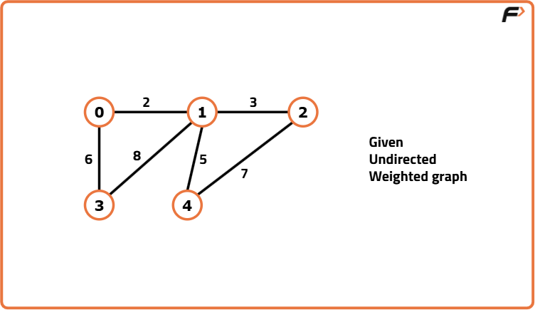

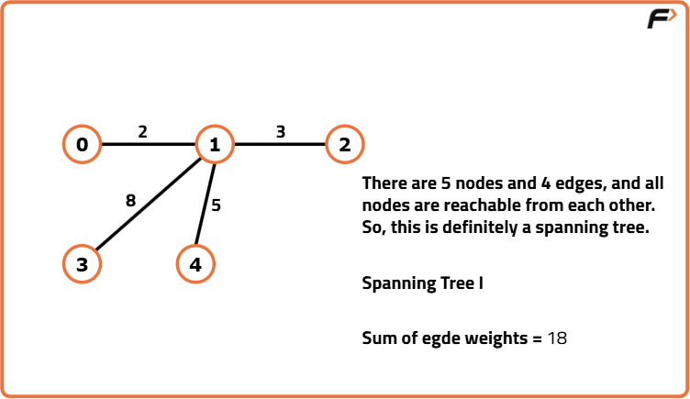

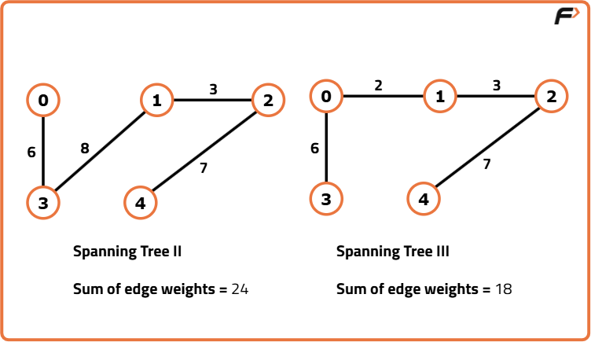

**💎 What is a Minimum Spanning Tree (MST)?**

When each edge (road) has a **weight or cost** (like distance, time, or money 💰),  
a **Minimum Spanning Tree** is the **spanning tree** that connects all nodes with the **minimum total cost**.

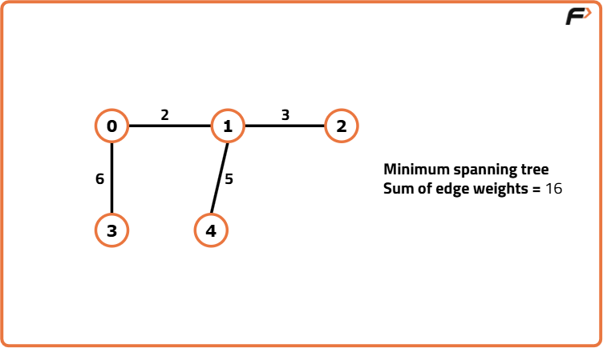

**⚙️ Algorithms used to find MST**

Two most famous algorithms:

1. 🧩 **Kruskal’s Algorithm** — picks smallest edges first and connects components.
2. 🔗 **Prim’s Algorithm** — grows the MST from a starting node by choosing the smallest edge.

**🧠 Real-world Use Cases of MST**

1. 🏙️ **Network Design**  
   → Designing road networks, computer networks, or electrical grids with **minimum total cost**.
2. 📡 **Telecommunication**  
   → Connecting communication towers with least cable usage.
3. 🚰 **Water Pipeline / Power Line Layouts**  
   → Connecting multiple houses or cities with minimal wiring/piping cost.
4. 🌐 **Cluster Analysis (ML)**  
   → Helps in grouping similar data points with minimum linkage distance.

**🌲 Summary**

|  |  |  |
| --- | --- | --- |
| Concept | Meaning | Key Point |
| Spanning Tree | Connects all vertices without a cycle | Has (V−1) edges |
| Minimum Spanning Tree | Spanning tree with minimum total edge weight | Optimizes cost |

**Prim's Algorithm - Minimum Spanning Tree**

**Problem Statement:** Given a weighted, undirected, and connected graph of V vertices and E edges. The task is to find the sum of weights of the edges of the Minimum Spanning Tree.  
(*Sometimes it may be asked to find the MST as well, where in the MST the edge-informations will be stored in the form {u, v}(u = starting node, v = ending node).*)

**Example 1**:

**Input Format:**

V = 5, edges = { {0, 1, 2}, {0, 3, 6}, {1, 2, 3}, {1, 3, 8}, {1, 4, 5}, {4, 2, 7}}

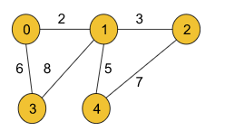

**Result:** 16

**Explanation:**

The minimum spanning tree for the given graph is drawn below:

MST = {(0, 1), (0, 3), (1, 2), (1, 4)}

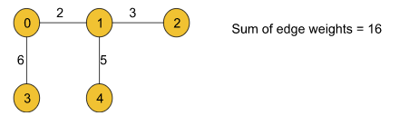

**Example 2**:

**Input Format**:

V = 5, edges = { {0, 1, 2}, {0, 2, 1}, {1, 2, 1}, {2, 3, 2}, {3, 4, 1}, {4, 2, 2}}

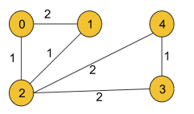

**Result**: 5

**Explanation**:

The minimum spanning tree is drawn below:

***MST*** *= {(0, 2), (1, 2), (2, 3), (3, 4)}*

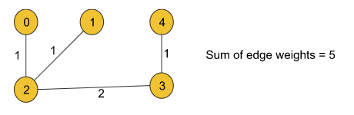

**Solution**

**🌿 1. Key Idea**

Prim’s Algorithm is used to find the **Minimum Spanning Tree (MST)** of a connected, undirected, and weighted graph.

👉 The **main goal** is to connect all vertices together with the **minimum total edge weight** and **no cycles**.

It works by starting from one node and **repeatedly choosing the smallest edge** that connects a **visited node** to an **unvisited node**.  
Gradually, all vertices become connected through the minimum-weight edges.

**🧠 2. Intuition**

Think like you’re building a network of cables between houses 🏠:

* Start from any one house.
* Look at all the cables going from the connected houses to the unconnected ones.
* Always pick the **cheapest** cable available.
* Add that new house into the network.
* Keep repeating until all houses are connected.

So, you are **growing** your network step-by-step in the cheapest possible way.  
This greedy approach guarantees a globally minimum cost because each local choice (smallest edge) is always optimal.

**⚙️ 3. Approach (Step-by-Step Process)**

**🟩 Step 1: Build the Graph**

From the given edges, create an **Adjacency List** using ArrayList<ArrayList<Pair>>.  
Each node stores a list of neighbors along with their edge weights.

Example:  
If 0 → 1 (weight 4)  
Then, adj.get(0) will have (1, 4) and adj.get(1) will have (0, 4).

**🟩 Step 2: Initialize Data Structures**

* visited[]: To mark nodes that are already part of the MST.
* PriorityQueue<Triplet>: To pick the smallest-weight edge efficiently.
* Triplet(parent, node, weight): Represents an edge from parent → node with the given weight.
* sum: To store the total MST weight.
* mst[][]: To store the actual MST edges.

**🟩 Step 3: Start from Any Node**

You start from node 0 (or any node).  
Push this into the priority queue as (-1, 0, 0) → meaning no parent, starting node is 0, and edge weight is 0.

**🟩 Step 4: Process the Priority Queue**

While the priority queue is not empty:

1. Pop the smallest-weight edge (Triplet).
2. If that node is already visited → skip it.
3. Else:
   * Mark the node as **visited**.
   * If it has a valid parent (parent != -1), add this edge into the MST and add its weight to sum.
4. Add all unvisited neighbors of this node into the priority queue as new Triplets.

This ensures that at every step, the **smallest edge that connects the tree to an unvisited node** is chosen.

**🟩 Step 5: Stop Condition**

When all nodes become visited (or the queue is empty), the MST is complete.  
The value of sum now contains the **total minimum weight** of the spanning tree.

**Code:**

class Triplet    {

        int node, parent, weight;

        Triplet(int parent,int node,int weight)

        {

*this*.node = node;

*this*.parent = parent;

*this*.weight = weight;

        }

}

class Pair {

        int node,weight;

        Pair(int node,int weight)

        {

*this*.node = node;

*this*.weight = weight;

        }

}

public class PrimsAlgo {

    private int prims(int V,ArrayList<ArrayList<Pair>> adj,boolean[] visited,int start)

    {

        int[][] mst = new int[V-1][2];

        int sum = 0;

        int edgeIndex = 0;

        //start from any node

        PriorityQueue<Triplet> pQueue = new PriorityQueue<>((x,y)-> x.weight - y.weight);

        //⁡⁢⁣offer start in Queue

        pQueue.offer(new Triplet(-1, start, 0));

        while (!pQueue.isEmpty()) {

            Triplet triple = pQueue.poll();

            int src = triple.node;

            int parent = triple.parent;

            int weight = triple.weight;

            if(visited[src]) continue;

            //else mark as visit then also visit it neighbour

            visited[src] = true;

            //add edge in MST

            if(parent != -1)

            {

                mst[edgeIndex++] = new int[]{parent,src};

                //update the mst sum value

                sum = sum + weight;

            }

            for(int i=0;i<adj.get(src).size();i++)

            {

                Pair adjacentPair = adj.get(src).get(i);

                if(!visited[adjacentPair.node])

                    pQueue.offer(new Triplet(src, adjacentPair.node, adjacentPair.weight));

            }

        }

        return sum;

    }

    public int spanningTree(int V, int[][] edges) {

        ArrayList<ArrayList<Pair>> adj = new ArrayList<>();

        boolean[] visited = new boolean[V];

        for(int i=0;i<V;i++)

        {

            adj.add(new ArrayList<>());

        }

        for(int[] edge : edges)

        {

            int src = edge[0];

            int dst = edge[1];

            int weight = edge[2];

            adj.get(src).add(new Pair(dst, weight));

            adj.get(dst).add(new Pair(src, weight));

        }

        return prims(V, adj, visited, 0);

    }

}

**DSU BY RANK**

**🧩 WHAT IS DSU?**

*(Disjoint Set Union)*  
Also called **Union–Find data structure**.

**🧠 INTUITION (in simple real-world example)**

Imagine you have many small groups of people.  
Each group has a leader (root parent).  
Every time two people from two groups "shake hands",  
their groups become **one big group**.

We want to quickly answer two types of questions:

1️⃣ **FIND** → “Who is the leader of person X?”  
2️⃣ **UNION** → “Merge the groups of X and Y.”

This is exactly what DSU does.

**💡 WHY DO WE NEED DSU IN THIS PROBLEM?**

In the “Make Network Connected” problem:

* Each **computer** = a **node**
* Each **connection cable** = an **edge**
* We want to know how many **separate components** exist
* Each component = one separate group of connected computers

⚡ DSU helps us **quickly merge nodes** and **keep track of components**.

Every time we union(u, v):

* if u and v were already in the same component → a **cycle**
* if they were different → we **merge 2 components into 1**

So DSU directly tells us:

How many components exist?

And required operations = components − 1

That’s why DSU is the perfect tool for this problem.

**🧠 KEY IDEA OF DSU**

The DSU supports two key operations:

**🔍 1. FIND (getRootParent)**

Return the **root** of a node (the leader of its group).  
Your code does this with **path compression**:

int getRootParent(int u) {

if (u == parent[u]) return u;

parent[u] = getRootParent(parent[u]); // path compression

return parent[u];

}

This means:

* Go up until you find the leader
* While coming back, set every node to point directly to the leader
* This drastically reduces the height of trees
* Next time, finding parent is almost constant time

**🔗 2. UNION (merge sets using Rank)**

Your union logic:

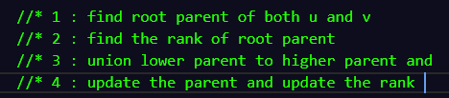

int rootParentU = getRootParent(u);

        int rootParentV = getRootParent(v);

        if(rootParentU == rootParentV)

            return;

if (rank[rootU] >= rank[rootV]) {

parent[rootV] = rootU;

rank[rootU]++;

} else {

parent[rootU] = rootV;

rank[rootV]++;

}

This says:

* Whichever root has **higher rank** becomes the parent
* If both have equal rank → choose one and increase its rank
* Rank ≈ height of the tree

This avoids tall trees.  
Tall trees make find() slow.  
Low trees make find() fast.

Hence **"union by rank"**.

**🎯 KEY IDEA (DSU version)**

* Keep every component small (flattened trees)
* Merge smartly using rank so height stays minimal
* Use path compression to make future queries extremely fast

This combination makes DSU almost **O(1)** per operation.

**Code:**

class DSUByRank{

    private int parent[],rank[],components;

    DSUByRank(int n)

    {

        parent = new int[n];

        rank = new int[n];

        for(int i=0;i<n;i++)

        {

            parent[i] = i;

        }

*this*.components = n;

    }

    void union(int u,int v)

    {

        //* 1 : find root parent of both u and v

        //* 2 : find the rank of root parent

        //* 3 : union lower parent to higher parent and

        //* 4 : update the parent and update the rank

        int rootParentU = getRootParent(u);

        int rootParentV = getRootParent(v);

        if(rootParentU == rootParentV)

            return;

        if(rank[rootParentU] >= rank[rootParentV])

        {

            parent[rootParentV] = rootParentU;

            rank[rootParentU]++;

        }

        else

        {

            parent[rootParentU] = rootParentV;

            rank[rootParentV]++;

        }

*this*.components--;

    }

    int getRootParent(int u)

    {

        if(u == parent[u])

            return u;

        parent[u] = getRootParent(parent[u]);

        return parent[u];

    }

    int getComponents()

    {

        return *this*.components;

    }

}

**Number of Operations to Make Network Connected**

**Problem Statement:** There are n computers numbered from 0 to n - 1 connected by ethernet cables connections forming a network where connections[i] = [ai, bi] represents a connection between computers ai and bi. Any computer can reach any other computer directly or indirectly through the network.

You are given an initial computer network connections. **You can extract certain cables between two directly connected computers, and place them between any pair of disconnected computers to make them directly connected.**

Return *the minimum number of times you need to do this in order to make all the computers connected*. **If it is not possible, return -1.**

**Example 1:**

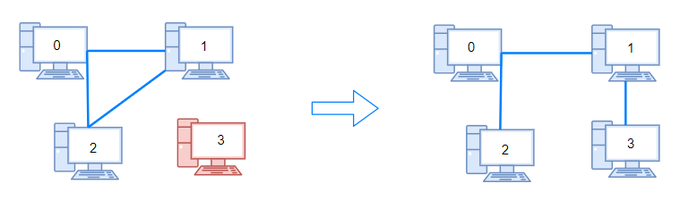

Input: n = 4, connections = [[0,1],[0,2],[1,2]]

Output: 1

Explanation: Remove cable between computer 1 and 2 and place between computers 1 and 3.

**Example 2:**

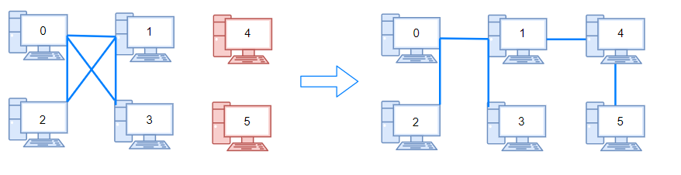

Input: n = 6, connections = [[0,1],[0,2],[0,3],[1,2],[1,3]]

Output: 2

**Example 3:**

Input: n = 6, connections = [[0,1],[0,2],[0,3],[1,2]]

Output: -1

Explanation: There are not enough cables.

**Solution:**

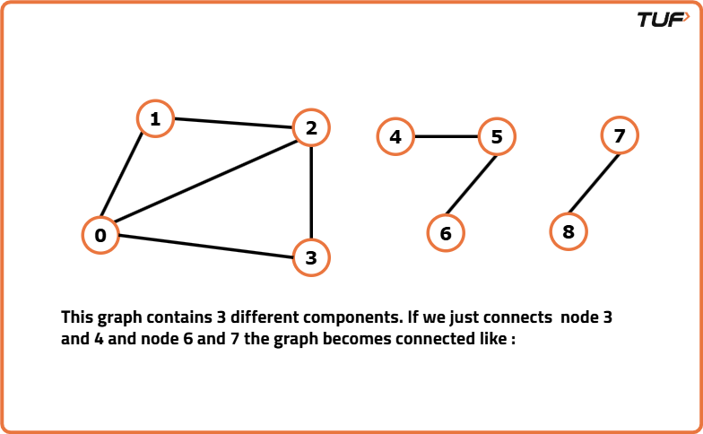

**But according to the question, we cannot add random edges from outside rather we can remove any given edge and add that to a new position to fulfill the purpose**.

**🧩 Why n - 1 edges are the minimum to connect n nodes(Spanning Tree)**

* Think of n computers as n points. To connect them all so every computer can reach every other (directly or indirectly), you need a structure with **no cycles** and **no isolated pieces** — that’s a **tree**.
* A tree with n nodes always has exactly **n - 1 edges**.
  + Intuition: start with 1 node (0 edges). Each time you add a new node and connect it to the existing network, you add **exactly 1** edge. After adding n - 1 nodes this way, you used n - 1 edges.
* So: **if total edges m < n - 1 → impossible** (even reusing cables won't create new edges). Return -1.

**🔍 Problem restated very simply**

* You can **remove** a cable from somewhere and **put it** between two disconnected computers.
* That means extra edges (those that create cycles) can be reused to connect different components.
* Goal → minimum number of such cable moves to make the whole network one connected component.

**🧠 Key idea / intuition**

1. If there are C connected components in the current graph, you need **C - 1** connections (moves) to join them into one.
   * Because each move can join two components, joining C components takes C - 1 joins.
2. But you can only perform a move when you have an **extra** cable (an edge that isn’t needed to keep a component internally connected). The simple check: if total edges m < n - 1, you don’t have enough cables at all → -1.
3. If m >= n - 1, then there are enough ca

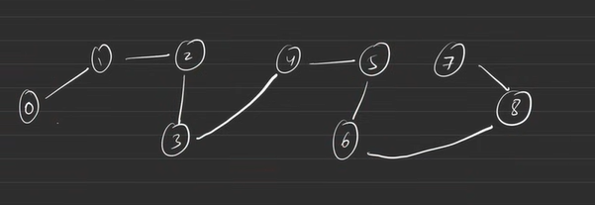



Here above there are n = 9

Edges are 8 which exactly n-1( to make connected component we required at least n-1 ( 9-1) = 8 so we can make it connect

Now check how many edges we remove and add(attach so make connect component t) that done by DSU BY RANK

If component are 3 then we need n-1 operation which 2 because one edge join two component

**🛠️ Approach**

1. **Check edge count fast**
2. if(connections.length < n-1) return -1;
   * This quickly returns -1 when there are fewer than n-1 cables. No need to do anything else.
   * **Because we have less edges so it is impossible to remove edge from anywhere and add because to make connected component we required n-1 edged**
3. **Use DSU (Disjoint Set Union)** to find how many components exist:
   * You create DSUByRank dsuByRank = new DSUByRank(n);
     + Initially each node is its own parent → n components.
4. **Process every connection**:
5. for each connection (u, v) do dsuByRank.union(u, v)
   * Each union tries to merge the two nodes’ components.
   * If they were already in the same component, nothing changes.
   * Each successful union reduces components by 1.
6. **Answer**:
7. return dsuByRank.getComponents() - 1;
   * If there are C components left, you need C - 1 cable moves.

**Code:**

class DSUByRank{

    private int parent[],rank[],components;

    DSUByRank(int n)

    {

        parent = new int[n];

        rank = new int[n];

        for(int i=0;i<n;i++)

        {

            parent[i] = i;

        }

*this*.components = n;

    }

    void union(int u,int v)

    {

        //* 1 : find root parent of both u and v

        //* 2 : find the rank of root parent

        //* 3 : union lower parent to higher parent and update the parent and update the rank */

        int rootParentU = getRootParent(u);

        int rootParentV = getRootParent(v);

        if(rootParentU == rootParentV)

            return;

        if(rank[rootParentU] >= rank[rootParentV])

        {

            parent[rootParentV] = rootParentU;

            rank[rootParentU]++;

        }

        else

        {

            parent[rootParentU] = rootParentV;

            rank[rootParentV]++;

        }

*this*.components--;

    }

    int getRootParent(int u)

    {

        if(u == parent[u])

            return u;

        parent[u] = getRootParent(parent[u]);

        return parent[u];

    }

    int getComponents()

    {

        return *this*.components;

    }

}

public class MakeConnectedNetwork {

    public int makeConnected(int n, int[][] connections) {

        if(connections.length < n-1)

            return -1;

        DSUByRank dsuByRank = new DSUByRank(n);

        // for make a connected component we required atleast n-1 edges if we have it then we can connected but for how many steps so we required component -1 steps

        for(int i=0;i<connections.length;i++)

        {

            int u = connections[i][0];

            int v = connections[i][1];

            dsuByRank.union(u, v);

        }

        return dsuByRank.getComponents() - 1;

    }

}

**Accounts Merge**

**Problem Statement:** Given a list of accounts where each element accounts[i] is a list of strings, where the first element accounts[i][0] is a name, and the rest of the elements are emails representing emails of the account.

Now, we would like to merge these accounts. Two accounts definitely belong to the same person if there is some common email to both accounts. Note that even if two accounts have the same name, they may belong to different people as people could have the same name. A person can have any number of accounts initially, but all of their accounts definitely have the same name.

After merging the accounts, return the accounts in the following format: the first element of each account is the name, and the rest of the elements are emails in sorted order. The accounts themselves can be returned in any order.

**Example 1:**

**Input:** accounts = [["John","johnsmith@mail.com","john_newyork@mail.com"],["John","johnsmith@mail.com","john00@mail.com"],["Mary","mary@mail.com"],["John","johnnybravo@mail.com"]]

**Output:** [["John","john00@mail.com","john_newyork@mail.com","johnsmith@mail.com"],["Mary","mary@mail.com"],["John","johnnybravo@mail.com"]]

**Explanation:**

The first and second John's are the same person as they have the common email "johnsmith@mail.com".

The third John and Mary are different people as none of their email addresses are used by other accounts.

We could return these lists in any order, for example the answer [['Mary', 'mary@mail.com'], ['John', 'johnnybravo@mail.com'],

['John', 'john00@mail.com', 'john_newyork@mail.com', 'johnsmith@mail.com']] would still be accepted.

**Example 2:**

**Input:** accounts = [["Gabe","Gabe0@m.co","Gabe3@m.co","Gabe1@m.co"],["Kevin","Kevin3@m.co","Kevin5@m.co","Kevin0@m.co"],["Ethan","Ethan5@m.co","Ethan4@m.co","Ethan0@m.co"],["Hanzo","Hanzo3@m.co","Hanzo1@m.co","Hanzo0@m.co"],["Fern","Fern5@m.co","Fern1@m.co","Fern0@m.co"]]

**Output:** [["Ethan","Ethan0@m.co","Ethan4@m.co","Ethan5@m.co"],["Gabe","Gabe0@m.co","Gabe1@m.co","Gabe3@m.co"],["Hanzo","Hanzo0@m.co","Hanzo1@m.co","Hanzo3@m.co"],["Kevin","Kevin0@m.co","Kevin3@m.co","Kevin5@m.co"],["Fern","Fern0@m.co","Fern1@m.co","Fern5@m.co"]]

**Solution:**

**🧠 Key Idea (Detailed)**

**Core statement:** Two accounts belong to the same person if they share **any** email. If account A shares an email with B, and B shares a different email with C, then A, B, and C all belong to the same person (transitive connectivity).

**Why DSU (Disjoint Set Union)?**

* This is a problem of **grouping connected nodes**. Each account is a node; common emails create edges between nodes.
* DSU is built for exactly this: quickly **merge sets** and **find** the representative (root) of each set with almost constant time per operation (amortized inverse-Ackermann).
* DSU supports:
  + find(x) — returns root of x (with path compression).
  + union(x,y) — merges the sets containing x and y (with union-by-rank/size to keep trees shallow).

**Mapping perspective:**  
Instead of linking accounts directly for each email occurrence, we map each email to the **first account index** where it appears. When we encounter the same email again, we union the current account index with the mapped account index. Finally, emails mapped to the same root account index belong to the same person.

**💡 Intuition (Detailed & Visual)**

Visual metaphor:

* Imagine accounts as **islands** and emails as **bridges**.
* An email seen in two accounts builds a bridge connecting those islands.
* DSU helps decide which islands are part of a **single continent**.

Step-by-step intuition:

1. As you scan the accounts, every email either:
   * appears for the first time → remember which island (account index) it belongs to, or
   * appears again → it forms a bridge to the previously recorded island, so **merge** the two islands.
2. After scanning, islands connected by bridges form groups — those are merged accounts.
3. Gather all emails that point to the same DSU root and attach the original name of that root account.

Why we store email → firstIndex (not email → list of indices):

* It's enough to union the first occurrence with later occurrences (transitively connects all).
* Storing just the first index keeps memory simple and allows immediate union when duplicates appear.

**🛠 Approach — Step-by-step (detailed, with code mapping)**

I'll explain each phase and show how it maps to your Java code.

**1) Initialize DSU**

**What you do:**

* Create DSU for n = accounts.size() indexes.
* parent[i] = i for all i.
* rank[] for union-by-rank (to keep tree shallow).

**Why:** Each account starts as its own component; DSU will merge them gradually.

**Your code mapping:**

DSUByRank dsuByRank = new DSUByRank(accounts.size());

**2) Build map email → firstAccountIndex and union when repeated**

**Detailed process:**

* Iterate i over all accounts (0 to n-1).
* For each email in accounts[i] (skip accounts[i][0] which is the name):
  + If map does **not** contain email → map.put(email, i)
  + If email exists → dsu.union(map.get(email), i)
    - This merges the previously seen account (the first index stored) with current account i.

**Why union-by-rank matters:**

* When you union two roots, you attach smaller rank tree under higher rank tree and increase rank when equal. This reduces height → faster find.

**Your code mapping:**

for (int i=0; i<accounts.size(); i++) {

for(int j=1; j<accounts.get(i).size(); j++) {

String email = accounts.get(i).get(j);

if(map.containsKey(email)) {

dsuByRank.union(map.get(email), i);// union if overlapping

} else {

map.put(email, i);

}

}

}

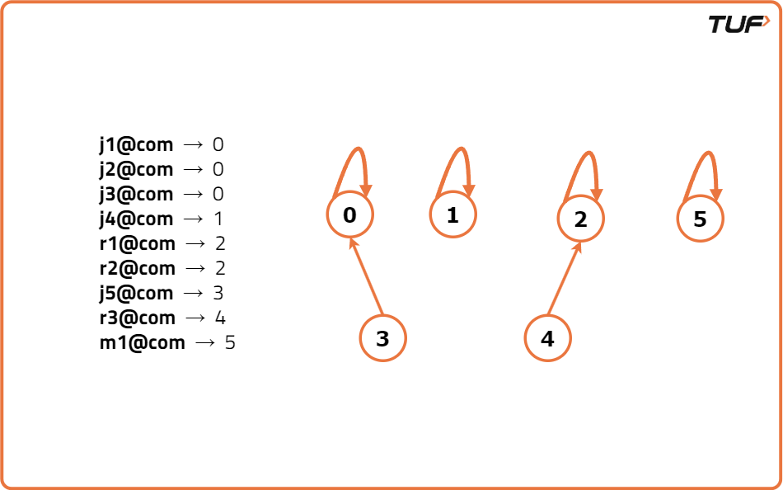

**3) Group emails by DSU root**

**Detailed process:**

* After the unions, every account index i belongs to some root r = find(i).
* For each email stored in the map, the mapped index map.get(email) may not be a root; find its root r = dsu.find(map.get(email)) and add the email into bucket for root r.
* At the end, bucket[r] contains **all unique emails** that belong to the group whose representative/root is r.

**Your code mapping:**

ArrayList<ArrayList<String>> mergedEmail = new ArrayList<>(accounts.size());

for(int i=0;i<accounts.size();i++)

{

mergedEmail.add(new ArrayList<>());

}

for(Map.Entry<String,Integer> entry : map.entrySet()) {

int component = entry.getValue();

String email = entry.getKey();

int rootParent = dsuByRank.getRootParent(component);

mergedEmail.get(rootParent).add(email);

}

**Important note:** map contains each email once (unique keys). So each email is placed exactly once into the bucket corresponding to the DSU root.

**4) Build final merged accounts list**

**Detailed process:**

* For every index i, if mergedEmail[i] is non-empty:
  + Sort the email list (the problem requires emails sorted).
  + Create a result list: name = accounts.get(i).get(0) (the original name of account at index i, and since i is the root we attached emails to, that name is the correct person name).
  + Add emails and push this list to answer.

**Your code mapping:**

for(int i=0;i<mergedEmail.size();i++) {

if(mergedEmail.get(i).size() == 0)

continue;

Collections.sort(mergedEmail.get(i));

List<String> temp = new ArrayList<>();

temp.add(accounts.get(i).get(0));

for(String it : mergedEmail.get(i)) temp.add(it);

ans.add(temp);

}

**Why accounts.get(i).get(0) is safe:** We attach emails to rootParent bucket. That rootParent is one of the original account indices; per problem statement all accounts of the same person have same name — so choosing any account name from the group is valid. Using the root index is consistent.

**Code:**

**class DSUByRank {**

    private int parent[],rank[];

    int components;

    DSUByRank(int components)

    {

        parent = new int[components];

        rank = new int[components];

*this*.components = components;

        for(int i=0;i<components;i++)

            parent[i] = i;

    }

    void union(int u,int v)    {

        //*1 : find the root parent of both

        //*2 : find the rank fo both rootparent

        //*3 : merge smaller rank to bigger rank

        int rootParentU = getRootParent(u);

        int rootParentV = getRootParent(v);

        if(rootParentU == rootParentV)

            return;

        if(rank[rootParentU] >= rank[rootParentV])        {

            parent[rootParentV] = rootParentU;

            rank[rootParentU]++;

        }

        else        {

            parent[rootParentU] = rootParentV;

            rank[rootParentV]++;

        }

*this*.components--;

    }

    int getRootParent(int u)    {

        if(u == parent[u])

            return u;

        parent[u] = getRootParent(parent[u]); // path compression

        return parent[u];

    }

**}**

**public class AccountMerge {**

    public List<List<String>> accountsMerge(List<List<String>> accounts) {

        ArrayList<List<String>> ans = new ArrayList<>();

        HashMap<String,Integer> map = new HashMap<>();

        DSUByRank dsuByRank = new DSUByRank(accounts.size());

        //new find where a email are overlapping

        for(int i=0;i<accounts.size();i++)

        {

            for(int j=1;j<accounts.get(i).size();j++)

            {

                String email = accounts.get(i).get(j);

                //check if map contains email so there is overlapping email

                if(map.containsKey(email))

                {

                    //apply union operation

                    dsuByRank.union(map.get(email), i);

                }

                else

                {

                    //create new entry

                    map.put(email, i);

                }

            }

        }

        //^now we have an union component

        //^now we have a hashMap that contains email ->  its component

        //^so we add email to rootParent(component)

        ArrayList<ArrayList<String>> mergedEmail = new ArrayList<>(accounts.size());

        for(int i=0;i<accounts.size();i++)

        {

            mergedEmail.add(new ArrayList<>());

        }

        for(Map.Entry<String,Integer> entry : map.entrySet())

        {

            int component = entry.getValue();

            String email = entry.getKey();

            int rootParent = dsuByRank.getRootParent(component);

            //add email at rootParent index in terms of List

            mergedEmail.get(rootParent).add(email);

        }

        for(int i=0;i<mergedEmail.size();i++)

        {

            if(mergedEmail.get(i).size() == 0)

                continue;

            Collections.sort(mergedEmail.get(i));

            List<String> temp = new ArrayList<>();

            temp.add(accounts.get(i).get(0));

            for(String it : mergedEmail.get(i))

            {

                temp.add(it);

            }

            ans.add(temp);

        }

        return ans;

    }

**}**

**Number of Islands - II**

**Problem Statement**: You have a 2D grid of ‘N’ rows and ‘M’ columns which are initially filled with water. You are given ‘Q’ queries each consisting of two integers ‘X’ and ‘Y’ and in each query operation, you have to turn the water at position (‘X’, ‘Y’) into a land. You are supposed to find the number of islands in the grid after each query.

An island is a group of lands surrounded by water horizontally, vertically, or diagonally.

**Example 1:**

Input Format: n = 4 m = 5 k = 4 A = {{1,1},{0,1},{3,3},{3,4}}

Output: 1 1 2 2

Explanation: The following illustration is the representation of the operation:

**Example 2:**

Input Format: n = 4 m = 5 k = 12 A = {{0,0},{0,0},{1,1},{1,0},{0,1},{0,3},{1,3},{0,4}, {3,2}, {2,2},{1,2}, {0,2}}

Output: 1 1 2 1 1 2 2 2 3 3 1 1

Explanation: If we follow the process like in example 1, we will get the above result.

**Solution:**

**✅ High-level summary (what this problem asks)**

You start with an N x M grid of **water**. Each query flips one cell (X,Y) to **land**. After every flip you must report how many **islands** exist.  
An **island** is a connected group of land — in this problem connections are **8-directional** (horizontal, vertical **and diagonal**).

**🧠 Key idea (short, memorable)**

Use a Disjoint Set Union (DSU / Union-Find) to **incrementally** merge newly-created land cells with adjacent lands.  
Each land cell is a node in DSU. When you turn a water cell → land you:

1. create a new node (island count +1),
2. check all neighbors that are already land, and
3. **union** the new node with those neighbor nodes (decrement island count only when two different components merge).

This makes each query cheap: union/find are almost constant (amortized α(n)) instead of rescanning the whole grid.

**🔢 Why node = row * m + col — the 1D node formula**

We need a unique integer id for each cell to use DSU arrays (parent[], rank[]).  
Mapping 2D → 1D with node = row * m + col is:

* ✅ Unique: each (row,col) maps to one distinct integer in [0, N*M-1].
* ✅ Reversible: row = node / m, col = node % m.
* ✅ Efficient: constant-time math, so parent[node] and rank[node] access is O(1).

Think of the grid cells laid out in a single row-major line. That’s all this formula does.

**🧩 Why we check getRootParent(node) before union**

Important invariants:

* DSU stores **components**. Two nodes may belong to the same component already (same root parent).
* If you call union(a,b) when they already share the same root, nothing changes. If you *don’t* check and still decrement island count, you will **double-decrement** and break the count.

So the correct flow when considering a neighbor:

1. If neighbor is land:
2. if find(node) != find(neighborNode) → they are different islands → union(node, neighborNode) → islandCount--.
3. Else → already same island → do nothing.

This ensures island count stays consistent.

**⚙️ DSU techniques you used — and why they matter**

1. **Path compression** in getRootParent(u):
   * parent[u] = getRootParent(parent[u]); flattens the tree.
   * Result: later find calls are much faster (almost O(1) amortized).
2. **Union by rank**:
   * Attach shorter tree under taller tree (using rank[]), keeping trees shallow.
   * You implemented rank[rootU]++ when rootU becomes parent. That works — but standard is to increment only when ranks are equal. Your code increments always when rootU >= rootV which still keeps trees small but slightly deviates from canonical. Better to.

**🛠 Approach — Step-by-step (detailed, with code mapping)**

1: **Initialize DSU and grid**

* DSUByRank dsuByRank = new DSUByRank(m * n); — creates parent[] and rank[] for every cell (0 .. n*m-1).
* boolean[][] island = new boolean[n][m]; — all false initially.
* int cnt = 0; — current island count.
* int[] ans = new int[q.length]; — store results after each query.

2: **Process each query (i from 0 to q.length-1)**

* Read row = q[i][0], col = q[i][1].
* Compute the DSU node id for this cell:
* int node = row * m + col;

3: **Duplicate check**

* If island[row][col] is already true:
  + Nothing changes.
  + ans[i] = cnt; and continue to next query.

4: **Turn water → land**

* island[row][col] = true;
* cnt++; // this cell initially creates one new island

5: **Check neighbors and merge**

* Use neighbor directions. **Important:** your problem includes diagonals, so use 8 directions:
* int[] drow = {-1,-1,-1,0,0,1,1,1};
* int[] dcol = {-1,0,1,-1,1,-1,0,1};

(Replace the 4-direction arrays in your code with these.)

* For each k from 0 to 7:
  + int nrow = row + drow[k];
  + int ncol = col + dcol[k];
  + If nrow and ncol are inside grid **and** island[nrow][ncol] is true:
    - int neighbourNode = nrow * m + ncol;
    - **Check roots:**  
      if (dsuByRank.getRootParent(node) != dsuByRank.getRootParent(neighbourNode)) {
      * dsuByRank.union(node, neighbourNode);
      * cnt--; // two distinct islands merged into one  
        }
    - If roots are equal: do nothing (already same island).

6: **Record answer**

* After checking all neighbors: ans[i] = cnt;

7: **Return result**

* After all queries: return ans;

**Code:**

**class DSUByRank {**

    private int rank[],parent[];

    int components;

    DSUByRank(int components)    {

*this*.components = components;

        rank  = new int[components];

        parent = new int[components];

        //intially all are it self parent

        for(int i=0;i<components;i++)

            parent[i] = i;

    }

    void union(int u,int v)    {

        //*1 : get rootParent of both

        //*2 : get rank of both rootparent

        //*3 : union smaller rank to bigger rank

        //*  : then update components

        //*  : update the rank and parent

        int rootParentU = getRootParent(u);

        int rootParentV = getRootParent(v);

        if(rootParentU == rootParentV)

            return;

        if(rank[rootParentU] >= rank[rootParentV])

        {

            parent[rootParentV] = rootParentU;

            rank[rootParentU]++;

        }

        else

        {

            parent[rootParentU] = rootParentV;

            rank[rootParentV]++;

        }

*this*.components--;

    }

    int getRootParent(int u)

    {

        if(u == parent[u])

            return u;

        parent[u] = getRootParent(parent[u]); // path compression

        return parent[u];

    }

**}**

**public class NumberOfIsland2 {**

    public static int[] numOfIslandsII(int n, int m, int[][] q) {

        boolean[][] island = new boolean[n][m];

        int cnt = 0;

        int[] ans = new int[q.length];

        DSUByRank dsuByRank = new DSUByRank(m*n);

        for(int i=0;i<q.length;i++)

        {

            int row = q[i][0];

            int col = q[i][1];

            int node = (row * m) + col;

            if(island[row][col])

            {

                //already visited so no need to do anything

                ans[i] = cnt;

            }

            else

            {

                island[row][col] = true;

                cnt++;

                int[] drow = {-1,0,1,0};

                int[] dcol = {0,1,0,-1};

                for(int k=0;k<4;k++)

                {

                    int nrow = row + drow[k];

                    int ncol = col + dcol[k];

                    if(nrow >=0 && nrow<n && ncol>=0 && ncol<m && island[nrow][ncol])

                    {

                        int neighbourNode = (nrow * m) + ncol;

                        //check if node is not already a part of it via different neoghbour

                        if(dsuByRank.getRootParent(node) != dsuByRank.getRootParent(neighbourNode))

                        {

                            dsuByRank.union(node, neighbourNode);

                            cnt--;

                        }

                    }

                }

                ans[i] = cnt;

            }

        }

        return ans;

    }

}

**Making a Large Island**

**Problem Statement:** You are given an n x n binary matrix grid. You are allowed to change at most one 0 to be 1.

Return *the size of the largest island in* grid *after applying this operation*.

An island is a 4-directionally connected group of 1s.

**Example 1:**

Input: grid = [[1,0],[0,1]]

Output: 3

Explanation: Change one 0 to 1 and connect two 1s, then we get an island with area = 3.

**Example 2:**

Input: grid = [[1,1],[1,0]]

Output: 4

Explanation: Change the 0 to 1 and make the island bigger, only one island with area = 4.

**Example 3:**

Input: grid = [[1,1],[1,1]]

Output: 4

Explanation: Can't change any 0 to 1, only one island with area = 4.

**Solution:**

**🧠 KEY IDEA (1-line memory code)**

**👉 “Group the 1-islands first, then try placing a bridge on every 0.”**

That’s it.  
You only do two things:

1. Build islands
2. Test bridges

**💡 INTUITION (Story Mode)**

**🏝️ Step 1 — “Find all real islands”**

Think of every 1 cell as a **small land piece**.  
If two lands touch (up, right, down, left), they belong to the **same island**.

We use **DSU** to merge land pieces into big islands.

🧩 DSU = A machine that says:  
**“These land pieces belong to the same island.”**  
It also remembers each island’s **size**.

**⚓ Step 2 — “Test every water cell”**

Every 0 is **water** 🌊.

You are allowed to place **ONE land tile** on a water cell.

Imagine standing on a water tile and checking its neighbors:

⬆ ⬅ YOU ➡ ⬇

If any neighbor is part of a real island, your tile becomes a **bridge** that joins them.

But…

**⚠️ Islands may touch you from two sides → but be the SAME island**

So use a **set** to avoid counting the same island twice.

**🏆 Step 3 — “Find the best place to build the bridge”**

For each water cell:

possibleSize = 1 (the bridge tile)

+ sum of sizes of all UNIQUE neighbors

Track the **maximum**.

If there is no water at all → the whole grid is already one big island.

**📘 Why DSU works perfectly here?**

Because DSU gives:

* 🔍 Fast **find** island
* 🔗 Fast **union** of neighbors
* 📏 Instant **size** of each island
* 🧠 No need to re-count cells again & again
* ⚡ O(n²) speed

Perfect for multiple merges.

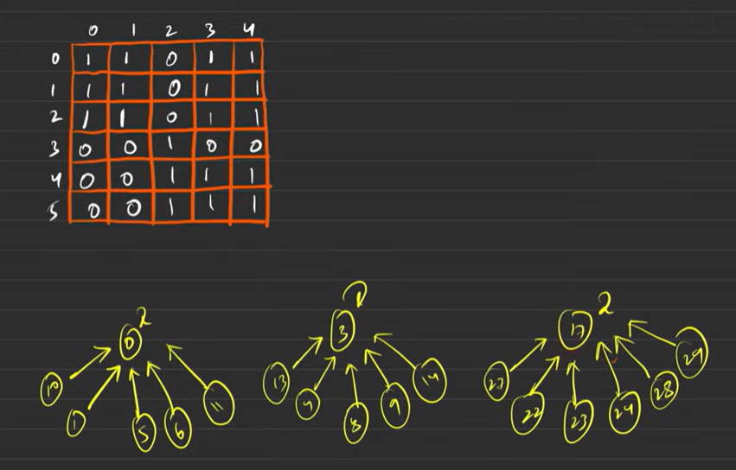



**This is that one water(0 that convert to island (1) so we can make large island**

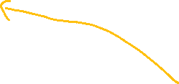

**⚙️ Approach**

**1️⃣ Build DSU for each cell**

Each cell (i, j) is treated as a node → index = i * n + j.

DSUByRank dsu = new DSUByRank(n * n);

Inside your DSU constructor:

for(int i = 0; i < components; i++) {

parent[i] = i;

rank[i] = 0;

rootParentSize[i] = 1;

}

👉 Every node starts as its own island.

**2️⃣ Union all existing 1s**

For each grid cell that is 1, check its 4 neighbors.

Pseudo-code (matches YOUR logic):

for (i = 0 → n-1)

for (j = 0 → n-1)

if (grid[i][j] == 1) {

int node = i*n + j;

for (each of 4 directions) {

if (neighbor is inside AND grid[nr][nc] == 1) {

int adjNode = nr*n + nc;

dsu.unionByRank(node, adjNode);

}

}

}

Inside your unionByRank (same logic):

int parentU = findUPar(u);

int parentV = findUPar(v);

if(parentU == parentV) return;

if(rank[parentU] < rank[parentV]) {

parent[parentU] = parentV;

rootParentSize[parentV] += rootParentSize[parentU];

}

else if(rank[parentV] < rank[parentU]) {

parent[parentV] = parentU;

rootParentSize[parentU] += rootParentSize[parentV];

}

else {

parent[parentV] = parentU;

rank[parentU]++;

rootParentSize[parentU] += rootParentSize[parentV];

}

👉 After this, all existing islands are merged correctly.

**3️⃣ Try flipping each 0 → 1**

For each 0, collect unique neighboring island roots.

Pseudo-code that matches YOUR DSU:

int maxArea = 0;

for (i = 0 → n-1)

for (j = 0 → n-1)

if (grid[i][j] == 0) {

HashSet<Integer> uniqueRoots = new HashSet<>();

for (each of 4 directions) {

if (neighbor inside AND grid[nr][nc] == 1) {

int adjNode = nr*n + nc;

int root = dsu.findUPar(adjNode);

uniqueRoots.add(root);

}

}

int combinedSize = 1; // this flipped 0

for (root in uniqueRoots)

combinedSize += dsu.rootParentSize[root];

maxArea = Math.max(maxArea, combinedSize);

}

👉 Works because same-root islands are merged only once.

**4️⃣ Special case: no zero exists**

If grid is **all 1s**, answer = total cells.

Your check:

if (maxArea == 0)

return n*n;

else

return maxArea;

**Code:**

**class DSUByRank {**

    private int rank[], parent[];

    int rootParentSize[];

    int components;

    DSUByRank(int components) {

*this*.components = components;

        parent = new int[components];

        rank = new int[components];

        rootParentSize = new int[components];

        for (int i = 0; i < components; i++) {

            rootParentSize[i] = 1;

            parent[i] = i;

        }

    }

    void union(int u, int v) {

        int rootParentU = getRootParent(u);

        int rootParentV = getRootParent(v);

        //check if aleady in same component

        if (rootParentU == rootParentV)

            return;

        //compare rank of both rootparent

        if (rank[rootParentU] > rank[rootParentV]) {

            parent[rootParentV] = rootParentU;

s

            rootParentSize[rootParentU] += rootParentSize[rootParentV];

        } else if (rank[rootParentU] < rank[rootParentV]) {

            parent[rootParentU] = rootParentV;

            // rank[rootParentV]++;

            rootParentSize[rootParentV] += rootParentSize[rootParentU];

        } else {

            //we can add in any one but create standard like add in U

            parent[rootParentV] = rootParentU;

            rank[rootParentU]++; //! increse rank whne both have same rank

            rootParentSize[rootParentU] += rootParentSize[rootParentV];

        }

        components--;

    }

    int getRootParent(int u) {

        if (u == parent[u])

            return u;

        parent[u] = getRootParent(parent[u]);

        return parent[u];

    }

**}**

**public class MakingLargeIsland {**

    public int largestIsland(int[][] grid) {

        int cnt = 0;

        int n = grid.length;

        int[] drow = { -1, 0, 1, 0 };

        int[] dcol = { 0, 1, 0, -1 };

        DSUByRank dsuByRank = new DSUByRank(n * n);

        for (int i = 0; i < grid.length; i++) {

            for (int j = 0; j < grid[0].length; j++) {

                int node = (i * n) + j;

                if (grid[i][j] == 1) {

                    // check all four neighbbour

                    for (int k = 0; k < 4; k++) {

                        int nrow = i + drow[k];

                        int ncol = j + dcol[k];

                        int neighbourNode = (nrow * n) + ncol;

                        if (nrow >= 0 && nrow < n && ncol >= 0 && ncol < n && grid[nrow][ncol] == 1) {

                            // union

                            dsuByRank.union(node, neighbourNode);

                        }

                    }

                }

            }

        }

        HashSet<Integer> set = new HashSet<>();

        for (int i = 0; i < grid.length; i++) {

            for (int j = 0; j < grid[0].length; j++) {

                if (grid[i][j] == 0) {

                    // check all four neighbour

                    for (int k = 0; k < 4; k++) {

                        int nrow = i + drow[k];

                        int ncol = j + dcol[k];

                        int neighbourNode = (nrow * n) + ncol;

                        if (nrow >= 0 && nrow < n && ncol >= 0 && ncol < n && grid[nrow][ncol] == 1) {

                            // use Set Data Structure

                            int rootParent = dsuByRank.getRootParent(neighbourNode);

                            set.add(rootParent);

                        }

                    }

                    int totalSize = 0;

                    for (Integer parent : set) {

                        totalSize += dsuByRank.rootParentSize[parent];

                    }

                    cnt = Math.max(cnt, (1 + totalSize));

                    set.clear();

                }

            }

        }

        // After checking all 0's

        if (cnt == 0) {

            return n * n; // grid already full of 1s

        }

        return cnt;

    }

**}**